This learning progression is writing for a 10th -11th grades Geometry class. The textbook for this class is CORD Geometry 1 Learning in Context 4th edition. For this textbook student cannot access it only the teacher can. This book is use a guide to making the class run. The book is often used to make notes for the student and worksheets. The standards for this classroom will be using CCSS are HSG.CO.A.3, HSG.CO.A.4 and HSG.CO.A.5. The CCSS- mathematical practices that are used in this learning progression are; MP4: Model with mathematics, MP6: Attend to precision, MP7: Look for and make use of structure.
This learning progression is to be taught when student need a hand on activity. In this learning progression student will learn how to do reflection, rotation, and translation on a given shape. This learning progression is broken up into four lessons.
A teaching strategy that is used throughout the learning progression is peer tutoring. Peer tutoring is a great strategy to use to help student learn math. According to Kunsch, Jitendra, & Sood in there article; The effects of peer-mediated instruction in mathematics for students with learning problems: A research synthesis, they found that “peer tutoring works best when students of different ability levels work together.” In a normal classroom a teacher can have student from all different kind of math level. Thus, it important for student to help other students. This does not only benefit the peer that is getting help but as the peer that is giving the help. So for all activity not benchmark student can get help from one another.

Lesson 1
In lesson 1 student will learn about reflections about how to do them on a given shape. At the start of class the student will be given an entry task which will have them define reflections. This entry task will help see where your students are and see how much you as the teacher need to go over. After the entry task in over the teacher would move into notes. In the notes the teacher will make a definition of reflection and do an example of a reflection. Such has reflected a square over the y-axis. When doing this the student will have a note sheet which will have the shape the teacher is reflected this will help the student fellow along. This will also help them develop math precision.^{MP6} Also the teacher will teach about the general rule for doing a reflection in the Cartesian plane. Once the lesson has been taught the teacher will more into a worksheet where student can work together to get done. On this worksheet there will be three problems on doing reflection on a given shape and two problems of identity the reflection and explain how you found the answer.^{MP7} This worksheet is made to help student model there math.^{MP4} During the worksheet the three problem will be the benchmark

HSG.CO.A.3, HSG.CO.A.4 and HSG.CO.A.5 (For the full standard please check out the lesson plan)

MP6: Attend to precision

MP7: Look for and make use of structure
MP4: Model with mathematics
assessment. The benchmark assessment will show the teacher if the student are ready to more on or not. If they are not the teacher can spend another day on reflections and if they student are ready to move on they will start or not. If they are not the teacher can spend another day on reflections and if they student are ready to move on they will start lesson 2 which is rotations.
Lesson 2 (for this lesson there is a lesson plan attached)
In lesson 2 students will learn about rotation about how to do them on a given shape. At the start of class the student will be given an entry task which will have them define reflections and to label the quadrant in a Cartesian plane. This entry task will help see where your students are and see how much you as the teacher need to go over. After the entry task in over the teacher would move into notes. In the notes the teacher will make a definition of rotation and do an example of a rotation. Such has rotation a square 90 degrees. When doing this the student will have a note sheet which will have the shape the teacher is rotation this will help the student fellow along. This will also help them develop math precision.^{MP6} Also the teacher will teach about the general rule for doing a rotation in the Cartesian plane.

Benchmark see on last page

HSG.CO.A.3, HSG.CO.A.4 and HSG.CO.A.5

MP6: Attend to precision

Once the lesson has been taught the teacher will more into a worksheet where student can work together to get
done. On this worksheet there will be three problems on doing rotation on a given shape and two problems of identity the rotation and explain how you found the answer.^{MP7} This worksheet is made to help student model there math.^{MP4} During the worksheet the three problem will be the benchmark assessment. The benchmark assessment will show the teacher if the student are ready to more on or not. If they are not the teacher can spend another day on rotations and if they student are ready to move on they will start lesson 3 which is translation.
Lesson 3
In lesson 2 students will learn about translation about how to do them on a given shape. At the start of class the student will be given an entry task which will have them define rotation. This entry task will help see where your students are and see how much you as the teacher need to go over. After the entry task in over the teacher would move into notes. In the notes the teacher will make a definition of translation and do an example of a translation. Such has translation a square up 2 over 1.

MP7: Look for and make use of structure
MP4: Model with mathematics

Benchmark: Please look at problem 3 in lesson plan.

HSG.CO.A.3, HSG.CO.A.4 and HSG.CO.A.5

When doing this the student will have a note sheet which will have the shape the teacher is translation this will help the student fellow along. This will also help them develop math precision.^{MP6} Also the teacher will teach about the general rule for doing a translation in the Cartesian plane. Once the lesson has been taught the teacher will more into a worksheet where student can work together to get done. On this worksheet there will be three problems on doing translation on a given shape and two problems of identity the translation and explain how you found the answer.^{MP7} This worksheet is made to help student model there math.^{MP4} During the worksheet the three problem will be the benchmark assessment. The benchmark assessment will show the teacher if the student are ready to more on or not. If they are not the teacher can spend another day on translation and if they student are ready to move on they will start lesson 4 which is review.
Lesson 4
In lesson 4 students will learn doing a review of reflection, rotation, and translation. At the start of class the student will be given an entry task which will have them define rotation, reflection and translation.^{MP6} This

MP6: Attend to precision

MP7: Look for and make use of structure
MP4: Model with mathematics
Benchmark see on last page

HSG.CO.A.3, HSG.CO.A.4 and HSG.CO.A.5

MP6: Attend to precision
entry task will help see where your students are and see how much you as the teacher to review. The teacher will do a quick review by ask student questions on reflection, rotation, and translation. The student will answer the questions. After this the teacher will have notecard with different reflection, rotation, and translation on them. Each student must get a pair and do the reflection, rotation, and/or translation on a whiteboard. Each pair will need to draw a model and then explain how to do it to the class.^{MP4} Once each group has gone the teacher will give out an exit slip which will be the benchmark assessment for the review.

MP4: Model with mathematics
Benchmark see on last page
Benchmark assessment for lesson 1
Do a y=x reflection for the given shape
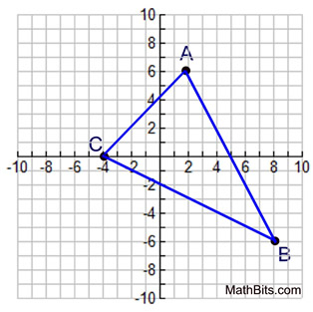
Benchmark assessment for lesson 3
Do a translation down 4 and to the left 1 to the given shape.
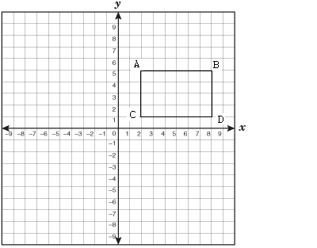
Benchmark assessment for lesson 4
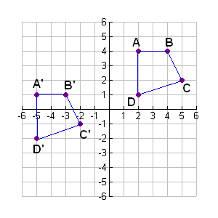
What happen n to this shape?

