Lesson Title: Stacking Cups
Unit Title: Linear Equations
Teacher Candidate: Jessica Lovell, Shannon Fischer, Estela Rodriguez, Daniel Deal
Subject, Grade Level, and Date: 8th grade Mathematics on May 2, 2016 at 10:00-10:50 AM
Placement of Lesson in Sequence and Lesson Rationale
This is the 9th activity in the linear equations unit, students have worked with writing linear equations when given a table or graph and can graph a line when given an equation.
Central Focus and Purpose
The central focus of this lesson is on the conceptual understanding of linear relationships and their properties such as a constant rate of change. This lesson will build upon the student’s previous knowledge of plotting points, graphing lines and finding slope. Prior to this lesson, students developed an understanding of slope and procedures, such as counting rise over run for calculating its value. All students can write a linear equation when given a table or graph and can graph a line when given an equation. During this lesson, students will use this prior knowledge during the stacking cups activity to construct a cup model of linear data. Students will look for patterns in the data and express these patterns as a linear relationship first verbally and later filling out the worksheet determining an equation using the slope intercept form of a line. Each group will present their cup model firsthand explain their reasoning for the equation they came up with to the rest of the class, providing an opportunity for whole group discussion. Following this lesson, students will be able to independently recognize models of linear data that represent linear relationships. In the lessons following, students will graphically and quantitatively look for patterns in models and express these patterns as a linear or non-linear relationship.
CCSS.MATH Content and Practice Standards
8.F.B.4, 8.F.B.5, MP.4
Prior Content Knowledge and Pre-Assessment
Students have been exposed to properties of functions such as expressing the relationship between a functions input and output, identifying domain and range of continuous and discrete functions, identifying functions from ordered pairs, tables, and graphs. All students are aware and practiced analyzing models and group discussions. According to the most recent assessment, all but two students can interpret the linear equation when appropriate.
Learning Target(s) and Plan for Clarifying Intending Learning
I can generalize equations in slope intercept form in scenarios depicting linear growth.
I can demonstrate how I developed my formula using different representations and valid arguments.

Strategy for using assessments to guide student learning
The assessment process begins with taking anecdotal notes, calling on students, peer practice, and individual check-ins. The teacher can address misconceptions and misunderstandings as they surface. Students are encouraged to learn from and correct their peers’ work, as well. The cup activity is accompanied by a handout and a journal for each student to complete. The handout is checked over by peers, then by the teacher for a class check-in. The journal includes written equations, labeled graphs, and responses to the questions about the cup activity.

Success Criteria (criteria for interpreting student success of the learning target) | Plan for providing feedback and students’ monitoring of their own learning
Students need to complete a table using the worksheet that accompanies the cup challenge (see sample worksheet) to record the height of 1, 2, 3, and 4 cups. Additionally, students will turn in a journal to include the following components: the equation, a graph, solve for when height is 100cm, and solve for when 500 cups are stacked. Each Journal component carries a score, in standard Earth points, to resemble the following: 2, 4, 2, and 2, respectively, for a total of 10 points. | Students will monitor their own learning progress through journals and an end of unit reflection and analysis. The teacher will provide an end of unit document which asks students to plot their scores to include previous and future exams. This method allows students to set goals and make plans so they are accountable for their own success. Additionally, the document asks students to articulate their knowledge of obstacles and their plan to overcome such obstacles. Exit cards are available, also, to identify strengths and weaknesses of students. The cards are graded and handed back to students on the following day to provide specific feedback on practice problems.

Sample Worksheet:

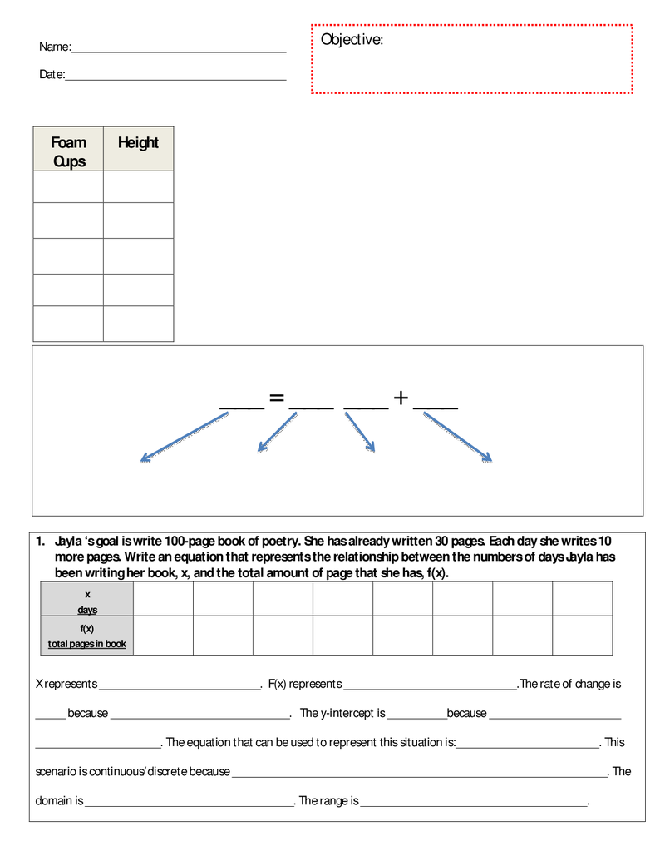

Example answers:
- Objective: “I can generalize equations in slope intercept form in scenarios depicting linear growth.”
- Foam cups (as a stack of #): 1,2,3,4; Height (cm): 8, 8.5, 9, 9.5
- f(x)=mx+b where f(x) is the dependent variable; m is coefficient, rate, and slope of line; x is the independent variable; and b is where the line crosses the y-axes (y-intercept)
- In the practice question, the stem considers Jayla and the time it takes to write a book:
    - x = days writing; F(x) total pages of 100; the rate of change is 10 because each days she writes (adds) 10 more pages. The y-intercept is 30 because this is the amount of pages that already exists.
    - The equation => 100=10x+30
    - This scenario represents discrete data (counted, not measured)

Student Misconceptions and Struggles (from J.R. Olsen @ WIU):

1. All functions are linear.
2. All functions are one-to-one.
3. All functions in real life are one-to-one.
4. It is difficult to make examples of functions in real life that are non-linear, not one-to-one, constant, and/or whose graphs are disconnected.
5. Has an overly restricted view of the forms that graphs of functions can take.
6. The graph of a function should be "reasonable," that is, it should be "regular"--not have any angles.
7. Relations represented by graphs that are disconnected are not functions. (This difficulty/belief may not appear when the algebraic representation is given.)
8. Changing the dummy variable in the algebraic representation changes the function. That is, believes {(x,f(x)) | f(x)=x²+3} and {(t,f(t)) | f(t)=t²+3} are different functions.
9. Fails to realize that all ordered pairs on the graph satisfy the algebraic equation defining the function.
10. Constant functions are not possible. Equivalently, the student believes if the image set is a single value, then it isn't a function, or if all the second coordinates are the same, then it isn't a function.
11. Has the expectation regarding a function that is embodies causality.
12. Has difficulty with the terms preimage, image, (preimage, image) pair, domain, range, image set.
13. Has difficulty moving from one representation of a function to another.
14. May have a variety of unrelated methods for determining if something is a function, depending on the representation. There may be no connections between methods and no connections to the ("formal") definition of a function.

Academic Language Demands
Language Function | Vocabulary & Symbols | Secondary Language Demand
- Students will explain how they resolved the cup challenge.  - Students will construct reasons for their predictions and solutions within small groups.  - Students will create a linear function to model the increase in cup height. This function can then be fitted to solve for cups need to reach a specific height. | - Math terms: output, range, total, rate of change, slope, input, domain, y-intercept, starting point, initial value  - f(x)=mx+b | Mathematical Precision:  Students must apply the fixed change in cup height to a linear equation.  Syntax:  Students must use their formula to solve for cups when height is 100 and 500 cm.  Discourse:  The challenge is presented to the entire group with guiding questions and within small group discussion. Students then construct predictions and solutions within small groups for sharing, later, as a large group. In the large group, students develop solutions based on their previous, small group exploration of the cup activity. The class breaks into smaller groups, again, to discern a working equation which best fits the change in cup height.

Language Support (instructional and assessment strategies)
Language Instruction | Guided Practice | Independent Practice
The learning targets of, “I can demonstrate how I developed my formula using different representations and valid arguments” and “I can generalize equations in slope intercept form in scenarios depicting linear growth” will be explained. The teacher will model this explanation in the “Explain” section of the lesson. | Students will have practice by working on problems 1 and 2 as a whole group and afterwards they will work with a partner for the rest of the problems. We will check back every 10 minutes to review the responses to a few problems. | Students will complete an exit card so that the teacher can review each student’s work before tomorrow’s lesson.

Differentiation, Cultural Responsiveness, and Accommodation for Individual Differences
“To accommodate for a large difference in mathematics ability the students will work in groups or with a partner to find and explain their work, but the final assessment will be done individually to assess each student’s ability to understand how to compare functions and how it relates to the cup activity. The “Five E” lesson plan will be used to engage the students in an investigation to ensure that students are modeling rather than following steps. Manipulatives such as Styrofoam cups are used to help tactile learners make sense of linear equations and functions.
In order to accommodate the various types of learners in my classroom I will write out the steps for the activity in the board. See context for learning. All accommodations will be done as documented/stated.
- Math assignments can be translated in to their language if they need it to be that way.
- Teacher will provide visuals on overhead and whiteboard.
- All students with 504s and IEPs will be accommodated as documented. This information is found in the upper drawer of the teacher desk within the sub folder.

Materials – Instructional and Technological Needs
We will need multiple bags of 8 ounce Styrofoam cups and the writing linear equation worksheet.

Instructional Plan (detailed explanation for thing the lesson)
Pacing | Teacher Activities | Student Activities
10 | Engage- whole class  Explain to students that they have a challenge that needs solving. Students are to figure out how many Styrofoam cups it will take to reach the top of the teacher’s head. The catch is that students will only be given 4 cups to work with in completing this challenge. Ask students what information they need to know in order to solve the task. After a quick discussion with their neighbors, have students share their thoughts. Provide answers to the height of the teacher and the height of one cup, Assign students to partner groups and instruct them to complete the challenge. | Discuss with a partner when instructed by the teacher on what information is needed to complete this task. Share ideas with the class.
20 | Explore- partners  Explain to students that each partner group will be given 4 Styrofoam cups to work with. Partners will be instructed to create a table to measure the height of 1, 2, 3, and 4 cups. Students also must show their thinking process (in any way they want) for how they came to an answer. | Investigate with a partner how many cups it will take to reach the height of the teacher. Complete a table demonstrating the height of 1, 2, 3, and 4 cups. Show any additional work and thinking process for the solution to the challenge.  Teacher will be walking around the classroom and observing groups. Additional support will be provided to those that need it through guided questions to lead to students in the right direction.
10 | Explain- whole class  Have partners share to the whole class what their solution is and how they came up with it. After 3-5 groups share their thinking process, the teacher will stack the predicted number of cups to give a visual representation as to whether the answer found is correct. | Share solution and reasoning with partner to the entire class. Listen to other partners present to see different ways of thinking and other possible solutions. Was the prediction accurate?
10 | Elaborate- partners  Ask the question, “Is there a way for us to represent this with an equation?” Have students get back with their partner and create an equation to match the data collected. | Discuss with partner an equation to represent the information using previous knowledge of linear models. Write down the equation.  Teacher will be walking around the classroom, observing the students, and assisting as needed.
15 | Evaluate- individual  Each student will individually write the equation created in their math journals. Students will graph the equation with labeled x and y axis, and a title for the graph. Students will determine how many cups are needed to reach a height of 100 cm. Student will determine what the height will be when 500 cups are stacked.  The journal entry is worth 10 points:  2 points for equation  4 points for graph  2 points for when height is 100cm  2 points for when 500 cups are stacked | Students will independently complete the task assigned in their math journals. The task includes:  - writing an equation found  - graphing equation with labeled x and y axis, and a title  - answer how many cups will be needed to reach a height of 100cm  - answer what the height will be if 500 cups are stacked  Turn in math journals to the “turn-in” box when complete.

