Lesson Title: Pokémon Functions
Unit Title: Linear Functions
Teacher Candidate: Katie Simpson, Christina Stark, Brienna Agapov, Christina Kazaryn, Oksana Rudenko
Subject, Grade Level, and Date: Math, 8th grade, July 21, 2016

Placement of Lesson in Sequence and Lesson Rationale
This is the second to the last activity in the progression of the linear functions unit. This lesson will take multiple days to complete.

Central Focus and Purpose
This lesson is an exercise in the practice of creating algebra equations to model a recently popularized activity of the app game Pokémon Go. In this activity students will create a generalizable linear model and justify both the processes to create their model and its validity. The main question is how does the amount of the Pokémon caught effect the amount of stardust? This is our leading question and it connects to all learning targets.

CCSS.MATH Content and Practice Standards
CCSS.MATH.CONTENT.8.F.B.4- Construct a function to model a linear relationship between two quantities. Determine the rate of change and initial value of the function from a description of a relationship or from two (x, y) values, including reading these from a table or from a graph. Interpret the rate of change and initial value of a linear function in terms of the situation it models, and in terms of its graph or a table of values.

Math Practice (MP): Modeling

Prior Content Knowledge and Pre-Assessment
Students will need to know how to design their own graph (labelling and numbering), and also how to plot points onto said graph. The pre-assessment will be a quick class discussion. So to quickly review with the class we will label and plot some points on the white board, and we will focus on a linear graph and equation.

Students will also need to know what Pokémon go is. Since it is so popular right now we can assume that almost the entire class knows what it is, or at least heard of it. If there is anyone who is confused we can simply ask another student to explain.

Learning Target(s) and Plan for Clarifying Intending Learning
I can create a table and graph my linear equation.
I can explain and justify the relationships between the y-intercept and the x-intercept.
I can identify the y-intercept on a table and graph
I can use the slope and y-intercept to create a linear function.

Strategy for using assessments to guide student learning
The formative assessment cycle will be, students will work in groups to complete the “Functions of Pokémon” packet. While in these groups, students will propose ideas and solutions to the questions in the packet. They will discuss these questions as a group to come up with the answer. During this time the teacher will be monitoring each group’s progress. Once the packet is complete, each group will orally present their findings to the class. During the presentations, the teacher will watch for any misconceptions and use that time as a learning opportunity to discuss these misconceptions.
Success Criteria (criteria for interpreting student success of the learning target) | Plan for providing feedback and students’ monitoring of their own learning
To meet expectations, explanations to each question must be thorough and thoughtful. Answers must also must have evidence as to why their answer is correct. This assignment is worth 20 points. The rubric address all learning targets. | On each group packet the teacher will provided positive and constructive feedback. This feedback is to help students progress to better meet expectations.  Also, during the activity the teacher will be taking notes on how well the groups worked together. For example, if the group showed they took great care in involving everyone the teacher may write, “Your group did a great job with getting everyone’s input.”  Students’ will be able to monitor their own learning through the series of questions in the packet. There will also be a reflective exit ticket at the end of this lesson.

Academic Language Demands
Language Function | Vocabulary & Symbols | Secondary Language Demand
- Students will justify the design of their graphs  - Students will explain how they developed their formula and the reasoning behind it. | Math Terms:  - Independent Variable  - Dependent Variable  - X & Y Axis  - Plot Points  Special Terms:  - Stardust  - Pokémon | Mathematical Precision:  Students will need to have their graphs labelled, and they will need to label what their variables are.  Syntax:  Their formulas will need to have the amount of stardust equal to the number of Pokémon caught using correct math operations and symbols.  Example:  Y= 100x  Discourse:  The pre-assessment will be conducted with the whole group, and the activity will be conducted in small groups.

Language Support (instructional and assessment strategies)
Language Instruction | Guided Practice | Independent Practice
The vocabulary words would be translated into the language that students speak. There will be a word wall for all students to visually see what we have learned. The lesson would be accommodated or modified to fit the needs of the students. Also, additional tutoring would be offered in some cases. | In groups, students will have practice formulating linear equations through organizing the information found from their group Pokémon search. They will organize their data onto a data table as well as through a graph as a group. | Students will individually reflect on and answer the reflection questions provided, such as “is your function linear? Explain,” or “put into words the relationship you found between the number of Pokémon caught and the amount of Stardust gathered.” These reflection questions show whether or not students understand conceptually what linear functions are and how to form them.

Differentiation, Cultural Responsiveness, and Accommodation for Individual Differences
Gifted students will be asked to focus on completing all the entry/entry task questions when the average student will not finish all of them.
ELL students will have a word wall for visual representation and the vocabulary words would be translated into their language. More visual examples will be addressed throughout the lesson.
IEP’s or 504’s students will receive accommodations or modification to the lesson such that if they are ADHD, they will get to sit in the back row to move around because it is necessary for them and they will cause no distraction. For the deaf, there will be an interpreter at all times. Manipulative such as the phone will be used to help the visual learners make sense of what is going on.
Materials – Instructional and Technological Needs (attach worksheets used)

- Pokémon Go App
- Smart Phones
  - At least 8 for a class of 32
- Functions of Pokémon Packet
- Doc Cam
- Pencils
- Binder, clipboard, or something hard to write on.
  - Students will be walking around while they record their data
- Timer
  - Students will use this to keep track of the time so they can make their way back to class by a designated time.

Instructional Plan (detailed explanation for thing the lesson)
Pacing | Teacher Activities | Student Activities
5 min | Explain the SWBAT, procedures, and expectations. | Students will read the objects (Learning Targets)  They will be able to understand the objectives and share them in their own words to someone else in the class other than the people sitting closely to them.
10 min | Engage- the whole glass  Explain while handing out the guided worksheet; Pokémon Go, students will be working in groups of 4 to collect Pokémon around the school. Every time they collect a Pokémon they will record it in the packet and they also need to record the amount of Stardust they gained. The 100 that is circled in the image below is the Stardust. This a consistent amount regardless of what kind of Pokémon is caught.  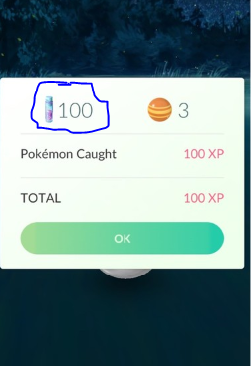  Student will use the table and graph provided in the guided worksheet will help the groups answer the questions in the packet.  “What is a linear function look like?”  “Do you think the amount of the Pokémon caught effects the amount of stardust?”  Ask two groups what their answer to each of those questions was and why. | Students are engaged in a classroom discussion.
5min | Explore Groups start guided worksheet  The teacher will go from group to group monitoring student progress and making sure group roles have been assigned. | Start the guided worksheet. Assign roles within the each group (scribe, manager, guide, and clarifier).
15min | The teacher will be monitoring the progress and conduct of the students while they collect their data | Students will be collecting data by playing Pokémon go (this will be done in multiple locations throughout the school) and recording there progress on the worksheet. During this time the student assigned to the role of the manager will be responsible for the group to return to the class on time. The student with the role of the scribe will be recording the data and the guide is in charge of the phone.
10 min | Explain  The teacher will monitor whether or not students have any misconceptions or questions. The teacher will ask students to discuss in their groups how they think they should go about in the completion of the worksheet, and will emphasize that if everyone in the group is confused that they can then go to the teacher for help. The teacher will also cover any class misconceptions. | Students in their groups will then use the data collected to collaboratively work on the worksheets and discuss any misconceptions or questions that arise and the strategies they will use to complete the worksheet. Create a variable that represents the amount of stardust and the independent variable that represents the amount of Pokémon.
10 min | Elaborate  In groups find, find the direct formula that gives the number of stardust corresponding to the number of Pokémon collected. Use the table to help you collect your data. | In their groups, students will create their formulas, fill out the table and draw the graph corresponding to the equation. Students will then use this while they present the following day.
30 min | Evaluate in groups (the following day)  Have each spokesperson stand and explain their group’s formula.  Students will ask the evaluation questions such as: “How did we come to this conclusion?” How will we justify my graph and table?” | Each group uses the correct reasoning and communication skills:  - Use examples from the table and graph to explain how they derived their formula.  - Use multiple representations by pointing or writing different representation of what they are saying.  - Form a logical argument for why their formula is correct: pattern, y-intercept.
5 min | Exit ticket  Students need to explain what their big take away (what they learned) was from this activity. This will also be an activity that is a formative assessment on the effectiveness of the instruction. | Students will individually reflect on and answer the question from the exit ticket; “Do you feel like your understanding of linear equations has grown?”
*Material can be found in attached document.

Materials
Pokémon Go Guided Worksheet
Group Name: ________________________ | Teacher:_______________________

Date of Presentation: ____________ | Title of Work: ___________________

 | Criteria | Points

 | 1 | 2 | 3 | 4
Organization | The explanation isn’t fluid and jumps from one thought to another. Doesn’t make connections between at least 2 concepts. | The explanation is hard to follow, but it can be understood. Doesn’t makes connections between at least 2 concepts. | The explanation is easy to follow and is easily understood. There are at least 2 connection made between 2 concepts. | The explanation is thorough and easy to follow. There are more than 2 connection made between concepts. | ____
Precision | Students made more than 3 computation errors. | Students made 3 computation errors. | Students made more no more than 2 computation errors. | Students made no more than 1 computation error. | ____
Graph | X and Y axis are not labeled and no points are plotted. | X and Y axis are labeled, but they are not correct. There some points plotted, but more than half are incorrect. | X and Y axis are labeled and are correct. Points are plotted, but there may be no more than 2 points plotted incorrectly. | X and Y axis are labeled correctly and points are all plotted correctly. | ____
Table | Table is not filled out. | Table is filled out with more than 2 errors. | Table is completely filled out, with no more than 1error. | Table is completely filled out with no errors. | ____
 |  |  |  | Total----> | ____

Teacher Comments:

Powered by TeAch-nology.com- The Web Portal For Educators! (www.teach-nology.com)

Functions of Pokémon
Hello Pokémon Masters! You and your team are on a journey to collect as much Stardust as possible to power-up you Pokémon. To keep things organized, please use the table and graph provided below. The fun doesn’t stop there! You’ll need to formulate a function that supports the data you collect. This function needs to be able to predict the x amount of Stardust.
Please list who in your team will be performing which roles:
Scribe: __________________________________________
Manager: ________________________________________
Guide: __________________________________________
Clarifier:_________________________________________
Good luck! ☺

Step 1:
Here is a table for you to use to organize your data. It may help you find the pattern needed to formulate equation. Make sure to label your x and y axis.
P=_________
S=_________
P | S
0
Do you see any patterns among the numbers in the S column?
______________________________________________________________________________________________________________________________________________________________________________

Why did I want you to record what S is when P is zero? How might this help you with your formula, explain? __________________________________________________________________________________________________________________________________________________________________________________________________________________________________
How might this pattern help you with your formula? _________________________________________________________________________________________________________________________________________________________________________________________________________________________________________

Step 2: Graph Your Data
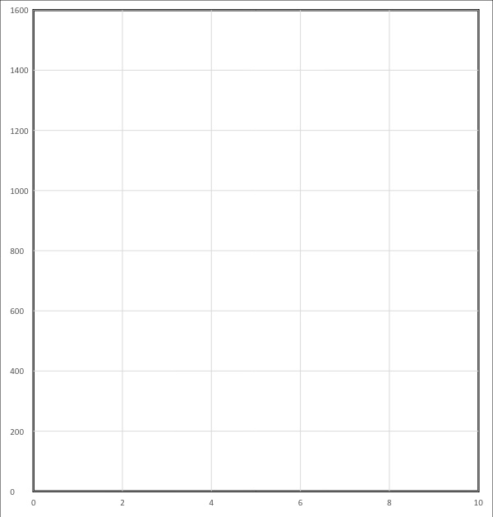

Step 3: Function Formula
Formula: ___________________________________________________________________
How much Stardust would you have if you collected 400 Pokémon? Show your work

Answer:_____________

Which Pokémon would you and your team power-up, why?________________________________________________________________________________________________________________________________________________________________________________________________________________________________________________________________________________________________________________
Is your function linear, explain._________________________________________________________________________________________________________________________________________________________________________________________________________________________________________________________________________________________________________________
Why do you think making a formula may or may not be important, explain?_______________________________________________________________________________________________________________________________________________________________________________________________________________________________________________________________________________________________________________
Put into words the relationship you found between the number of Pokémon (P)caught and the amount of Stardust (S). Please explain using proper math terms, if you are stuck please ask a teammate or me (the teacher☺).
________________________________________________________________________________________________________________________________________________________________________________________________________________________________________________________________________________________________________________________

Name:____________________
Exit Ticket
Do you feel like your understanding of linear equations has grown? If not, that’s okay :-). Please explain either way.
____________________________________________________________________________________________________________________________________________________________________________________________________________________________________________________________________________________________________________________________________________________________________________________________________________________________________________________________________________________

