From Here to There:
applications of the Distance Formula
$$d=\sqrt{{\left(x_{2}-x_{1}\right)}^{2}+{\left(-y_{2}-y_{1}\right)}^{2}}$$
Materials:
TI-Nspire handheld or computer and TI-Nspire software
data-collection interface
2 Motion Detectors
dowel rod or plastic pipe, about 50 cm by 1cm
meter stick
masking tape

Instructions:
If your Motion Detectors have a switch, set it to Normal. Connect the
Motion Detectors to the data-collection interface. Connect the interface to the TI-Nspire handheld or computer.
2. Remove the star figure sheet from your activity packet. It is a pattern sheet of a star with the vertices marked with letters. Tape the pattern to the table to keep the sheet from moving.

3. Set up the Motion Detectors on a table or desk as shown in the picture. Use the meter stick to
place each detector 50 cm from the points indicated on the star pattern sheet. Make certain that the first motion detector will collect x-data and the second motion detector will collect
y-data. Each detector must have an unobstructed view of the star region.
4. Set up DataQuest for data collection.
a. Choose New Experiment from the Experiment menu.
b. Choose Collection Mode ► Events with Entry from the Experiment menu.
c. Enter Point as the Name and leave the Units field blank. Select OK.
d. Click the Graph View tab.
e. Choose Options ► Point Options from the Options menu.
f. Click the Connect Data Point box to select this option. Select OK.
g. Choose Select X-axis Column ► Position from the Graph menu.
h. Choose Select Y-axis Columns ► run1.Position2 from the Graph menu.
i. You should now see a graph of y-values versus x-values to more easily view the star pattern.

5. Collect data.
a. Click the Start button to prepare to collect data.
b. Hold the rod vertically with the tip resting on point A of the star pattern. Keep your hands and arms out of the beams of the Motion Detectors and click the Keep button to make a measurement.
c. Enter A as the name of the point for the first measurement. Select OK to store the data.
d. Move the rod to point B of the start pattern. Hold the rod vertically and click the Keep button to store a measurement.
e. Enter B as the name of the point for the second measurement. Select OK store the data.
f. Repeat this process for the remaining points, including returning to point A. When you collect the point A data again, enter A as the name of the point.
g. After the last point is collected, stop data collection
6. When data collection is complete, the graph should show the data points in a star configuration. Check with your teacher if you are not sure whether you need to repeat the data collection. To repeat data collection, repeat Step 5.
7. Use the meter stick to measure the distance from the y-motion detector to point A on the star. Record the value in the data table.

DATA TABLE
Distance to point A from y-detector _____________ m
Point | x-coordinate | y-coordinate
A
B
C
D
E

Segment | Length using distance formula | Length using direct measurement
AB
BC
CD
DE
EA
ANALYSIS
1. Click any point on the graph. Use ► and ◄ to trace across your graph to determine the coordinates of the five vertices. Record the x- and y-coordinates in your data table and then answer Analysis Questions 1 and 2.
2. The star on the pattern sheet is composed of a number of line segments. Since you know the coordinates of each vertex, find the length of each segment using the distance formula. These lengths can be verified by direct measurement with a meter stick.
a. Use the values in your data table, together with the distance formula, to find the length of each of the line segments listed in the data table. Record these values in the data table.
b. Then use a meter stick to measure the length of each segment of the star on the pattern sheet. Record them in the data table. Then, answer Analysis Question 3.
ANALYSIS QUESTIONS
1. Compare the distance from the y-detector to point A (recorded in the data table) against the y-coordinate of point A. Are they similar? Should they be similar? Why?

2. Based on your answer to the previous question, what is the physical interpretation of the y-coordinates of the data? What is the physical interpretation of the x-coordinates?

3. How do the segment lengths calculated using the distance formula compare with those you found by direct measurement? Which method do you think is more accurate? Why?

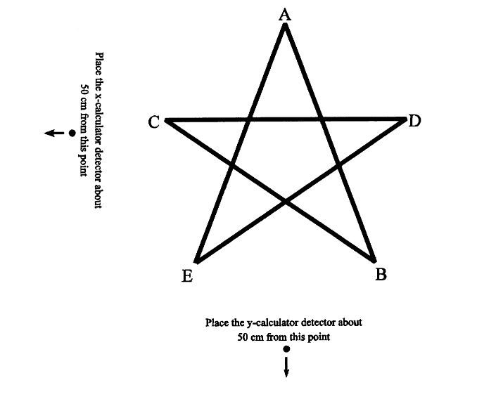
This activity was adapted from https://www.vernier.com/experiments/rwv/13/from_here_to_there_-_applications_of_the_distance_formula/

