Authored by Derek Borromeo, Olivia Camacho and Yuridy Rodriguez
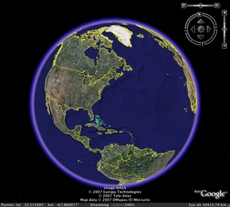

Introduction

A common comment made by most algebra and geometry students about math is, “When am I ever going to use this in my life?” The website Realworldmath.org utilizes Google Earth to provide teachers real world lessons on math concepts that are engaging to their students. Teachers can access premade lessons on the website that target specific areas of geometry and algebra such as proportions between quantities, unit conversions, perimeter, area and volume formulas. It’s important to engage students in activities that they can relate to. According to Boykin and Noguera, engagement is crucial in learning mathematical concepts and a way to engage students in math is creating ideas that connect to the real world and ultimately, to the students life (Creating the Opportunity To Learn, pg 45).
The activities are project based, students can access this resource anywhere with internet connection, and they only need to install Google Earth in their device. Teachers can create a free account to have access to worksheets and detailed lessons for various concepts such as ratios, scientific notation, volumes, areas, estimation, line graphs, etc. In addition to the concept lessons, teachers have access to exploratory and project based lessons which can be used as homework, or for the students to try at home in their own.

Goals for Teachers and Students

The goal of this technology is for teachers to use a modern and innovative approach to teaching mathematics. The purpose of the activities are student centered and task oriented meaning that students can develop their problem solving skills and mathematical reasoning by examining phenomena in the world. Students are actively learning, following the constructivism model, that will enhance higher order thinking. This technology creates opportunities for teachers to not only teach mathematics, but discipline in performing tasks outside of class. Students can find help from peers, teachers and online so they can ultimately, work independently on assignments and projects.

Examples of Lessons

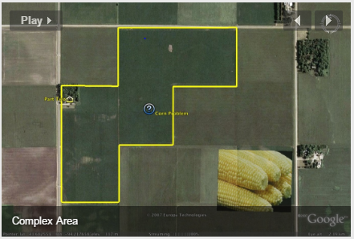
Complex Area Lesson

This lesson called “Complex Area” takes the student through farmland of the United States to do complex area problems that involve area, proportions, unit conversion and currency rates. Students must use the ‘ruler’ tool in Google Earth to calculate the total area of outlined crop fields and then use proportions to solve for yield and profit questions. In the above question, students are asked to find the total area of the outlined farmland in square feet. They then convert this to acres and then bushels using the proportion of $\frac{640 acres}{mi^{2}}$. Next, they are told a farmer is paid $5.00 per bushel of corn and to find how much the farmer is paid.This lesson follows Common Core State Standards of CCSS.MATH.CONTENT.6.RP.A.3
Use ratio and rate reasoning to solve real-world and mathematical problems, e.g., by reasoning about tables of equivalent ratios, tape diagrams, double number line diagrams, or equations.

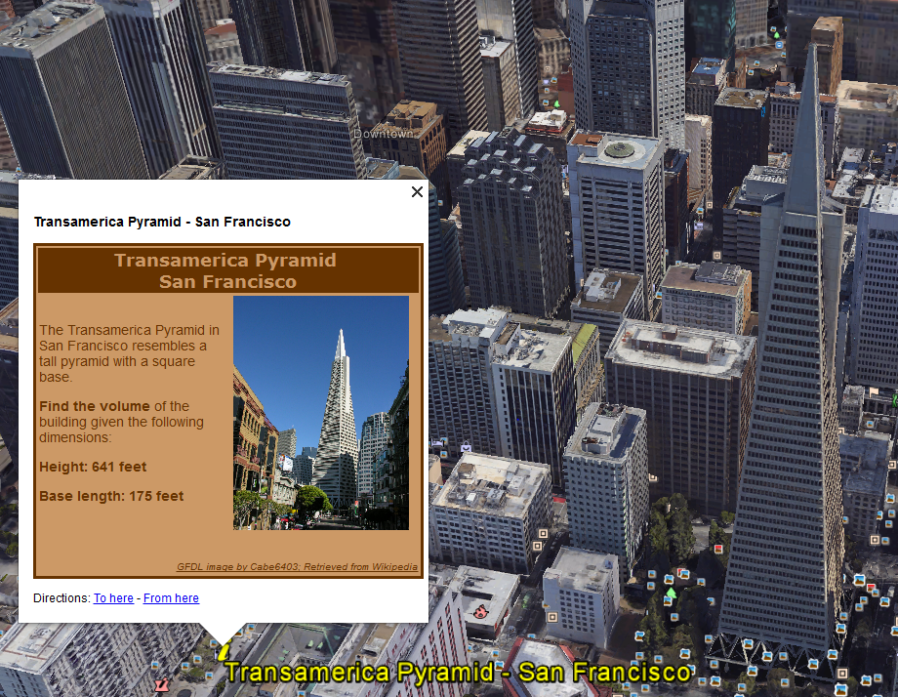
Volume of Solids

This lesson called “Volume of Solids” takes the student around the world to real structures that resemble geometric shapes. In the picture above, the student is taken to San Francisco, CA where the Transamerica Pyramid is located. The questions states for the student to find the volume and surface area of the pyramid given height and base length, $V=\frac{ l*w*h}{3}$ and surface area, $A=lw+l\sqrt{{\left(\frac{w}{2}\right)}^{2}+h^{2} }+w\sqrt{{\left(\frac{l}{2}\right)}^{2}+h^{2}}$. Another question brings the student to Italy where the Leaning Tower of Pisa is located. The structure is of cylindrical shape and the student is asked to find the surface area and volume of the tower. This lesson would demonstrate to the teacher that the student can conceptually use the formulas for surface area and volume of various shapes. The lesson follows Common Core State Standards of CCSS.MATH.CONTENT.7.G.B.6 - Solve real-world and mathematical problems involving area, volume and surface area of two- and three-dimensional objects composed of triangles, quadrilaterals, polygons, cubes, and right prisms.

Hurdles for instruction

Although this technology is free, obstacles that will make this type of instruction difficult are availability. Not all students can afford internet, let alone computers. It may be embarrassing if a teacher were to assign a lesson that a student knows they have no access to.

Another barrier is having students work together on projects. This might be harder to keep track of how much students are actually learning. Students would also have access to the internet therefore they might just be googling their answers.

Integrating realworldmath into mathematics curriculum

This type of assessment could be used if a teacher is able to get a computer classroom for a day or two. The teacher can then utilize the technology for the purpose of getting students to see a bigger picture in the math concepts. This will allow the teacher to support any student who might be struggling to use Google Earth or the mathematical concepts of the learning targets.

Students that are English Language Learners can utilize the change language function of Google Earth so they can understand the questions from the lessons. Tutorials are provided around the website to learn how to navigate around Google Earth.

Conclusion

Realworldmath.org is great resource for teachers to reinforce key math concepts such as proportions, rates, area, volume and distances. Students are able to visually see what they are learning in class and apply it to somewhere around the world. The beauty of this technology is teachers can use Google Earth to create new lessons or utilize pre-existing lessons to their advantage.

References

Boykin, A. Wade, Pedro Noguera, and Association for Supervision and Curriculum Development. Creating the Opportunity to Learn: Moving From Research to Practice to Close the Achievement Gap. Alexandria, Va.: ASCD, 2011.
"Real World Math." realworldmath.org. N.p., n.d. Web. 11 Oct. 2016.

