Lesson Title: Shifting, Reflecting and Stretching
Unit Title: Graphing Functions
Teacher Candidate: Olivia Camacho
Subject, Grade Level, and Date: Algebra II, High school 11th Grade, November 2016

Placement of Lesson in Sequence and Lesson Rationale
This is the last lesson in a three lesson unit. The three lessons are 1) Parent Function, 2) Graphing Parent Functions and 3) Graph Translations: Shifting, Reflecting and Stretching.
Central Focus and Purpose
The central focus is to learn about the different transformation for graphs. The purpose for this lesson is for students to identify the transformation (shifting, reflecting, and stretching) depending on the function. The purpose of this lesson is, first students need to identify the parent function, using their knowledge from the first and second lesson. Then students need to describe the changes on the graph and identify them by graphing the function in a computer software “DESMOS.” At this point students will be introduced to the new concepts, definitions and a handout with instructions for their assignment. The goals of the handout is to help students visualise the transformation in the graphs and further their understanding.
CCSS.MATH Content and Practice Standards
CCSS.Math.Content.HSF.BF.B.3
Identify the effect on the graph of replacing f(x) by f(x) + k, k f(x), f(kx), and f(x + k) for specific values of k (both positive and negative); find the value of k given the graphs. Experiment with cases and illustrate an explanation of the effects on the graph using technology. Include recognizing even and odd functions from their graphs and algebraic expressions for them
Prior Content Knowledge and Pre-Assessment
Students need to know the parent or commun functions and how the graph looks like (this material was learned on the previous lesson). At the beginning of class a short warm up about graphing functions with questions such as: What does the graph of y = x² , y = |x| should look? will be given to students to work on.
Learning Target(s) and Plan for Clarifying Intending Learning
Students will learn to name and describe the transformations in a graph from a given equation.
Students will be able to find the function, by analyzing a given graph.

Strategy for using assessments to guide student learning
The assessment cycle is going to start with the warm up. If students answer the warm up questions correct, then I do not need to review parent functions with them. Then I will explain the new material I will be asking questions. If they answer them correctly, then I will keep going, if not I will re explain the material again and clear any misconceptions.
Success Criteria (criteria for interpreting student success of the learning target) | Plan for providing feedback and students’ monitoring of their own learning
For this lesson, part of the grade will be following instruction, so students need to understand instructions and ask for clarification if needed. Students will also be graded in their work in the handout. | Students will be receiving instant feedback from their questions while instruction. After instruction, if students are following instructions, then they will be working on their own project. If students do not understand instruction or material, then they need to ask question to clarify any misunderstanding. While working with DESMOS, students will be able to check their own work by graphing the equation they find for the given graph.

Academic Language Demands
Language Function | Vocabulary & Symbols | Secondary Language Demand
- Student will be able to describe the transformations of a graph when the equation is giving.  - Students will learn how to analyze a graph and find the correct equation for the given graph. | - Parent Functions  - Shifting  - Reflecting  - Stretching  - Equation  - f(x)= | Mathematical Precision:  Students need to clearly identify the transformations based on the given equation. Students also need to precisely write the correct equation into the graphing software to obtain the right answer.  Syntax:  Students should be able to describe transformations of the graph using words such as right left, up and down depending on the graph behavior.  Discourse:  Students will have the chance to explain reasoning and discuss the new concepts with the class discussion. Students also have the chance to explain their reasoning in their handout by describing graph behavior with their own words.  Students also will need to carefully read the description of the graph given to find and write the correct equation.

Language Support (instructional and assessment strategies)
Language Instruction | Guided Practice | Independent Practice
Students will learn the needed vocabulary to verbally describe the behavior of the graphs in their work and also to learn the correct behavior in relation to the notation. | Students will learn the definitions, concepts and vocabulary during instruction. After instruction, students have the chance to review the definition of every transformation using their handout. | Students have the chance to practice their language function in their own by working in their handout and reviewing their definitions as well as in their work explaining the class behavior.

Differentiation, Cultural Responsiveness, and Accommodation for Individual Differences
For students wil different math levels and abilities, The handout will contain a short review of the new material learned today as well as tips for working with the graphing software DESMOS. For students with language deficiency, who might not be able to understand the instructions clearly, I will personally explain to them.

Materials – Instructional and Technological Needs (attach worksheets used)
Computer with internet access, printer, whiteboard and markers, and handouts.

Instructional Plan (detailed explanation for thing the lesson)
Pacing | Teacher Activities | Student Activities
Before | Before instruction begins, teacher asks students questions about the parent functions such as f(x) = x² ,  f(x) = |x|, f(x)= x, f(x)=-x, f(x)=x³ etc. On the board, the teacher will draw some graphs for students to obtain the correct equation as well as some equations to be graphed by students as a warm up for the activity.  This activity allows students to visualize how the parent functions looks like. .  Teachers can ask question such as:  How does the graph for this equation looks like?  How do you know?  Sketch a graph for this equation | Together as a class, students answer questions, explain their reasoning and draw examples to answer the question needed.  The answers for this activity will vary. Students need to know the parent functions to be able to complete this next assignment.
During | Teacher presents the new material by introducing the vocabulary terms, stretching, reflecting, and shifting as well as review the notation f(x) + k, and introduce the new notation k f(x), f(kx), and f(x + k) (for the graph transformations).  Definitions of this terms will be in the board as the class continues and in student’s activity handout to help students as a resource while completing the next activity.  At this point, I will ask students to draw examples of the graphs on the board, give the equation for the graph given, etc. | Students read the definitions from their activity handout to the whole class.  Students will have the chance to ask for clarification and to explain their understanding.  The purpose of this activity is to create an application for the new knowledge and also to help students understand the terms and to introduce students to the activity.
After | After instruction, students will receive instructions for their handout activity, how to use the software “DESMOS” and how to turn in their work. I will demonstrate how use DESMOS and how to complete the handout. | Students work individually in answering questions, describing graph behaviors and finding the equations of giving graphs.

Shifting, Reflecting and Stretching

Instructions: Choose four parent functions/graphs and using DESMOS, apply at least three transformations to each one.
Keep in mind:
You have to use positive and negative values
Add the changes in your functions as you go
Remember
Shifts
A shift is a rigid translation in that it does not change the shape or size of the graph of the function.
A vertical shift adds/subtracts a constant to/from every y-coordinate while leaving the x-coordinate unchanged.
A horizontal shift adds/subtracts a constant to/from every x-coordinate while leaving the y-coordinate unchanged. Vertical and horizontal shifts can be combined into one expression.
Stretch
A vertical stretching multiplies/divides every y-coordinate by a constant while leaving the x-coordinate unchanged.
A horizontal stretching multiplies/divides every x-coordinate by a constant while leaving the y-coordinate unchanged.
Reflections
A function can be reflected about an axis by multiplying by negative one. To reflect about the y-axis, multiply every x by -1 to get -x. To reflect about the x-axis, multiply f(x) by -1 to get -f(x).

Go to www.desmos.com/calculator
Type your function in the form f(x)=
Start Graphing!
- In your Answers sheet, Sketch a graph of the parent function. Ex: f(x)= x²
- Now, using DESMOS, apply the first transformation. Ex: f(x)= x² -3
- In your Answers handout, explain the change on the graph and how the graph looks like. you need to make an accurate sketch with appropriate labels (just as the one in desmos)
- For the next two transformations repeat steps 1-3. Do not go back to the parent function after each transformation your function needs to be changing as well. Ex: f(x)= -2(x² -3) *this function already has the second transformation.
- For the next three parent functions repeat steps 1-4
For the Answers handout in the second page find the equation for the two giving graphs and check your work!

Shifting, Reflecting and Stretching
Answers
Name:

- f(x)=
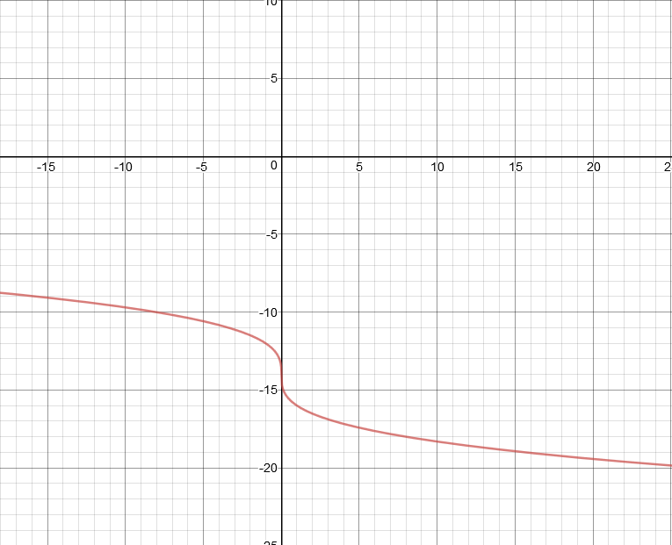

- f(x)=
