Illustrative Mathematics
Cross-sections In Relation to Volumes
HSG.GMD: Geometric Measurement and Dimension
Alignment: HSG.GMD.B.4
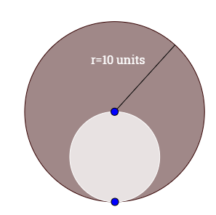

Given the above diagram of the cross-section of two spheres cut in half with the inscribed sphere passing through the center and the perimeter of the larger sphere, find the volume of the dark grey section.

Commentary:
This activity has students use the cross-section of two 3-dimensional objects to solve for the volume for said objects and to use the volumes to solve a posed problem. The diagram given was specifically vague and left the smaller cross-sections completely blank to promote students into wanting to fill it in. This task requires students to use what they know about spheres, volumes or spheres, cross-sections, and circles to problem solve how to even begin to solve for the volume of the shaded region. Since there is no 3-dimensional visual of the shaded region students will struggle to determine how to solve for the volume of the shaded region and what it even looks like. This activity promotes students to problem solve, visualize, and connect the concepts of circles to spheres. HSG.GMD.4 focuses on students’ ability to identify the shapes of two-dimensional cross-sections of three-dimensional objects. The problem being posed may be very basic but it teaches the fundamentals of how to interpret what an object is from it cross-section.

Solution:
Task 1: We must first find the volume of both spheres
- From the diagram above, we are given that the radius of the larger sphere is r=10units. (given)
- Since the smaller sphere pass through the center and the perimeter we know that the diameter of the smaller sphere is equal to the radius of the larger sphere; that is, d=r=10units.
- Since d=2r and d=10, then the radius of the smaller sphere must be equal to 5 units.
- Then we must know the formula for the volume of a sphere which is V=(4/3)r3.
- The we plug in both radii to the volume formula to get the volume for both spheres:
Large Sphere
$$V=\frac{4π{10}^{3}}{3}=\frac{4π1000}{3}=\frac{4000π}{3}$$
Small Sphere
$$V=\frac{4π5^{3}}{3}=\frac{4π125}{3}=\frac{500π}{3}$$

Task 2: now that we have both volumes we must find the volume of the shaded region which is the difference between the larger sphere’s volume and the smaller sphere’s volume.

$$V_{shaded}=\frac{4000π}{3}-\frac{500π}{3}=\frac{3500π}{3}$$

