Illustrative Mathematics

A-REI Solving Systems of Equations

Alignment 1:
A-REI.C.6 Solve systems of linear equations exactly and approximately (e.g., with graphs), focusing on pairs of linear equations in two variables.

A-REI.C.7 Solve a simple system consisting of a linear equation and a quadratic equation in two variables algebraically and graphically. For example, find the points of intersection between the line y = -3x and the circle x2 + y2 = 3.

Solve the following systems of equations. First, find an approximate answer (using a graph) and then algebraically by the given method.

a. x-2y=10
3x+y=9

Graphically: Algebraically using Substitution:

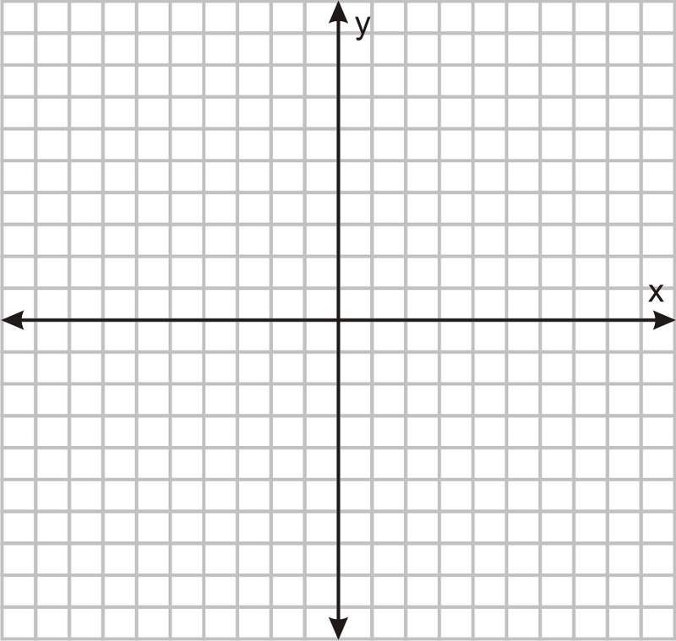

b. 6x+3y=18
3x-3y=9

Graphically: Algebraically using Elimination:
c. y=x²+3x-4
y=x-1

Graphically: Algebraically (student’s choice):

d. y=2x-2
x²+y²=4

Graphically: Algebraically (student’s choice):

Commentary

This task requires students to solve four systems of equations. There are two systems of two linear equations. The second two systems consist of a linear and quadratic equation as well as a linear equation and the equation of a circle. Students will be required in the first two systems to use a specified algebraic method, but in the second two systems if students use substitution, they will find the shorter route to an answer.

Solutions:

a. Graphically: Solve for y in both equations so that the equations are in y-intercept form:
x-2y=10
-2y= -x+10
y= ½ x-5

3x+y=9
y= -3x+9
There should be a sketch similar to the following graph although the student scales may be different:
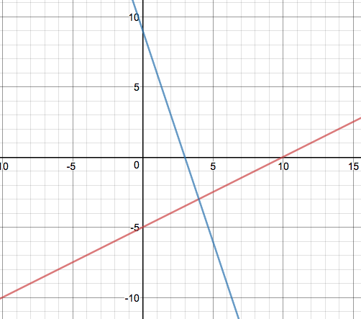

Algebraically: We will start by identifying which equation will be the easiest to solve for one variable so that we can use the substitution method. For this problem, we will solve the second equation for y:
3x+y=9
y=-3x+9
We will then substitute this into the first equation for the y variable and solve for the x variable:
x-2(-3x+9)=10
x+6x-18=10
7x=28
x=4
Plug 4 into the x value for second equation:
y= -3(4)+9
y= -12+9
y= -3
x=4, y=-3 or (4,-3)

b. Graphically: Solve for y in both equations so that the equations are in y-intercept form:
6x+3y=18
3y=-6x+18
y=-2x+6

3x-3y=9
-3y=-3x+9
y=x-3
There should be a sketch similar to the following graph although the student scales may be different:

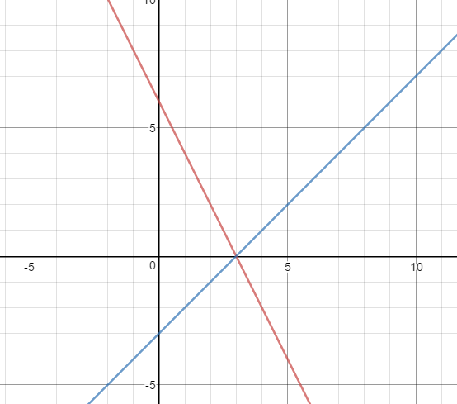

Algebraically: We will start by identifying which variable will be easiest to eliminate. For this problem, we will eliminate the y variable:
6x+3y=18
+ (3x-3y=9)
9x+0y=27
x=3
We will then substitute x=3 into the first equation for the x variable and solve for the y variable:
6(3)+3y=18
18+3y=18
3y=0
y=0
x=3, y=0 or (3,0)

c. Graphically: There should be a sketch similar to the following graph:

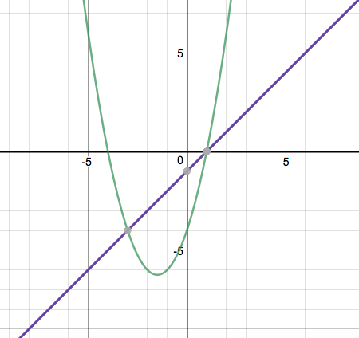

Algebraically: Since both equations are equal to y, we can set them equal to each other: x²+3x-4=x-1
x²+3x-4-x+1=0
x²+2x-3=0
(x+3)(x-1)=0
x+3=0 x-1=0
x=-3 x=1

Plug both x values back into the second equation:
y=-3-1 y=1-1
y=-4 y=0

We have two solutions: (-3,-4) and (1,0)

d. Graphically: There should be a sketch similar to the following graph:

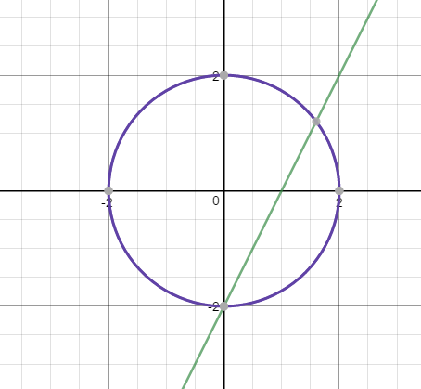

Algebraically: We will use substitution for this system. We will substitute our linear equation into our equation of a circle:
y=2x-2

x²+(2x-2)²=4
x²+4x²-8x+4=4
5x²-8x=0
x(5x-8)=0
x=0 5x-8=0
x=0 x=8/5

Plug both x values back into the linear equation:
y=2(0)-2 y=2(8/5)-2
y=-2 y=6/5

We have two solutions: (0,-2) and (8/5,6/5)

