Where Do We Meet?
Solving a System of Linear Equations
OBJECTIVES
• Simultaneously record motion data for two walkers.
• Graph both motions on a common axis and find their intersection.
• Find linear equations to model the motions.
• Solve the system of two linear equations to determine the intersection.
• Compare the algebraic solution to the graphical solution.
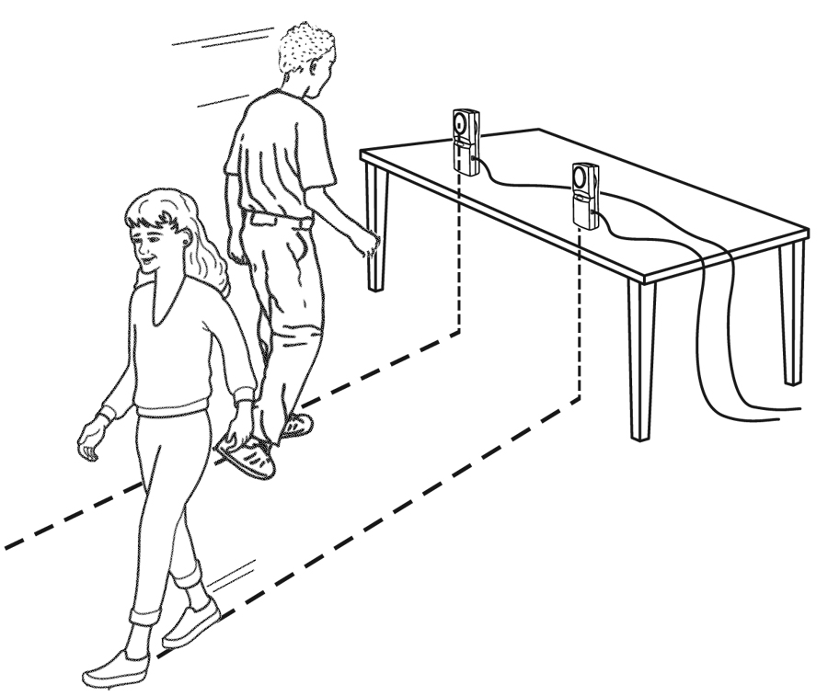
MATERIALS
- TI-Nspire handheld or computer
- TI-Nspire software data-collection interface
- 2 Motion Detectors
- Meter stick
- Stopwatch
- Tape
PROCEDURE
- If your Motion Detectors have switches, set them to Normal. Connect the Motion Detectors to the data-collection interface. Connect the interface to the TI-Nspire handheld or computer.
- Set up the Motion Detectors on a table or desk. The detectors should be about two meters apart, aimed parallel to one another and about 1.2 m above the floor.
- Set up DataQuest for data collection. a. Choose New Experiment from the Experiment menu. b. Choose Collection Setup from the Experiment menu. c. Enter 5 as the rate (samples/second). d. Enter 10 as experiment duration in seconds. The number of points collected should be 51. e. Select OK.
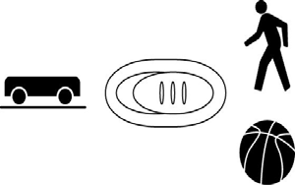
4. Click the Graph View tab ( Only the Position vs. Time Graph will be displayed.
). Choose Show Graph ► Graph 1 from the 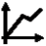 Graph menu.
- You will need two people to walk, a third (the timer) to operate the stopwatch, and a fourth (the marker) to mark the place where the two walkers pass each other. Practice walking in the following manner:
  - • Walker One stands about two meters from the first detector, and prepares to walk directly toward that detector.
  - • Walker Two stands about half a meter from the second detector, and prepares to walk directly away from that detector.
  - • Once the timer has started data collection, timing must also be started.
  - • At the moment the two walkers are shoulder to should, the marker must note the position on the floor, while the timer stops the stopwatch. The walkers then continue to walk at a slow but uniform pace until data collection ends. Walker One must never get closer than 15 cm to the Motion Detector. Practice the procedure several times.
- Start data collection ( ). Walk as you practiced. Data collection will run for ten seconds.
Where do we meet?
- When data collection is complete, graphs of position versus time and velocity versus time will be displayed. Examine the position versus time graph. Walker One’s graph should be a nearly linear and uniformly decreasing function. Walker Two’s graph should be a nearly linear and uniformly increasing function. If the final few seconds of data are not useful, do not be concerned. Check with the teacher if you are not sure whether you need to repeat the data collection. To repeat data collection, repeat Step 6.
- After a good run, have the marker use the meter stick to measure the distance from the point where the two walkers passed one another to the midpoint of the line between the two Motion Detectors. Record this directly measured distance in your data table (Round this and all other data to three significant figures.). Record the directly measured time interval determined by the timer in your data table.
DATA TABLE
 |  | direct measure |  | graphical trace |  | solve equation system
intersection time
intersection position
 | (x1, y1) |  | (x2, y2) |  | slope |  | intercept
walker one
walker two
ANALYSIS
- Begin your analysis by answering Analysis Question 1.
- Click any point on the position graph and use ► and ◄ to trace across either line to the place where the two lines cross. Record the coordinates in your data table as the Graphical Trace result.
- To create two linear models for your data, you need to record two points from each line. Ignore any short horizontal sections at the beginning or end of the lines. Trace across your graphs and record the coordinates of two well-separated points from each line. Record these values in your data table.
- Find the slope of each line using the standard slope formula, and enter the slopes in your data table.
m  y2  y1 x2 x1

- The point-slope form of the line equation, or y – y1 = m(x – x1), will let you determine the y-intercept from the two points you’ve already recorded. Here y and x are variables, m the slope, and x1 and y1 are the values of a point on the line. Use this relation to determine the y-intercept of the line fitting each walker’s motion, and record the intercepts in your data table.
- Create a Graphs page so you can model the two graphs with linear functions.
  - Insert a Graphs page.
  - Choose Scatter Plot from the 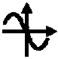 Graph Type menu.
  - Enter the following to s1:
x ← run1.time y ← run1.position
x ← run1.time y ← run1.position2
Window/Zoom menu to view all of your data.
- Chose Function from the 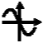 Graph Type menu.
- Enter your first model equation into the Entry Line replacing m and b with the values you determined earlier. f1(x) = mx + b
- Enter your second model equation into the Entry Line replacing m and b with the values you determined earlier. f2(x) = mx + b
- Experiment with your movable lines to find the best value for each corresponding m and b by grasping each line to translate and rotate it.
Answer Analysis Question 2.
- From your Graphs page, the TI-Nspire software can also automatically calculate the intersection of your optimized model equations. a. Choose Intersection from the 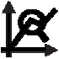 Analyze Graph menu. b. Select the lower bound by moving the pointer just left of the intersection and clicking. c. Select the upper bound by moving the pointer just right of the intersection and clicking. d. The TI-Nspire software will display the x- and y-coordinates of the intersection.
- Finally, you can find the intersection of the two lines algebraically. Using the slope and intercept of the walker one and walker two lines, write down two linear equations in the space below in the form y = mx + b. That is, you’ll have one equation for each line, each in terms of its own intercept and slope. What you have is a system of equations. There are two equations, each with two unknowns, x and y. Usually (but not always!), when you have two equations and two unknowns, you can solve the system to find specific values for x and y that satisfy both equations simultaneously. In this case, that solution will yield the time and location that both walkers had in common—that is, the time and location when they passed each other. Solve the system of equations, and write down the solution in your data table as the Solve Equation System answer. Answer Analysis Questions 3–5.
d. Enter the following for s2:
e. Choose Zoom – Data from the
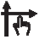
27 - 4 Real-World Math with Vernier
ANALYSIS QUESTIONS
- How can you identify which trace is walker one and which is walker two? Identify the trace of each walker for future reference.
- How do the model lines fit the walker data?
- Compare the values you obtained for the intersection time by all four methods: (1) direct measurement by stopwatch and meter stick; (2) graphical intersection by tracing, (3) the intersection search by TI-Nspire, and (4) by solving the system of equations. Are the values consistent?
- Is it possible for the walkers to move in front of the Motion Detectors so that the resulting plots would not intersect? If so, give an example; if not, explain why.
- Could the walkers move so that their plots intersect more than once? If so, how?
EXTENSION
Repeat the activity, but have the walkers move by starting slowly and then speeding up. The distance versus time plots will be non-linear, so that you can no longer use a linear model. What type of function might be used to model the motion?

This lesson was adapted from https://www.vernier.com/experiments/rwv/27/meet_you_at_the_intersection_-_solving_a_system_of_linear_equations/

