Chill Out: How Hot Objects Cool
Name:
OBJECTIVES
• Record temperature versus time cooling data.
• Model cooling data with an exponential function.
MATERIALS
TI-Nspire handheld or computer
TI-Nspire software EasyTemp or Go!Temp or Temperature Probe
and data-collection interface hot water

PROCEDURE
1. Connect the Temperature Probe to the data-collection interface. Connect the interface to the TI-Nspire handheld or computer. (If you are using an EasyTemp or Go!Temp, you do not need a data-collection interface.)
2. Choose New Experiment from the Experiment menu. For this experiment, the default data-collection parameters for a Temperature Probe will be used.
3. Obtain a cup of hot water at 45 to 55˚C. Place the Temperature Probe in the water, and wait about 20 seconds for the probe to reach the temperature of the water. Rather than waiting for the water to cool, just remove the Temperature Probe from the water and observe the cooling of the probe itself. Remove the probe from the water and rest it on the edge of a table. Do not let anything touch the tip of the probe.
4. Collect the cooling data. Start data collection ( ). Data collection will run for three minutes.
5. Newton’s law of cooling models the temperature difference between the warm object and its surroundings. As an estimate of the room temperature, use the minimum temperature on the graph. Click any data point and use ► and ◄ to read the values from the graph to determine the initial and minimum temperatures. Round the temperature values down to the next whole degree (for example, 24.64 ◊ 24) and record them in the data table.
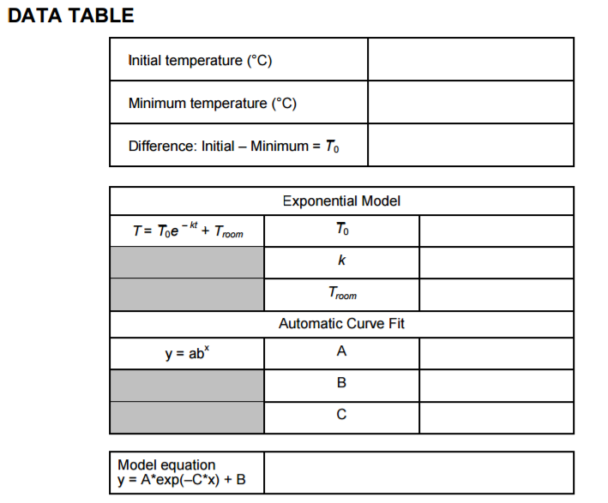
ANALYSIS
1. Begin your analysis by answering Analysis Question 1.
2. Since the model for Newton’s law of cooling uses the difference between the temperature of
the warm object and its surroundings, T – Troom = T0 e – kt, we can rewrite the model as
T = T0e – kt + Troom. One form of an exponential function is given by y = A*exp(–C*x) + B.
From the location of terms, identify the correspondence of terms in the model and the
exponential function. Complete the cross-reference table below for the parameters A, B, C
and T0, Troom, and k.
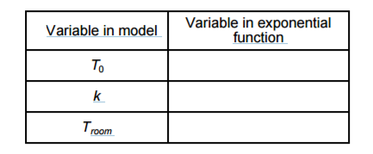
3. Since you have values for the initial and room temperatures, you can try plotting the model
using a guess for the k parameter.
a. Choose Model from the Analyze menu.
b. Enter A*exp(–C*x)+B as the equation for your model. Select OK.
c. Enter values for the parameters A (the value for T0) and B (the room temperature).
d. Now you can guess a value for C, and then look at the resulting graph. To obtain a good
fit, you will need to try several values for C. Start with C = 0.01.
e. Select OK.
f. To obtain a good fit, you will need to adjust the value of C. Adjust the value using the up
and down arrows in the details box to the left of the graph. You can also click the value of
C and enter a specific value of your choice.
g. Experiment until you find a value that provides a good fit for the data, and then answer
Analysis Question 2.
4. You can also automatically fit an exponential to the data. DataQuest’s Natural Exponential
curve fit does not take into account the room temperature so you will need to account for
this.
a. Choose New Calculated Column from the Data menu.
b. Enter Corrected Temps as the Name, Corrected as the Short Name, and C as the units.
c. Enter Temperature–“value” as the Expression. For example, if the room temperature is
25˚C, you would enter Temperature-25 as your expression. Note: The term
“Temperature” must exactly match the name of the column. If you are unsure how it was
entered, the available column names can be found below the Expression entry box.
d. Select OK.
e. Insert a new page.
f. Click the Graph View tab
g. Choose Select Y-axis Column ► Corrected Temps from the Graph menu.
h. Next, choose Curve Fit ► Exponential from the Analyze menu.
i. Record the automatic fit parameters in your data table, and then answer Analysis
Questions 3–8. Select OK to see your graph.
16 - 4 Real-World Math with Vernier
ANALYSIS QUESTIONS
1. Is the graph consistent with the model of a decreasing exponential? In what way?
2. Record the model equation in the data table.
3. How does the regression fit compare to the model? How can both models fit the data well
when the fit parameters are different?
4. When t = 0, what is the value of e–kt?
5. When t is very large, what is the value of the temperature difference? What is the
temperature of the sensor at this time?
6. What could you do to the experimental apparatus to decrease the value of k in another run?
What quantity does k measure?
7. Use either the model equation or the regression equation to predict the time it takes the
sensor to reach a temperature 1ºC above room temperature.
8. If the starting temperature difference is cut in half, does it take half as long to get to 1ºC
above room temperature? Explain.

This activity was adapted from
http://www.vernier.com/files/sample_labs/RWV-16-DQ-chill_out.pdf

