Frozen Yogurt Party!

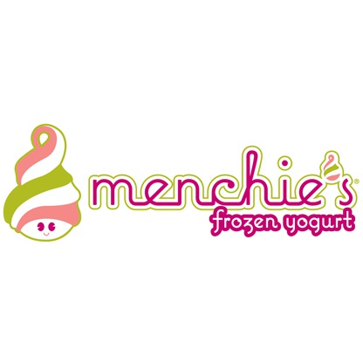
CLASS! We have a huge decision to make…. Where should we have our end of the year frozen yogurt party? Our two options are Menchies and Yogurtland. Before we choose where to have our party, we need to use math to justify our

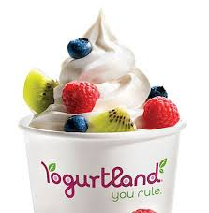
VS.

Menchies charges $150.00 to rent out and $4.00 per student to have unlimited frozen yogurt and toppings. On the other, hand Yogurtland charges $80.00 to rent out and $6.00 per student. If we have 26 students in the class what frozen yogurt store will cost the least? Please write two equations and show all you work.

Menchies Equation_____________________________________

Yogurtland Equation_____________________________________

Work:

Where we should have our frozen yogurt party? Write your answer in a complete sentence with justification.

For how many students will the two frozen yogurt places cost the same? Please write two equations and show all you work.

Menchies Equation_____________________________________

Yogurtland Equation_____________________________________

Work:

Write your answer in a complete sentence with justification.

