Perfect Purple Paint

As a class, we are getting tired of this boring white classroom…so let’s paint it a perfect purple!! We all know from art class that blue and red make purple, but how much of each to make the perfect purple you ask! Well I did some research found the perfect ratio: for every three cups of red paint, we need two cups of blue paint. Please write that ratio in all three notations below (in words, fractional, and with colon).

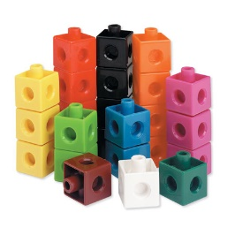

Take your interlocking colored math cubes at your table group and make this ratio. Please draw below what your cube model looks like and discuss with your table group.

Now we must decide how many cups of each color is needed to make a total of 35 cups of perfect purple paint! Please use your interlocking colored math cubes at your table group to model the amount of blue and red cups of paint are needed to paint our classroom. Please draw your completed cube model below and discuss with your table group.

