Adi Sanchez
Learning Progression
Modeling Matrices: Matrix Multiplication, Calculators & Matrices, Transition & Equilibrium Matrices
The learning progression will take place in an Algebra 2 class. The class has been introduced to matrices, and to how to use addition and subtraction. Students have also learned the rules on dimensions when multiplying, adding and subtracting them and how to perform row-reduce-echelon-form (rref) by hand. In this learning progression students will be introduce to matrix multiplication for lesson one. On lesson two, students will learn how to solve matrices using calculators. For lesson three, students will combine their knowledge of matrices and will use it to perform weather predictions using transition and equilibrium matrices. This learning progression will be taught using direct instruction for students to achieve the following state standards:
Perform operations on matrices and use matrices in applications.
- HSN.VM.C.6
  - Use matrices to represent and manipulate data, e.g., to represent payoffs or incidence relationships in a network.
- HSN.VM.C.7
  - Multiply matrices by scalars/matrices to produce new matrices.
- HSN.VM.C.8
  - Add, subtract, and multiply matrices of appropriate dimensions.
- HSN.VM.C.9
  - Understand that, unlike multiplication of numbers, matrix multiplication for square matrices is not a commutative operation, but still satisfies the associative and distributive properties.

Mathematical Practice
- MP1: Make sense of problems and persevere in solving them
- MP2: Reason abstractly and quantitatively.
- MP4: Model with mathematics
- MP5: Use appropriate tools strategically
- MP6: Attend to precision

After this lesson, students will be able to perform matrix addition, subtraction and multiplication by hand and with the aid of a calculator. In addition, students will be able to utilize matrices for real-life scenarios, e.g. whether predictions.
Matrix Multiplication (Lesson 1, 1-2 days)
Warm Up
Solve the following matrices
1) $\left[\begin{matrix}1 & 5 \\ -3 & 0\end{matrix}\right]+\left[\begin{matrix}-3 & 8 \\ 2 & 7\end{matrix}\right]=\left[\begin{matrix} & \\ & \end{matrix}\right]$

2) $\left[\begin{matrix}18 & 5 \\ -5 & 0\end{matrix}\right]-\left[\begin{matrix}-3 & 8 \\ 2 & 7\end{matrix}\right]=\left[\begin{matrix} & \\ & \end{matrix}\right]$

Objective: (1) Students will be able to accurately solve 2x2 matrices.
Goal: Students will be able to apply their newly acquired knowledge on 2x2 matrix multiplication and use it on any dimension of matrices.
Vocabulary: Matrix, matrices, row, column, product, multiplication, addition, subtraction, row reduced echelon form (rref), and commutative property.
Lesson one will consist of introducing students to 2x2 matrix multiplication.^{HSN.VM.C.8} [7-10 min] In the beginning of the lesson students will perform a warm up exercise to assess their proficiency in addition and subtraction of matrices. This activity will allow me to be certain students can perform these operations before moving on to multiplication. [10-15 min] After the warm up, I will first explain the rules to matrix multiplication, followed by the first example. I will be using explicit steps for students to follow. I will also be using different colors and letters for students to see how each step is made. Students will then be given the task to mathematically prove that [A]x[B]=[C] and [B]x[A]≠[C]. ^{HSN.VM.C.7 HSN.VM.C.9} ^{MP1} Students will be required to show every step. This will be so that they do not make any arithmetic mistake, i.e. sign error. ^{MP6} [5-8 min] I will then ask students for volunteers to show the class how they obtained their results. This will help students learn from each other and at the same time give them additional guided practice during the procedure. I will then follow up with questions to assess their understanding of matrix laws. For example, “Can I multiply a [2x4]x[2x3]? What about a multiplication of [2x4]x[3x5]? Explain your reasoning.” Students should be able to address a certain rule or strategy to assess if this multiplication is possible. [10-15 min] Students will then be assign matrix multiplication problems of 2x2 matrices (in class practice and as homework). There will also be questions for students to determine if a certain multiplication is possible, and if it is for them to write down the dimension of the product. For students that want to get challenged, there will be one problem that will ask them to solve the multiplication of a [2x4] and a [2x3].
One of the first rules to multiplication of a 2x2 matrix is that [A]x[B]=[C] and [B]x[A]≠[C].

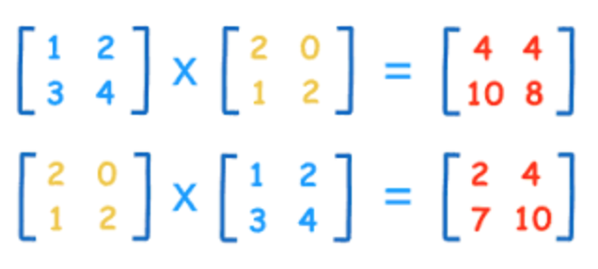

Example of 2x2 matrix multiplication.
$\left[\begin{matrix}a & b \\ c & d\end{matrix}\right]+\left[\begin{matrix}e & f \\ g & h\end{matrix}\right]=\left[\begin{matrix}ae+bg & af+bh \\ ce+dg & cf+dh\end{matrix}\right]$

Calculators & Matrices (Lesson 2, 1 day)
Referred to handout.
Objective: (1) Students will be able to use appropriate tools strategically.
Goal: Students will be able to apply their knowledge of matrix operations to accurately solve matrices. Students will become fluent in matrix procedures using calculators.
Vocabulary: Matrix, matrices, row, column, product, multiplication, addition, subtraction, row reduced echelon form (rref), commutative property, and functions of calculator buttons.
[5-10 min] The class will begin with asnwers to homework problems, and the answer and procedure of how to solve the challenge question from the previous lesson. This will be the time where I can observe the problems in which students had difficulty, and assess if is prudent to move forward or go over procedures again. If less than 3 students had trouble, I will move forward with the lesson. [30-40 min] The lesson will consists of a handout and the use of the calculator. The handout will guide students through the process of using their TI-83 calculators to complete operations on matrices.^{MP5, MP6} In order to be certain students stay on task and are participating, the handout will ask students to write down information based on the prompts. This lesson will use discovery-based instruction, as it has been found to be beneficial for students when scaffolding and feedback takes place (Alfieri, et al., 2011).

The handout will give students the opportunity to learn about the distinct functions of the calculators and it will prepare them for lesson 3 of the learning progression. Moreover, the handout it provide students with practice in solving matrices using their calculators.

Transition & Equilibrium Matrices (Lesson 3, 2-3 days)
Objective: (1) Students will be able to use matrices to represent and manipulate data. (2) Students will be able to create and utilize transition and equilibrium matrices.
Goal: Students will be able to utilize transition and equilibrium matrices to describe weather probability based on a given model.
Vocabulary: Matrix, matrices, row, column, product, multiplication, addition, subtraction, row reduced echelon form (rref), commutative property, and functions of calculator buttons.
[5-7 min] Students will receive a warm up exercise to recap their knowledge on using operations on matrices by hand and using the calculator. In order to move on to today’s lesson, students should have had mastered the skills of using operations on matrices by hand, understand and be able to apply rules and strategies to multiply 2x2 matrices. Lastly, be able to use the calculator to perform “rref”, multiplication, addition and subtraction on matrices.
[15-20 min] Students will be introduced to utilizing matrices to solve real life problems. To do so students will learn about Transition and Equilibrium matrices using a weather-based word problem. This problem will aid students in learning how to use data provide to set up the matrix.HSN.VM.C.6, HSN.VM.C.7, HSN.VM.C.9
Example of notes that could be written on the board or overhead projector.

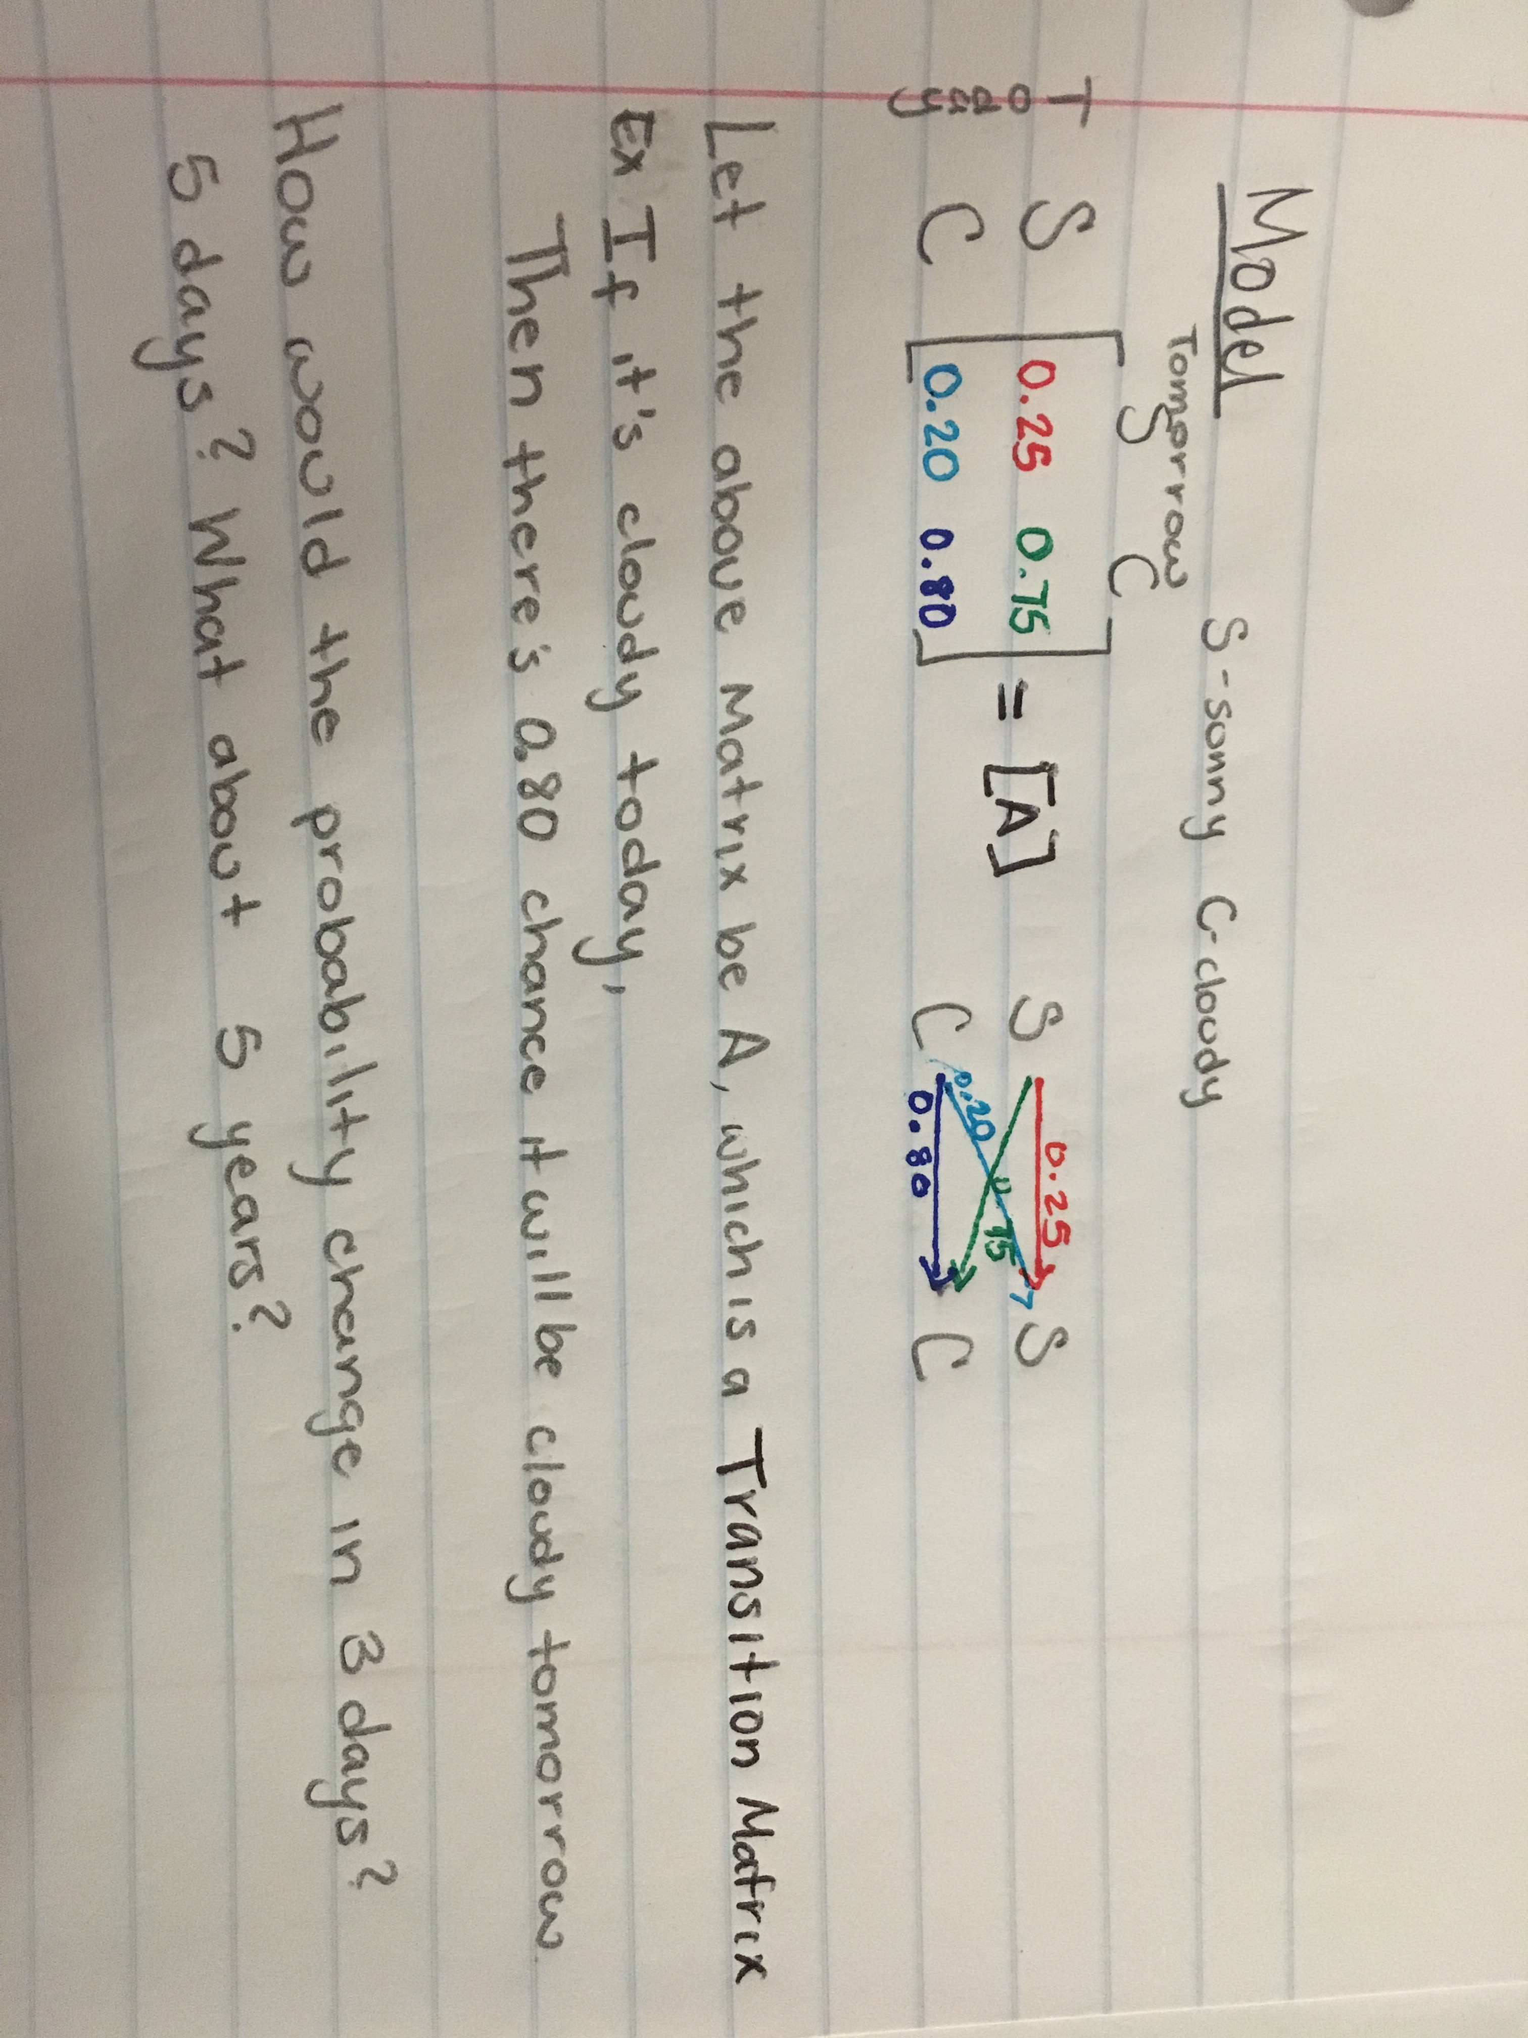

Day two/three, students will go in depth about equilibrium matrices.
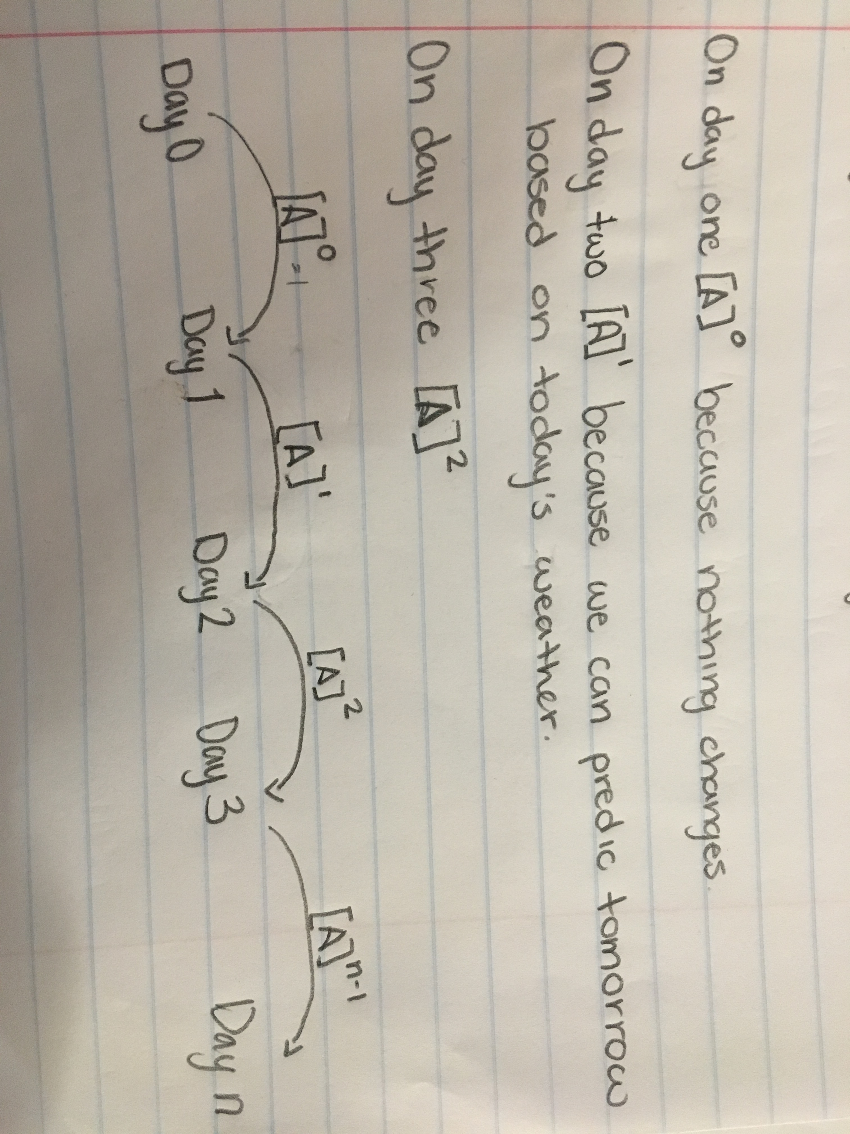
Students will first learn to set up transition matrices base on word problems of weather. Things to keep in mind are that the values of matrices across are to add up to 1. Additionally, that the once the transition matrix is set, there will not be rref apply to it.

[10-15 min] Once students have learned to set up the matrix based of the information provided, I will explain its purpose and its name, Transition matrix. I will then lead a discussion to help students develop theories as to what is going to happen when we try to predict the weather in 3 days, 5 days, and n days. This will lead to day 2/3 content.

On day 2/3 we will begin learning about applying operations on transition matrices to make weather predictions. It will also give students the opportunity to use more functions of their calculators. In this part of the lesson, students will be introduce to equilibrium matrices, by using predictions of the weather in long terms. To go into depth, teacher can provide word problems that required matrices of bigger dimensions. Moreover there will be a new change, the addition of a probability vector. ^{HSN.VM.C.6, HSN.VM.C.7}

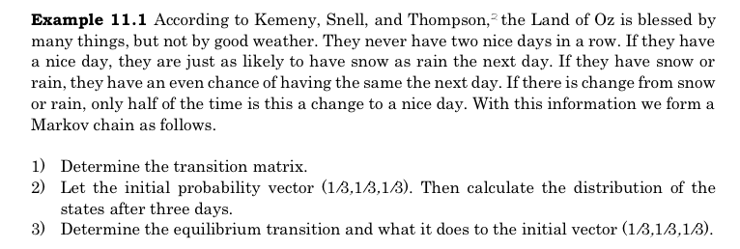
In this part, students will add a vector to the transition matrix to find the equilibrium when we try to predict what will happen in the long run. In addition, we can also make applications to economic models. This can be use as a challenging example for gifted students or used as an extra credit opportunity where students can learn by discovery using knowledge from the lessons.

Alfieri, Louis, Brooks, Patricia J., Aldrich, Naomi J., & Tenenbaum, Harriet R. (2011). Does discovery-based instruction enhance learning? Journal of Educational Psychology,103(1), 1-18.

Name:
Date:
Period:
Calculators & Matrices
Use your calculators to answers the following questions.

How to input a matrix into the calculator
- Press .

- Press and to access the matrix menu.
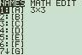

- Arrow to “EDIT” tab.

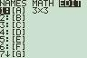

- Highlight [A] and press .

Type 2, , 2, to set the proper dimensions of the new matrix. Enter the following values: [A]= $\left[\begin{matrix}1 & 2 \\ 3 & 4\end{matrix}\right]$

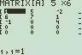
- Press to return to the home screen.

- Press to access the matrix menu. Move the arrow to MATH and search for “rref” and press . Access the matrix menu again and select [A] and press enter. Your screen should look like this:

Press enter and write your results here:

[A]= $\left[\begin{matrix}1 & 2 \\ 3 & 4\end{matrix}\right]$ rref([A])=

Now, enter the following for matrix [B]=$\left[\begin{matrix}2 & 0 \\ 1 & 2\end{matrix}\right]$

Perform the following operations:
[A]+[B]= [B]+[A]=

[A]-[B]= [B]-[A]=

[A]x[B]= [B]x[A]=

What is the commutative property applicable for the three operations? Explain using your results.

