Unit Title: Finding volume of geometric Shapes (3DS)
Teacher Candidate: Jennifer Ngobi and Ana Guerrero
Subject, Grade Level and Date: Grade 8 Mathematics Duration: About 60 minutes

Placement of Lesson in Sequence and Lesson Rationale
This is an 8th grade end-of-unit lesson on volume. It is expected that prior to this lesson students would have learned how to calculate the volume of various geometric shapes such as a sphere and a cylinder and that by this time students will be able to use these skills to help them solve a real-world mathematical problem related to volume.
Central Focus and Purpose
The central focus of this learning segment is to provide an opportunity for students to model and solve a real-world mathematical problem related to volume of different 3-D shapes. In this lesson students will use the formulas for volume of a sphere and volume of a cylinder to help them answer the guiding question, “How many meatballs will it take to completely fill this plastic container with sauce?” Students will then have an opportunity to put theory into practice by actually modeling the problem and testing their answers to see if they were correct. As students work to solve the problem they will provide written and oral responses to justify their work and through their responses it is expected that it will be made explicit by the students how and why they used certain volume formulas to find their answer.
CCSS.MATH Content and Practice Standards

CCSS.MATH.CONTENT.8.G.C.9

Solve real-world and mathematical problems involving volume of cylinders, cones, and spheres.
Know the formulas for the volumes of cones, cylinders, and spheres and use them to solve real-world and mathematical problems.

CCSS.MATH.PRACTICE.MP4 Model with mathematics

CCSS.MATH.PRACTICE.MP5 Use appropriate tools strategically

Prior Content Knowledge and Pre-Assessment
To date the students’ exposure to volume has consisted of using formulas to calculate the volume of various 3-dimensional shapes (shown below) and therefore all students should have an understanding of radius, diameter, height and pi. . All students, except for two, have shown proficiency in being able to use these formulas to calculate volume. For the pre-assessment, students will be asked to answer the question, “What information do you need know here?” and it is expected that they will consider volume of cylinder and volume of sphere in their response.
Learning Target(s) and Plan for clarifying Intending Learning
I can solve a real-world mathematical problem related to volume by using the formulas to find the volume of a cylinder and of a sphere to calculate how many meatballs it will take to completely fill up the plastic container.
I can justify how I got my answer and how I know that my answer is correct.

Strategy for using assessments to guide student learning
The formative assessment strategies: Students will be assessed formatively through their oral responses to questions made by the teacher both in their small groups and as a class. During these discussions, the teacher will ask questions that will illicit evidence to show that the student(s) understand how this problem relates to finding volume (the concept) by asking guiding questions such as, “What information do you already know about this problem?” During this time, the teacher will offer support to students struggling to make the connection to how this problem relates to volume by emphasizing that questions that ask how much of something will fit in something often relate to volume because volume tells us the amount of space that an object occupies. The teacher will also be looking for students to be able to solve, show, and justify how they used the volume formulas for a cylinder and sphere to calculate how many meatballs fit into the plastic container, students will do this during sharing their answers with the class, where they will also have to explain and justify the mathematical procedures they completed in order to solve the problem and because there will be two different types of meatballs, students will have to explain how the radius of the different meatballs effects how many meatballs fit into the plastic container using reasoning. The summative assessment strategies: students will also complete a worksheet that will require them to show how they found their answer and give a written explanation with justification for their work using the sentence frame provided “I solved the problem by….I know my answer is reasonable because…”. Here, the teacher will be looking for students to be able show procedural fluency related to finding volume and to be able to articulate how they found their answer using words. The final question on the worksheet will have students come up with their own values for the variables (height of the cylinder, the diameter of the cylinder, the diameter of the meatball) to assess their own ability to understand the problem without help from their peers.

Success Criteria (criteria for interpreting student success of the learning target) | Plan for providing feedback and students monitoring of their own learning
Students will be successful in this lesson if:  - The student is able to use the volume formulas for the volume of a sphere and volume of a cylinder to determine how many meatballs will fit into the plastic container.  - The student is able provide justification for their answers through oral and written responses to questions asked by the teacher and ones asked on the worksheet. | The teacher will provide written feedback on the students’ worksheets and will provide on-the-spot feedback at his or her discretion throughout the lesson. Students will monitor their own learning throughout the lesson by providing written responses on their worksheet which requires them to think more deeply about the learning and the mathematical processes being carried out.
Academic Language Demands
Language Function | Vocabulary and Symbols | Secondary Language Demand
- Student will be able to justify why they used the formulas for volume of a sphere and volume of a cylinder to solve the problem. | - Special terms: meat ball and plastic container  - Math terms: volume, sphere, radius, diameter, Pi (π), circle and height | Mathematical Precision:  In their small groups, students will calculate the volume of a cylinder and volume of sphere. They will calculate the volume to find out how many meatballs will completely fill the plastic container and thereafter, demonstrate the same in real world situation.  Syntax: “I solved the problem by….I know my answer is reasonable because…”  Discourse: Since the students would be discussing in small groups, there will be a pause to think, and share with the whole group. In order to give meaningful report to a larger group, students will write the formulas, and define key terms and present using the overhead projector as they answer peer questions.

Language Support (instructional and assessment strategies)
Language Instruction | Guided Practice | Independent Practice
The learning targets: “I can solve a real-world mathematical problem related to volume by using the formulas for volume of a cylinder and volume of a sphere to calculate how many meatballs it will take to completely fill up the plastic container” and “I can explain how I calculated and modelled the problem” will be modeled and explained by teacher using a hypothetical solution to the problem. | Students will practice justifying their answers in their table groups as they as the compare worksheets and answer questions posed by the teacher. | In their partnerships, students will present how they found their answer to the question to the class.
Differentiation, Cultural Responsiveness, and Accommodation for individual Differences
The differences in learning of each student will be accommodated through pairing strong students with struggling students in order to reinforce collaborative learning. In this plan, students will work together, each learning from the other, giving support in peer modelings. Each group will solve the problem together, but later each student will be assessed individually when they complete the last question on the worksheet. The tools used will vary from graphic papers, writing boards, and other drawing of shapes as they make visual representations of meatballs. Different manipulatives will be available to students to use whenever needed. ELL students are supported through the use of manipulatives which have been shown to support their comprehension of mathematical problems. For example, students that struggle comprehending the problem due to a language barrier will be read aloud the problem using the meatballs, the sauce, and the plastic containers as props as a way to support their understanding of the problem versus having them just reading and solving it abstractly.
Materials – Instructional and Technological Needs (attach worksheets used)
- Class set of plastic containers (1 per pair of students)
- Tomato sauce (enough for 4 inches in every container)
- Can opener (for teacher use only)
- Masking tape
- Black Marker
- Measuring tape
- 2 different types of meatballs (about 8-20 for each pair)
- Plastic spoons (one per pair)
- Class set of worksheets (1 per student)
- Pencils (1 per student)

Instructional Plan (detailed explanation for thing the lesson)
Pacing | Teacher Activities | Student Activities
(20-30 minutes before class) | Prior to class, the teacher should measure off 7-inch pieces of masking tape to place along the length of each plastic container and marked off the 4 inch mark for the students. The teacher should also open the tomato sauce containers for the students prior to the start of class (safety precaution).  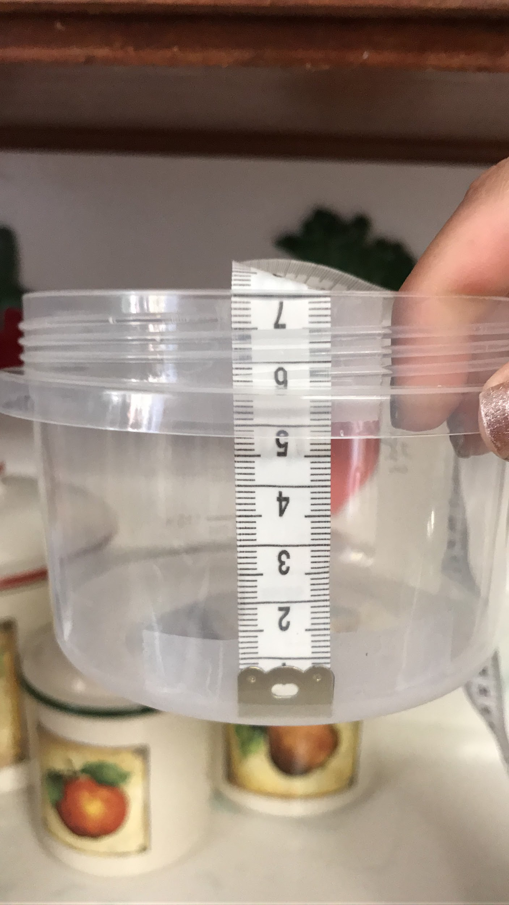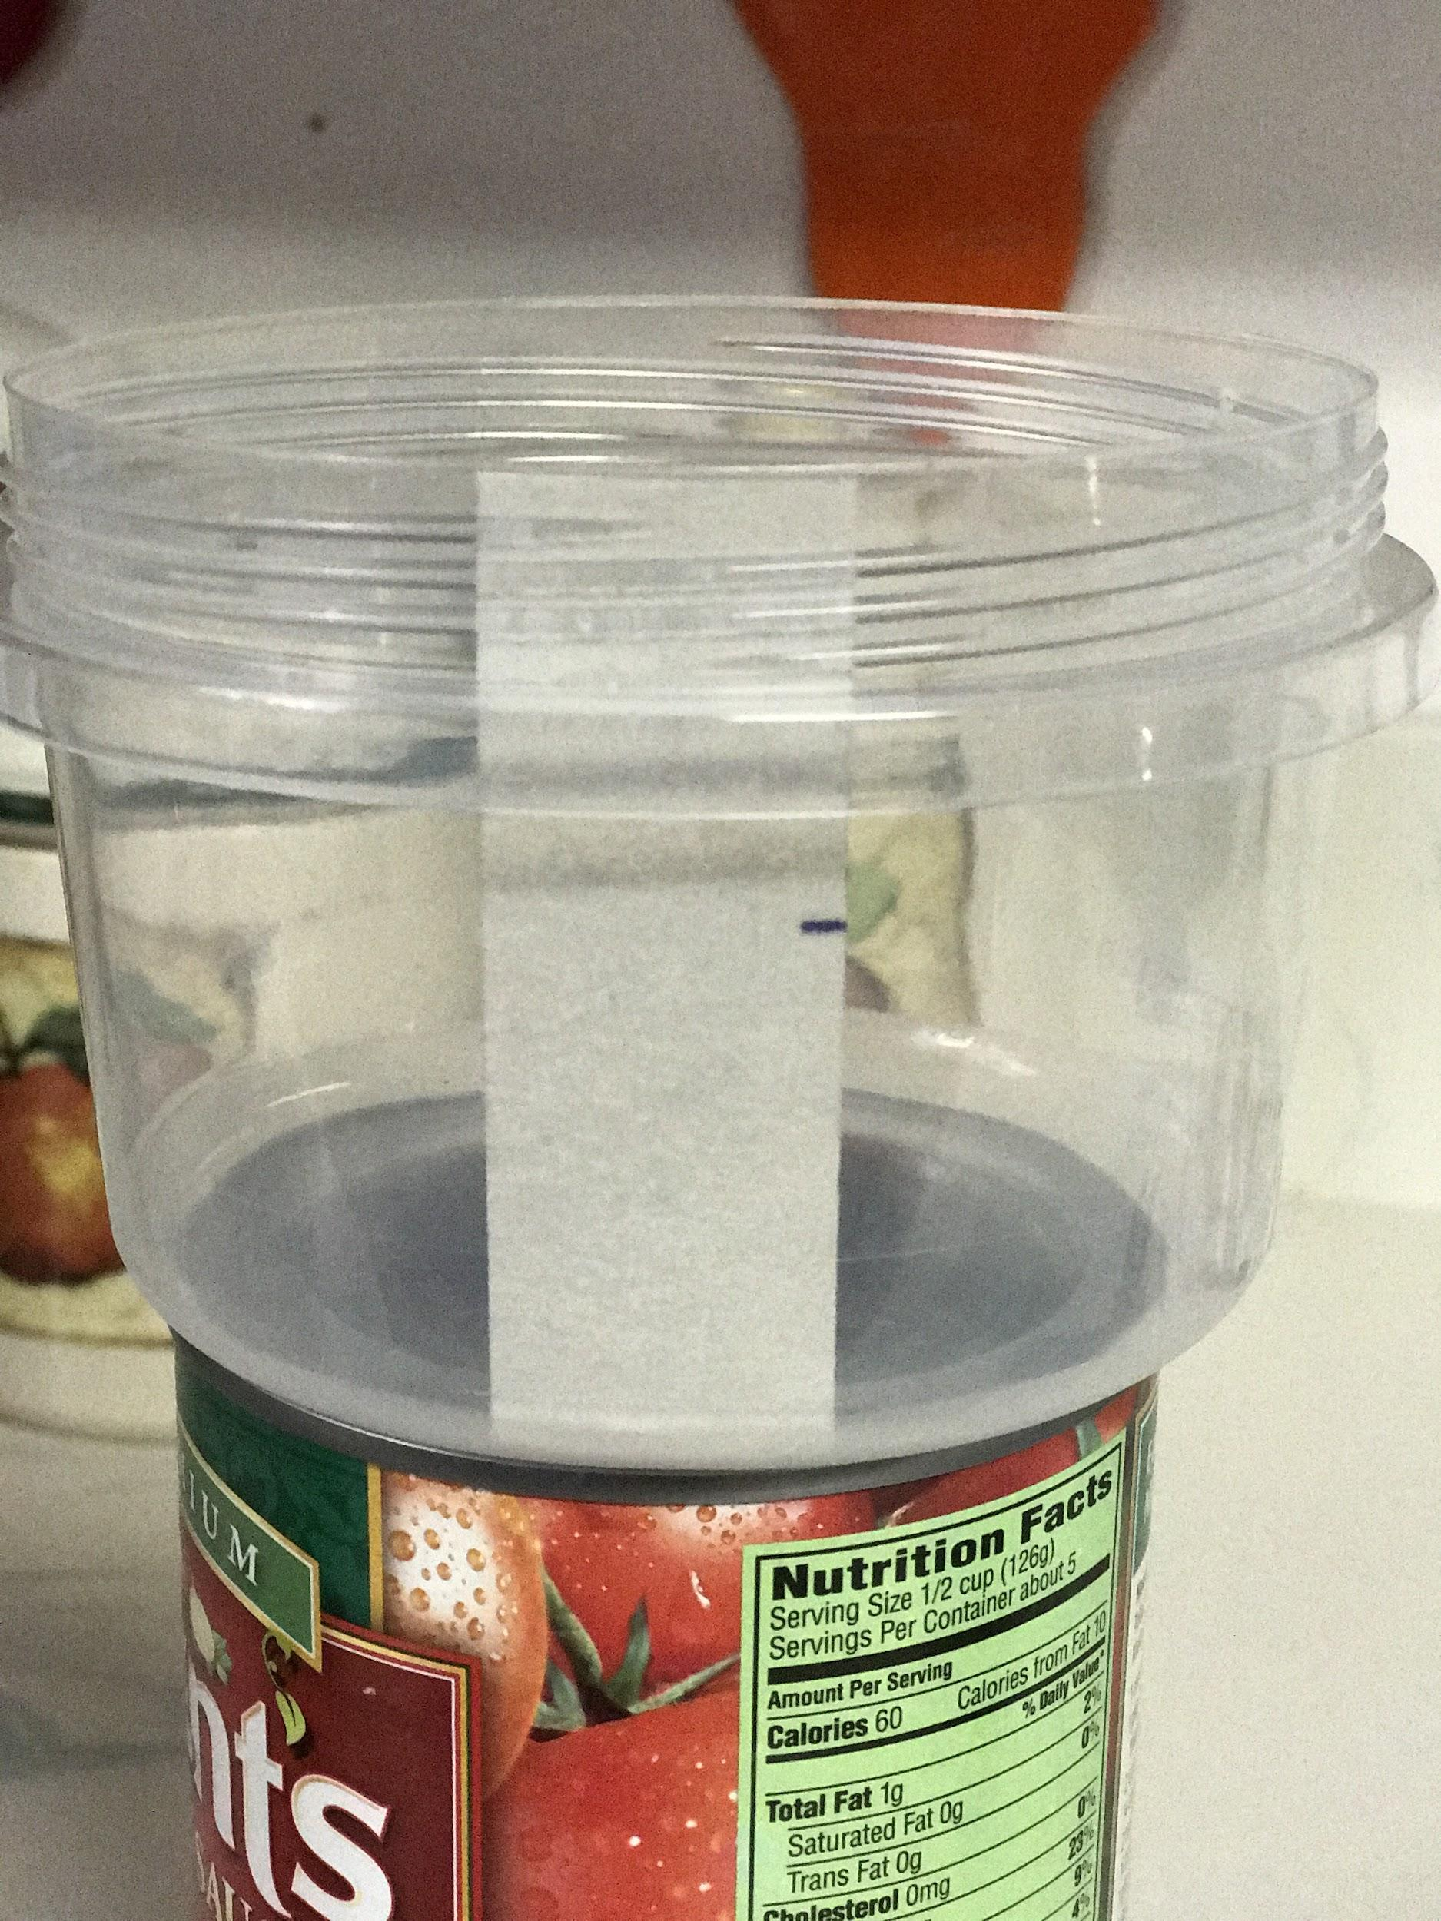 | N/A
10 minutes | Explore Groups:  The teacher will display the image and ask the question, “How many meatballs will it take to completely fill this plastic container?”. Then teacher should ask the first two questions from the worksheet to the class, “What do we already know about this problem?” and “What will you need to know?” provide 2-3 minutes for students to discuss their thoughts with their table and instruct them to write their thoughts down under the appropriate section of their worksheet (under questions 1 and 2).  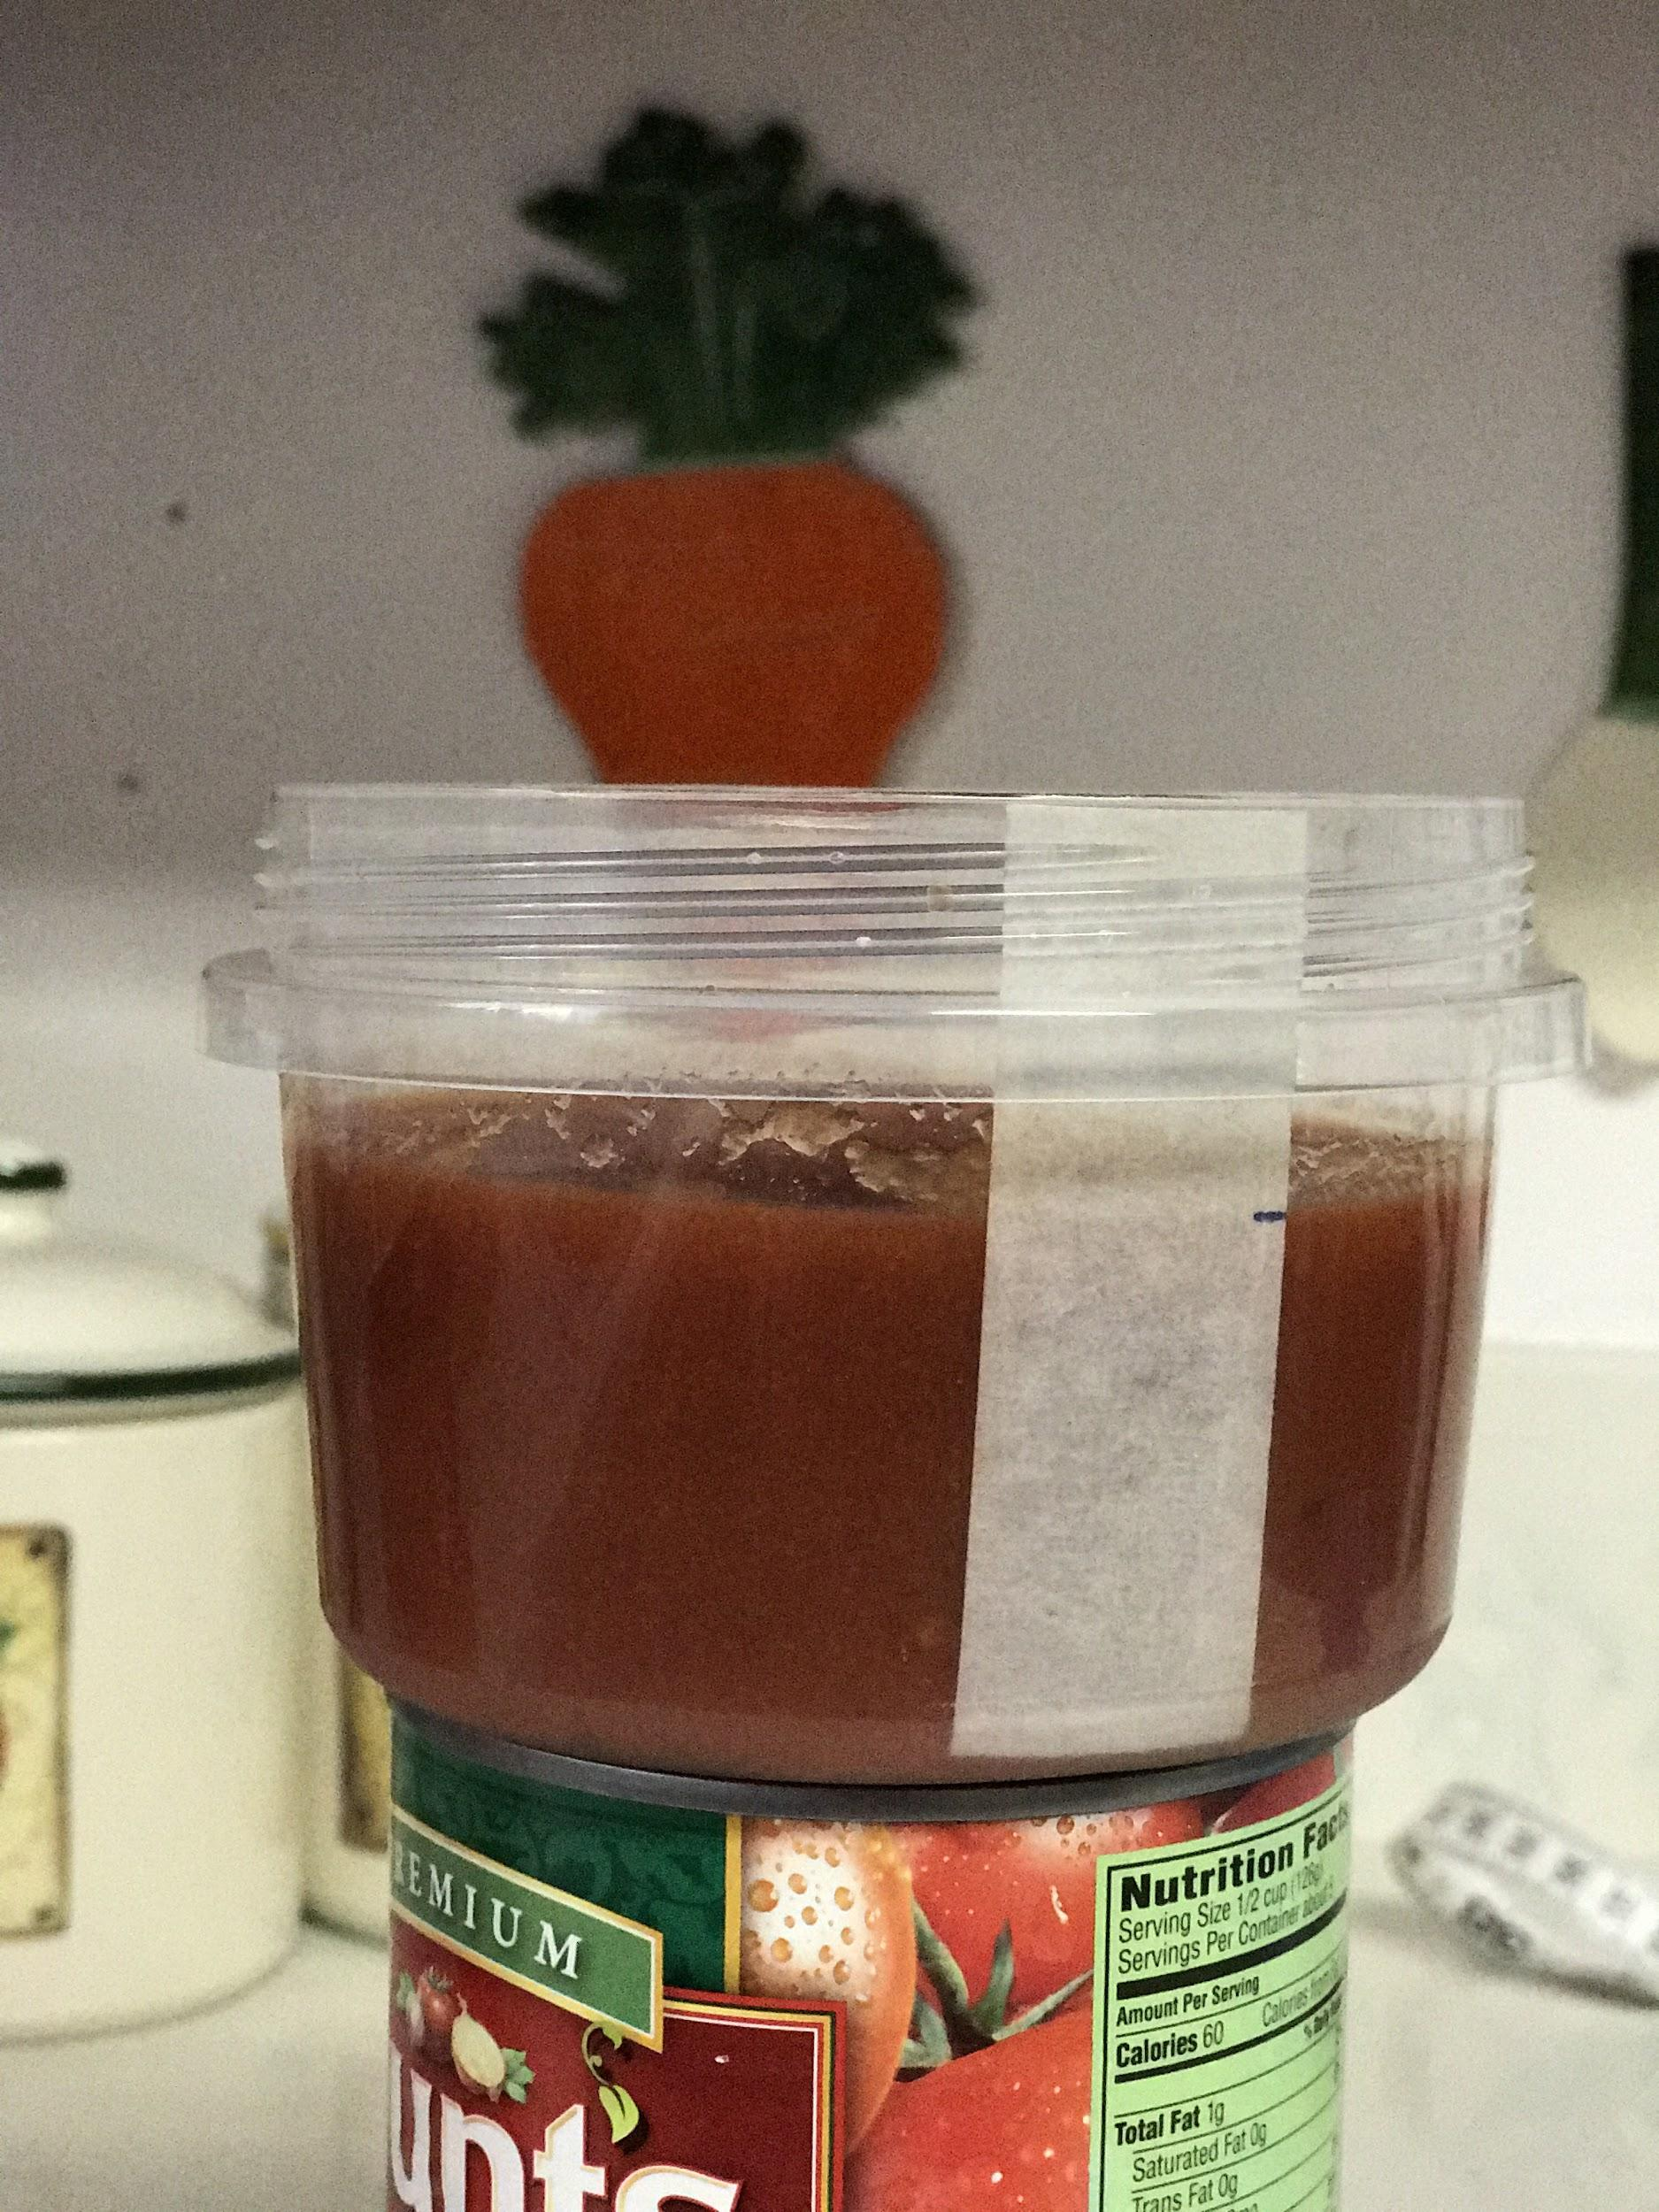 | Students will discuss their responses to the question with their table groups. They will be making connections to finding volume of a sphere and volume of a cylinder based on the image of the problem. Students will also want to know the length of the container, the height of the sauce, the dimeter of the container and the diameter of the meatballs.
1 minute | Place students into groups of two by grouping students with their elbow partners. Then, alternate assigning groups either group A or group B so that there is an even about group As and group Bs. | Get into their groups.
10 minutes | Explain to the whole class.  The teacher will ask for a volunteer from each group to identify the information needed to know in order to solve the problem and instruct students to add these answers under #1.  Student expected answers:  the height of the container, the height of the sauce, the diameter of the container, the diameter of the meatball  Teacher prompts students to elicit more information about the task:  - How do we know this is a volume problem?  - What are the formulas for volume?  - Why do we get the radius, from the given the diameter? Explain? Then:  - Write the the formula for volume of cylinder and of sphere.  - Use the formula to solve the task, and present it to your groups. | Task:  Students will:  - Explain how to get the radius for a given diameter.  - Writes the formula of a cylinder and of a sphere.
2 minutes | Present the needed for to the students.  Height of the container = 7 cm  Height of the sauce = 4 cm  Diameter of the plastic container = 10.5 cm  Diameter of the meatball will be either 3.3 cm or 4 cm. Group A will have the smaller meatballs, Group B will have the larger ones. | Students will write down this information on their worksheets and use the volume formulas to solve for an answer.
20 minutes | Elaborate Groups:  Teacher will ask a student to find how many meatballs that will completely fill the plastic container. What formulas will give the volume of meatballs and volume of the remaining space to fill up the plastic container? | Task: 15 minutes  Students follows the prompting and:  - In small groups, they will think, pair, and share the different formulas and decide on that which can be used to solve the problem.  - After you have decided on the formula use graphic organizer to calculate the volume of the cylinder and of the sphere.  - Use the volume calculated to find the number of meatballs that completely fill the plastic container.

20 minutes | Evaluate Whole class for 15 minutes.  Since there are two sizes of meatballs there are two different answers. Have each group model and explain their group’s problem solving strategy and the answer  Teacher will:  - Have the peers ask reflection questions to evaluate grasp of ideas.  - Explain individual assessment and give feedback. | Task:  Each group will present and explain mathematical understanding of the problem by  - Calculating the volume of cylinder and sphere using the formulas.  - Divide the volume of cylinder by the volume of sphere to get the number of meatball needed to completely fill the plastic container.  - Model how to solve the task to the whole class  - Provide justification for their work  Individual Assessments: EXIT ticket.  - Using the formulas you used in the problem, answer question 4 on the worksheet.

Name __________________________________

Meatball Problem Worksheet
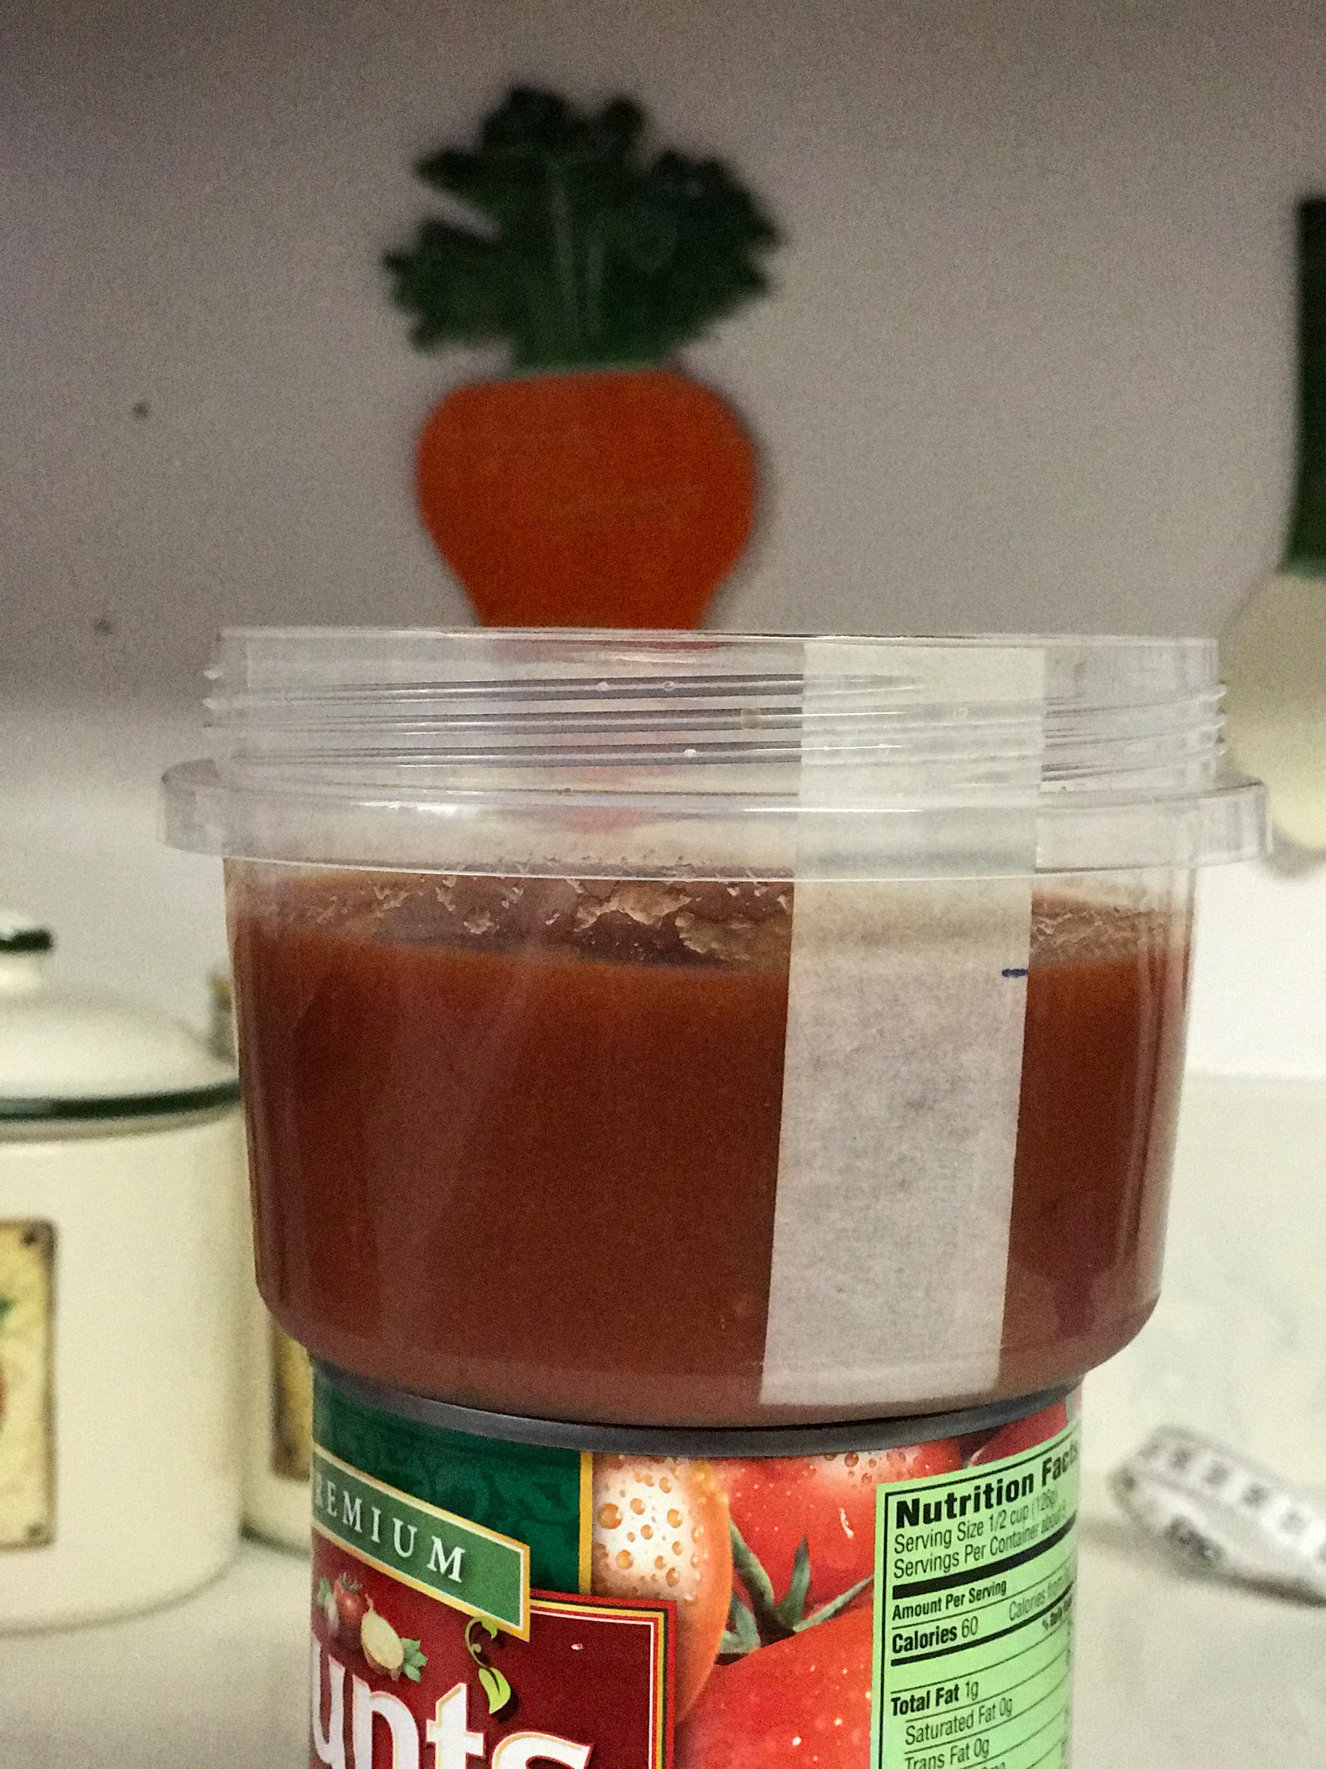
How many meatballs will it take to completely fill this plastic container? ____________

1. What information do you already know about this problem? Explain.

2. What information will you need to know? Explain.

3. Show how you and your partner found your answer. Provide justification for your work referring to specific steps you did. Use the following sentence frame to frame your response: “I solved the problem by….I know my answer is reasonable because…”

4. How does the length of the radius effect the number of meatballs that will fit inside the plastic container? Explain.

5. If the height of the container was 9 inches, the diameter of the container was 6 inches, the sauce had a height of 5 inches, and the diameter of the meatballs was 4 inches, how many meatballs would fit into the container? Show your work, explain how you got your answer. (hint: drawing a visual would help)

