ClassKick Keeps the Class Kicking!
Writing Functions

The technology of the future for math teachers and really teachers of all subjects is ClassKick. This online classroom platform is available in its simplistic form free to teachers and students. School districts can choose to get a pro subscription the benefit to this being that the students would have a permanent account.

However the free version has access to all of the same services. The teacher has an account that they can login to so they will never have to worry about losing any documents or assignments they have on it. The teacher then can create a roster. Each roster is assigned a Class Code. Generally teachers would create a roster for each class they teach. They could also choose to create a roster for groups so that each group could then interact and help their own members but not interfere with other groups.

Teacher Guide for Using ClassKick

Roster
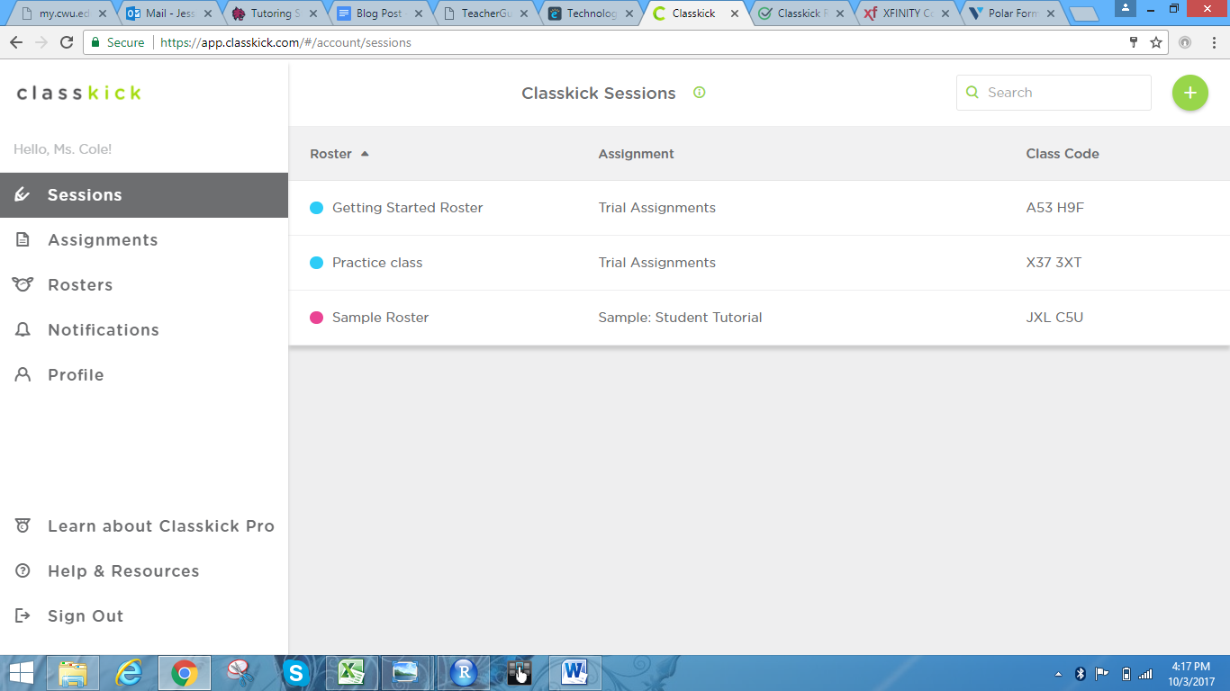
Teachers can keep track of their classes, worksheets, and students all within the roster.

Typically a teacher would create their assignment after they have made their roster. However when making an assignment they can then assign it to one or more rosters which is very helpful for teachers who teach more than one section of the same class. When creating the assignment teachers can give it a name and have the option to add a description, perhaps putting conversions, suggestions, or general directions there. Then a “question slide” can be added and the teacher can decide how many points each question is worth. The teacher can add and remove question slides.

Creating Assignments
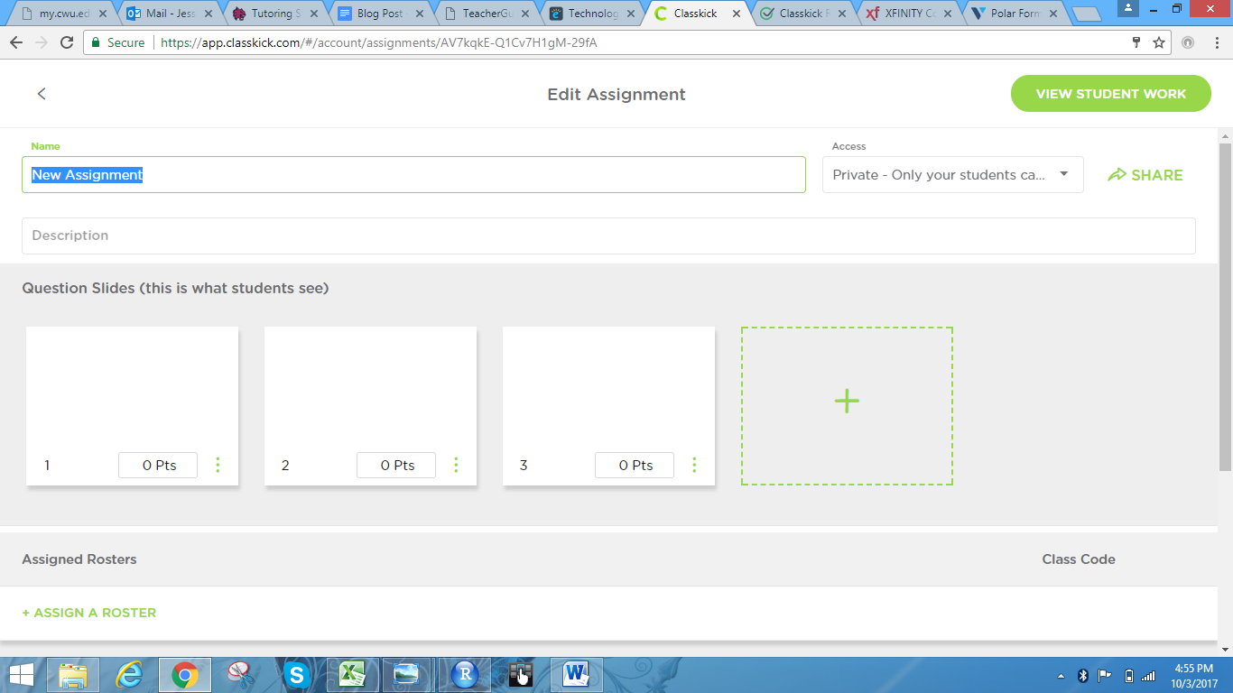
Teachers can assign points values to each question slide and add and remove these slides. They can then assign the assignment to a particular roster.

A benefit to the free version is that the students do not need to provide any personal information, such as an email, to be able to use it. All a teacher needs to do is provide the students with the class code. Class Codes are a 6 digit code composed of letters and numbers that are specific to the class roster.

Class Code
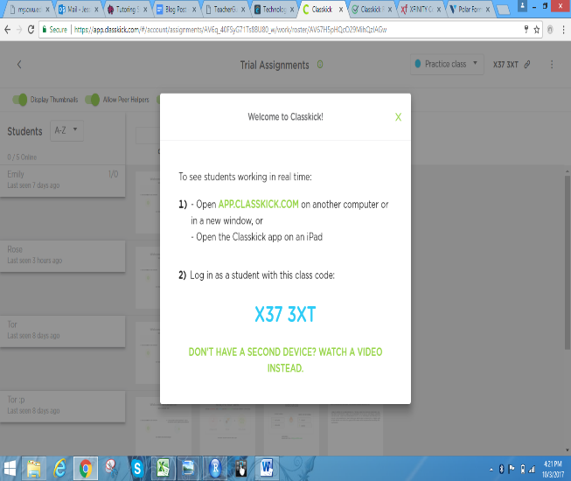
When teachers create an assignment, a class code is automatically made for students to access without creating an account through ClassKick.

In many districts the teachers in the same department will frequently find themselves collaborating. ClassKick aids teachers with this by having the capability to share assignments with fellow colleagues so that all of the classes can use same assignment and the teachers don’t have the extra work of recreating the same assignment.

Sharing Assignments with Colleagues
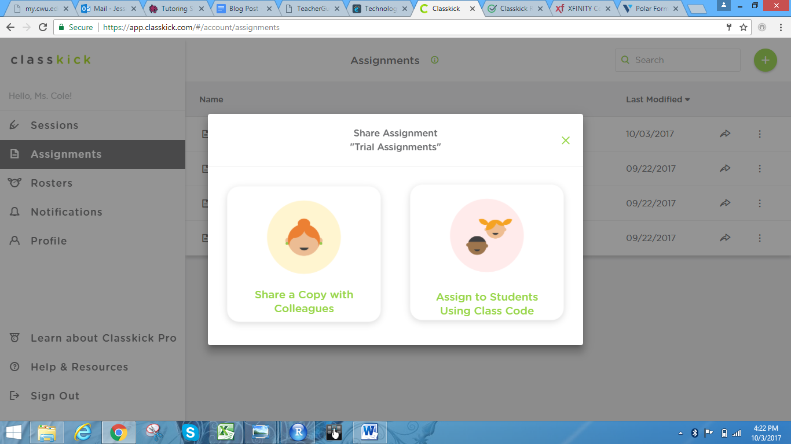
Teachers can share their worksheets with students and colleagues, and student progress with their peers.

Once students have opened their assignments they can choose how to respond. The student response below was done using the typing feature to type their response. They can do this by hitting the “T” button and creating a textbox to write in.

Typing Out Responses
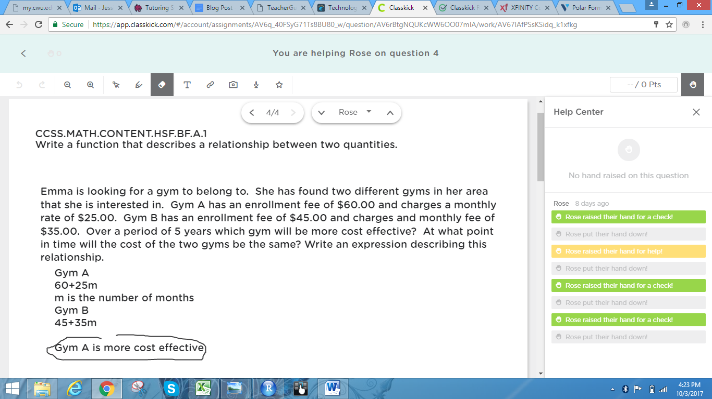
Students have the option of typing out their responses or drawing on their copy of the document.

Not all students will choose to type out their responses, some may opt for hand written responses. The image below is an example of a student who chose to hand write their answer off of their phone.
Hand Writing Responses from Phone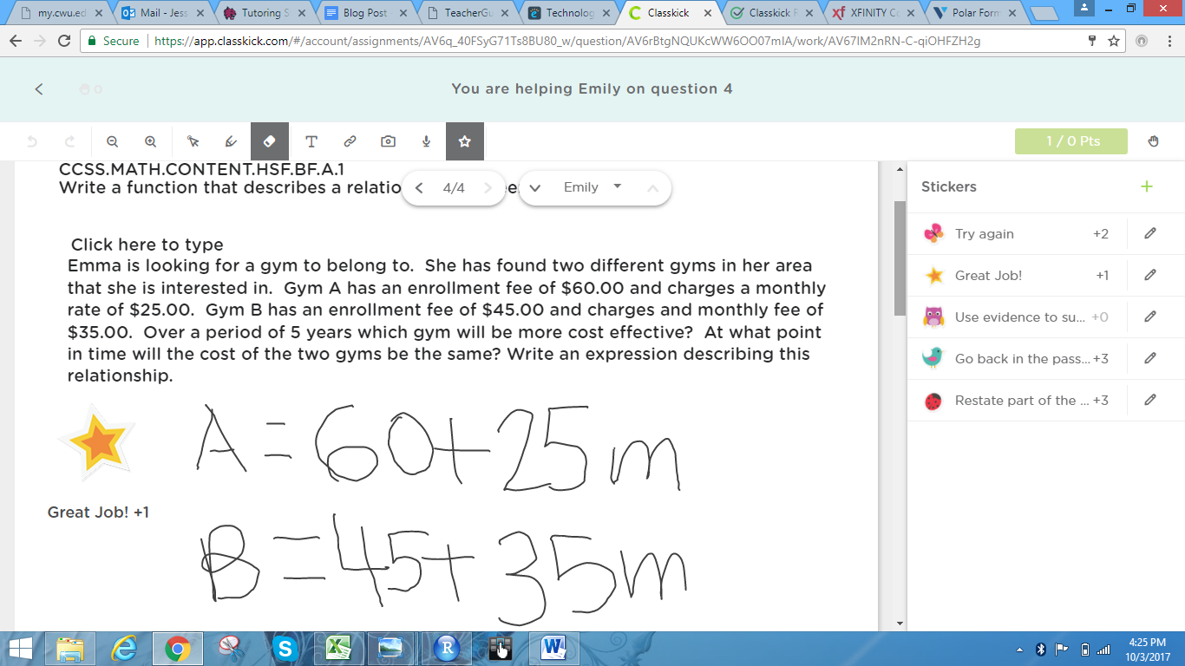
Students and teachers can access ClassKick from their computers, tablets, and phones!

Although students are working individually on their computers they still have the ability to ask questions, and do so anonymously. Student can ask for help by raising an online hand. The teacher is notified and knows which student it is. However the teacher can choose to let peers help one another and the students can only see aliases. This way there is a sense of anonymity but also peers can help each other to develop their understanding and identify misconceptions.

Raised Hand for Help
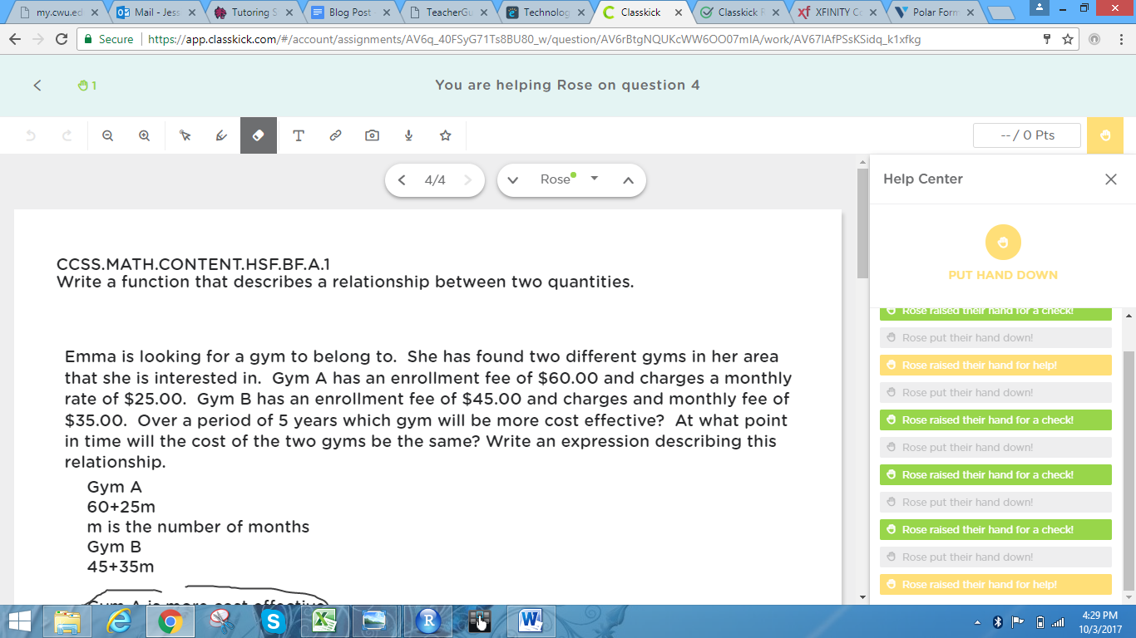
Students can easily “raise their hands” at the press of a button to ask their teacher for help or to check their work.

Teachers can grade on the spot and not have to do extra work at home. Along with the help hand there is also a check work hand where students can notify their teacher that they have completed the question and are ready to be graded.

Check Work Hand
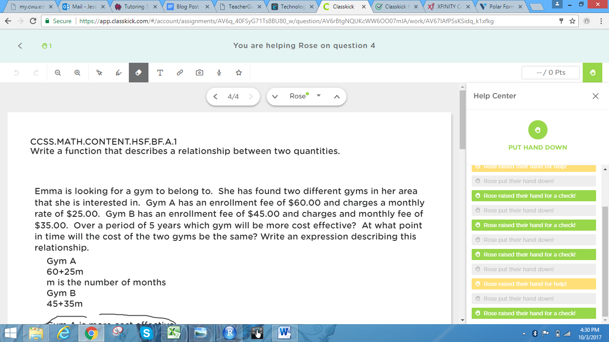
Students can easily “raise their hands” at the press of a button to ask their teacher for help or to check their work.

When teachers go to the assignment to grade it they can grade it using stickers. The teacher can choose the graphic and the amount of points assigned to each sticker. Once the sticker is put on the page ClassKick automatically gives the students that many points for the question.

Stickers that Grade work on the Spot
Teachers can grade assignments on the spot and place stickers on student’s work.

Teachers have the capability to adapt the online classroom environment with the assistance of sliders. These sliders can allow students to help their peers. They also can allow students to see their grades. But as the teacher you can just click the slider and automatically change that. Let’s say you were allowing a certain amount of time for peers to edit each other's work, when that time is up the teacher can turn of the peer helpers capability.

Setting Sliders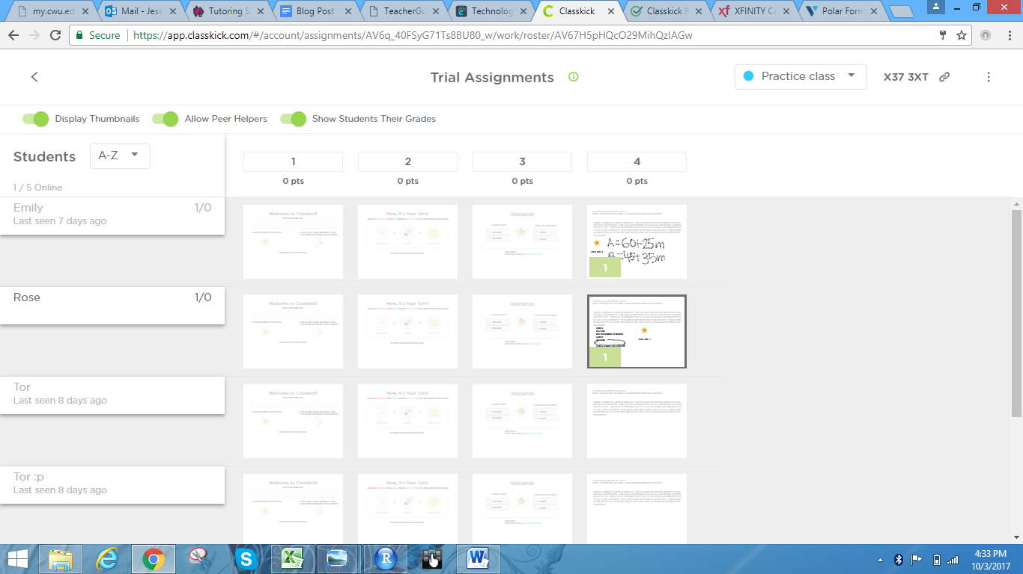
The sliders allow the teacher to change the online classroom format.

Teaching:

Plan to Teach Mathematical Understanding

ClassKick is a great resource for teaching mathematical understanding because each assignment created can be designed to achieve any learning target desired by the teacher. Once created, the teacher will be able to monitor students progress and engagement in the process of completing the assignment given. The student’s conceptual understanding, procedural fluency, and mathematical thinking is easy to assess in ClassKick. Teachers are able to make comments and help students who are not achieving the learning target during class without interrupting the flow of the lesson. When using the common core state standards in ClassKick, teachers are able to choose standards that emphasize mathematical understanding, such as CCSS.MATH.CONTENT.HSF.BF.A.1, with a hands on approach. For example, in our demonstration of ClassKick, the common core standard used involved writing a function that describes a relationship between two quantities. In our assignment we included a story problem that required students to use mathematical understanding to reason inductively and apply content knowledge to solve a real world problem involving single variable linear equations. ClassKick allowed students to show their work setting up a word problem and solving for the solution. ClassKick will help teachers and students gain feedback on mathematical understanding in every lecture!

Planning to Support Varied Students’ Needs

ClassKick is a great way to support varied students needs because of its flexibility in availability, communication, and methods of feedback. Many students learn and complete work at different rates, thus having homework available online gives students confidence that they will have adequate time to complete assignments. Developing communication is a key part of learning. Mathematical communication is something that many students lack confidence in. Being able to communicate your level of understanding of a concept effectivity is one of the eight mathematical practices. ClassKick helps students build their confidence by allowing them to ask questions anonymously. For example, when working on an assignment students have the option the “raise hand” to ask a question. This question can either be answered directly from the instructor or can be opened for students to give feedback to their classmates. Methods of feedback in ClassKick is very useful for teachers as well as student understanding. Since students can complete their assignments and submit them early, teachers are able to grade homework immediately and give notes/stickers/grades to the assignments. An example of students using this method of feedback to their learning advantage would be if the student receives their homework back graded during class and has time to ask questions to improve their understanding of the learning target. ClassKick overall is a great tool to support various student needs and decrease wait time on feedback.

Using ClassKick for Assessment

Teachers can easily use ClassKick to formatively assess their students. As students complete their work on an assignment, teachers can track real-time what their student is doing and thinking. Teachers can click on any student to see their progress. As the student is working, the teacher can also mark the student’s worksheet with comments, questions, or compliments. In this way, teachers can instantly give feedback on student’s mathematical thinking, procedural fluency, and conceptual understanding. ClassKick cuts out the long hours of grading at the end of a long day. Instead, teachers can address misconceptions and ask their students critical thinking questions as they work. Even better, teachers are able to see the progress and work of their entire class at once. The advantage to this is instead of figuring out a misconception or common mistake after helping three individual students, the teacher can see the thinking of the entire class at once and address the class as a whole. ClassKick is designed for quicker feedback so that the teacher can focus more on teaching, than grading.

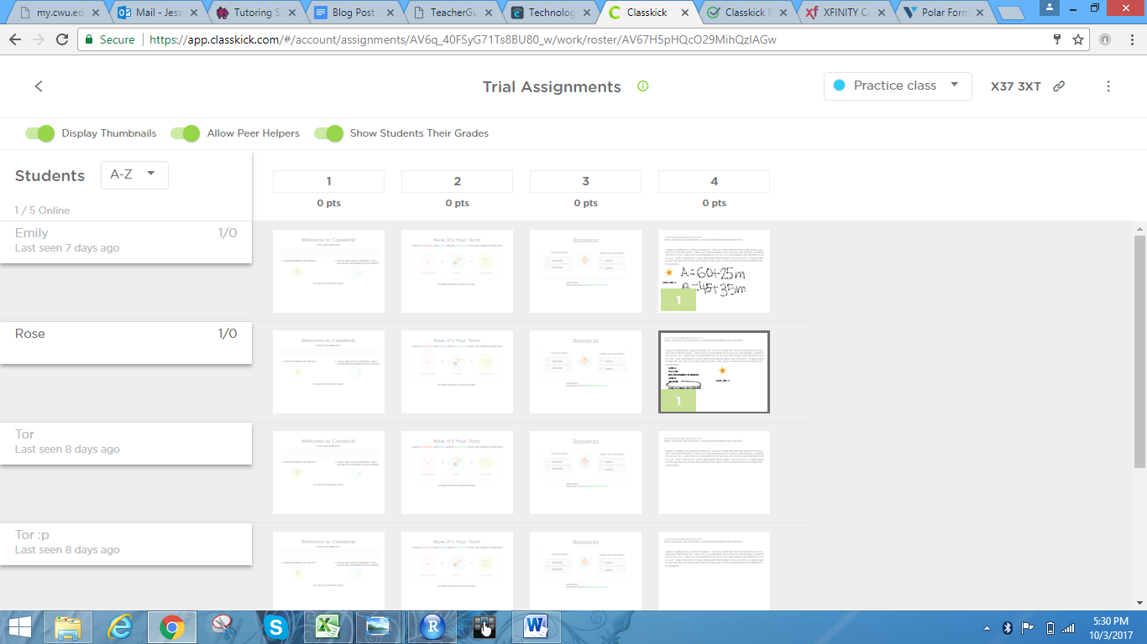
The teacher can see progress and work for the entire class all at once.

When using ClassKick in our demonstration, our teacher was able to instantly address her students when one of them raised their hand. One student raised their hand soon after the assignment was given out, asking for the teacher to grade their work. The teacher was able to see what the student did, and how much time they spent on the worksheet. As it turned out, the students had quickly sped through the worksheet and immediately went to social media, not even working for 2 minutes. The teacher was able to easily see that the student had not thought about the problems, and quickly addressed it. Another student raised their hand, asking for assistance. The teacher was able to help the student through their ClassKick browser, and then go back to watching the progress of the entire class.

Using ClassKick in a Mathematics Curriculum

ClassKick’s worksheet creator and editor is a powerful tool for learning. Above, we mentioned how to create a worksheet, but there are other ways to create amazing worksheets than adding text, pictures, or drawings. Links can be easily embedded into worksheets, as well as audio or video clips. Teachers can add links that send them to a Desmos graph for them to explore for hands on learners, or, embed a YouTube video featuring a scenario for a problem for visual learners. Audio clips can be embedded in the work sheets for students who learn better by listening. With these options, teachers can interesting, relevant, accommodating worksheets for students.

ClassKick Reviews

“Flexible features give teachers and students tons of options for interaction and support. . . . ClassKick has a neat format and lots of little details that make it especially user-friendly.” Common Sense Education

“ . . . often unaware of who needs help because some students are too shy to raise hands. Classkick is a free app that eliminates those roadblocks, showing teachers exactly what their students are doing . . . ” Laura Litton on Edshelf

“The teacher is able to identify struggling students or students who are too shy to ask questions. And, students can work at their own pace.” Classroom Tested Resources

