Justin Hastings, Gillian Giles, Savannah Lucero-Zey, Katie Johnson

Technology in the Classroom

Learning targets:
I should be able to construct a circumscribed circle of a triangle in GeoGebra

Standard:
CCSS.MATH.CONTENT.HSG.C.A.3: Construct the inscribed and circumscribed circles of a triangle, and prove properties of angles for a quadrilateral inscribed in a circle.

In this lesson, Geogebra and Kahoot will be used as our technology to better support the students in the class and hopefully to help them learn and remember the information well. Students can use the technology of Geogebra as they can move different points around and show that they understand how changing parts of a triangle changes the circumscribed circle without making multiple drawings. Kahoot is a good technology because it allows both the students and teacher to have instant feedback on how well the information was understood. It also allows the students to be having fun and working both with each other in groups and against other groups to win the most points.

Using GeoGebra, the students are able to have a visual representation of the lesson. Throughout the lesson, the teacher will guide the students and inform them of how to use GeoGebra to construct a circumscribed circle around a triangle.This allows the students to create their own constructions on their tablet, laptop, or whichever device they are working on, while at the same time, listening to the teacher lecture about the topic of a circumscribed circle. This adheres to two different learning styles; visual and auditory. The Kahoot website will allow the teacher to formatively assess the students at the end of the lesson while keeping the environment fun and technological.

GeoGebra: (About GeoGebra) :
Geogebra is a computer software that integrates geometry, algebra, calculus and graphing into one program. It is very user friendly and can be used on just about any tablet, iPad, laptop or PC. We will be using Geogebra to demonstrate how geometry constructions can be made. This lesson will focus on how to construct a circumscribed circle. There are tools at the top of the page, just like an Office or Google document. These tools will help make a triangle and construct the circle, as described below.
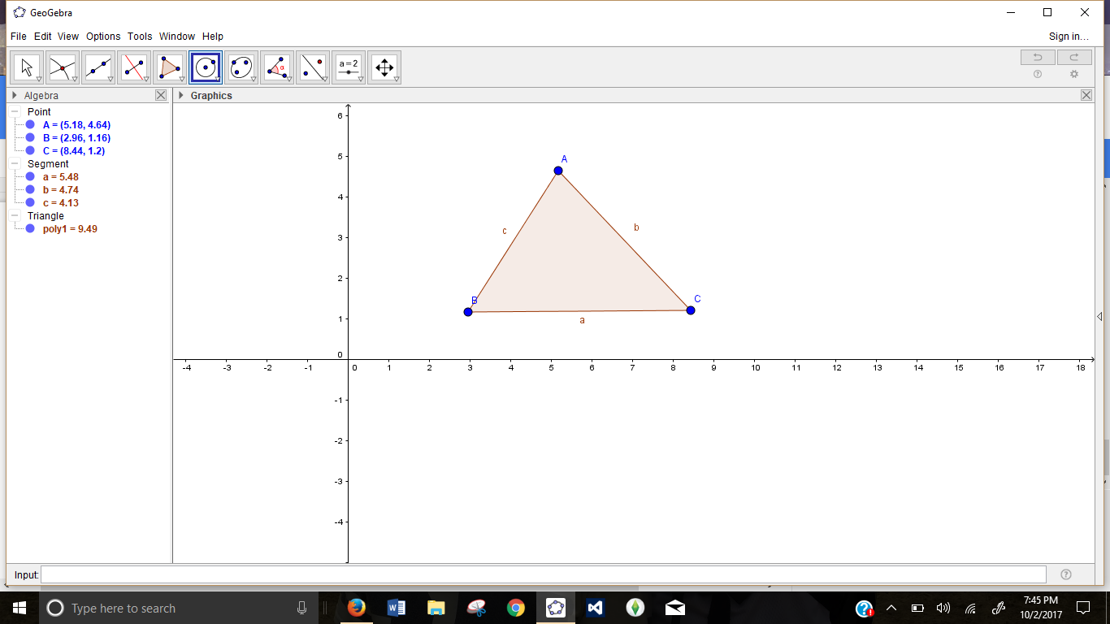

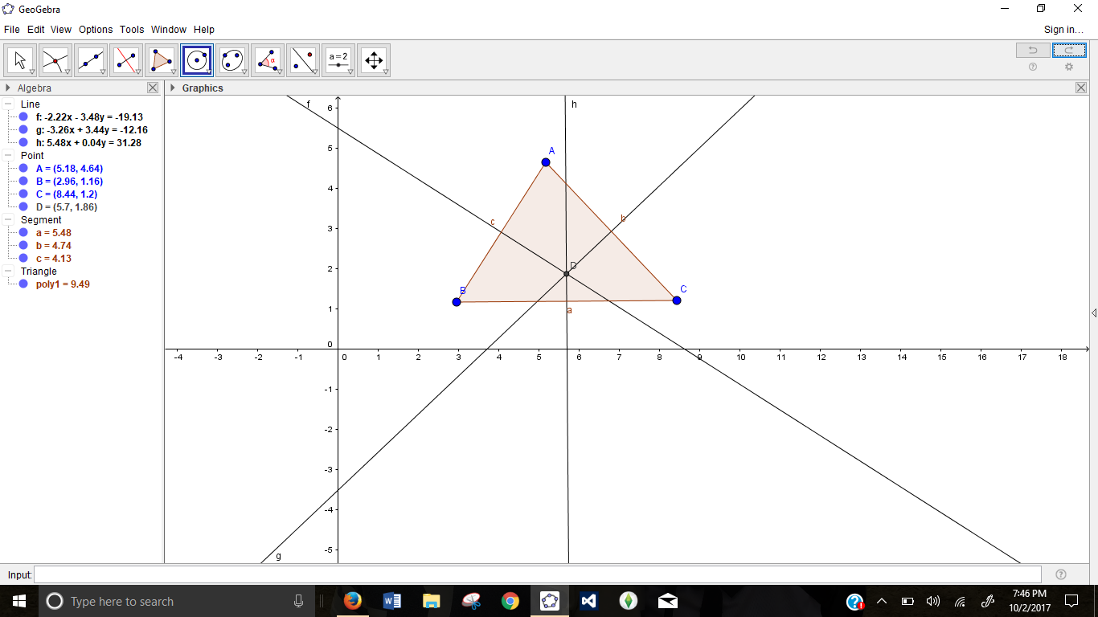
Construct a Triangle (Polygon tool)

Construct perpendicular bisectors of each side
This will create a point of intersection (d).
(Perpendicular Bisector tool)
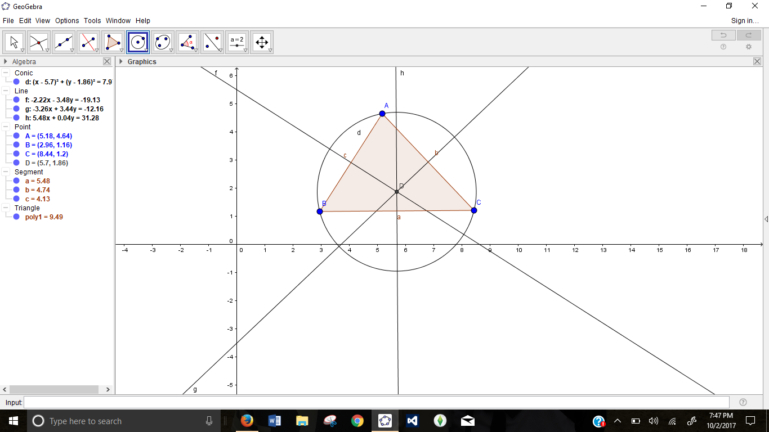

Construct a circle whose center is at d with a radius
that goes through each vertex of the triangle.
(Circle with center through point tool)

Kahoot:
Kahoot is an online tool that Teachers can use to formatively assess his or her students. In this example, we created a short two question quiz based on what the students should have retained from the GeoGebra lesson. Once the teacher has created the quiz for the students to take at the end of the lesson, the students can get out their phones, or have one student take out their phone per group. The students will go on the website Kahoot.it.com in order to access the game. This is what the beginning looks like.

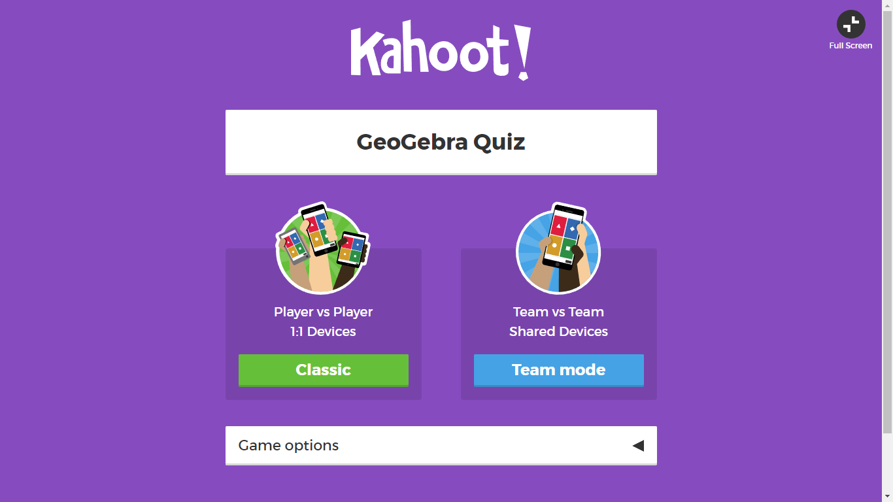

Each time the teacher opens the quiz, there will be a game pin unique to the quiz. This is what it will look like to the class. The students will have a screen that tells them to type this pin in. Once they do that, they will be able to use their phones as a sort of “clicker” to answer the questions. (Make sure that the Kahoot quiz is up on the overhead doc cam for the class to see.)

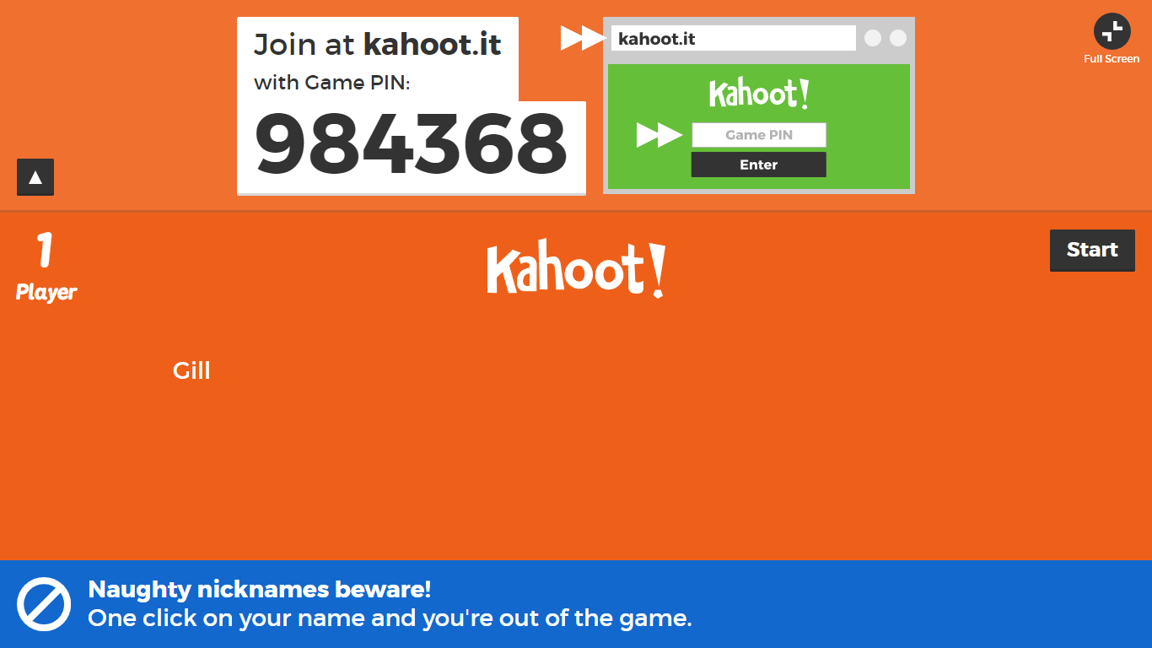

Once each student or group has entered the game/quiz with a class appropriate nickname, the teacher can start the quiz.

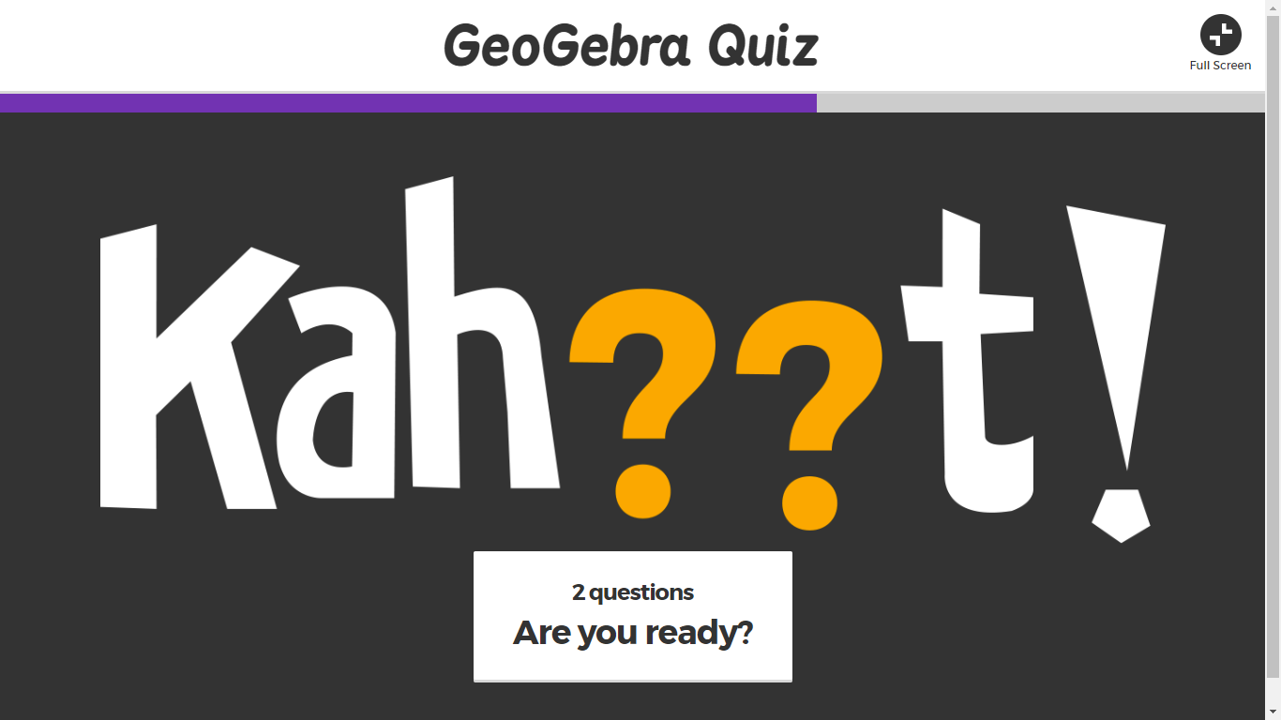

The questions will first appear like this:
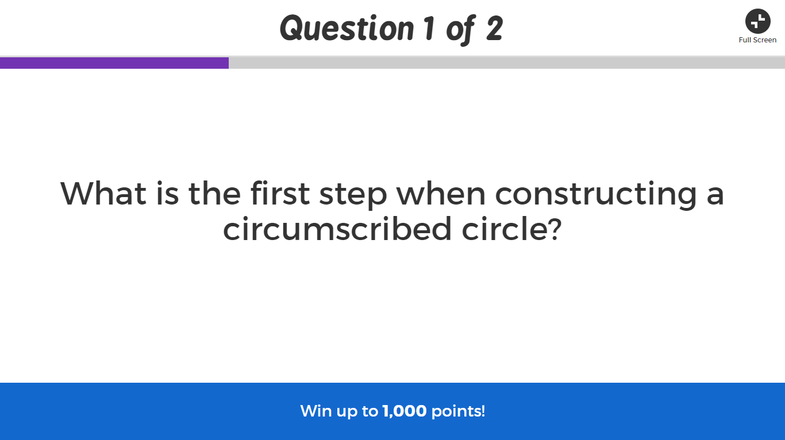

Then they will look like this:
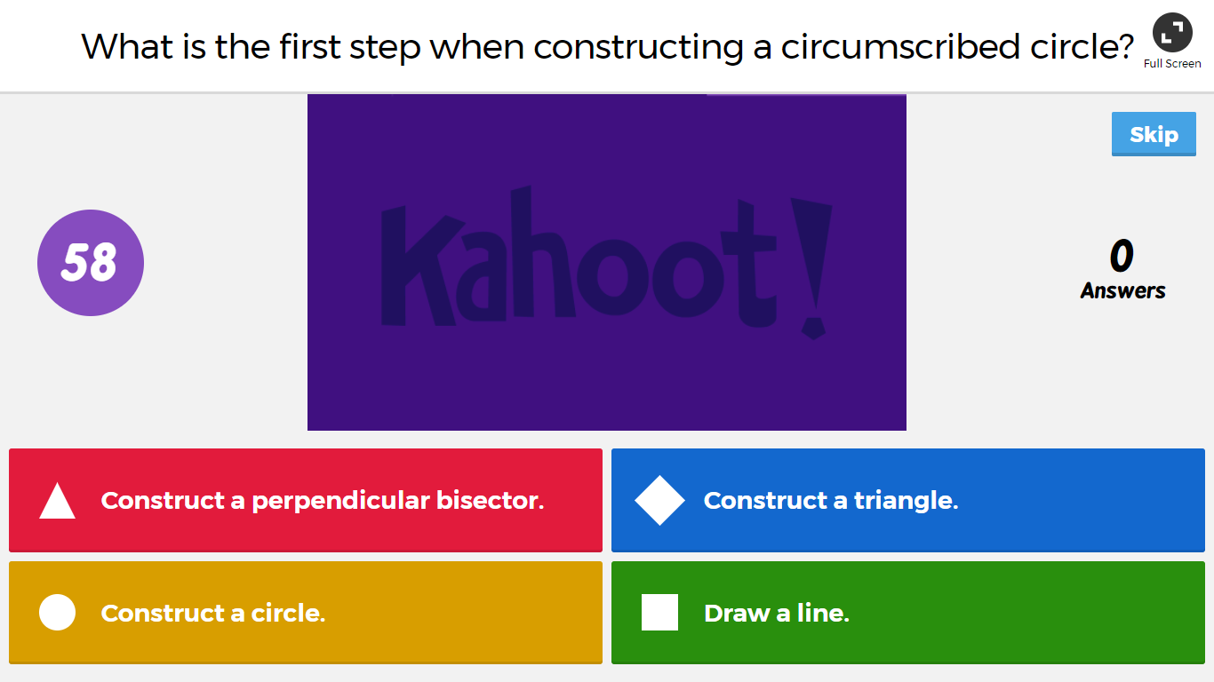
Once the students have all answered and/or the time has run out, the answer will appear as well as the amount of students who answered correctly.
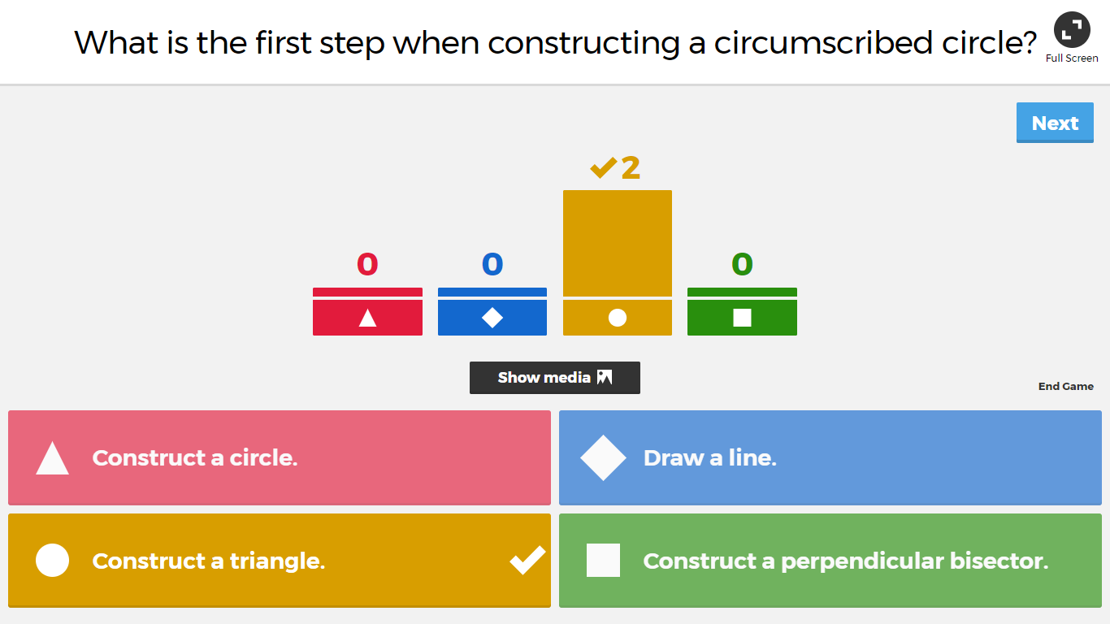

Once the quiz is finished, the teacher has the ability to save the results of the game. This allows the teacher to go back and see what the students struggled in and what they seemed to excel in.

