Finding Properties of Scale Factor G-SRT.A.1
Alignment to Content Standards
- G-SRT.A.1 “Verify experimentally the properties of dilations given by a center and a scale factor”
Task
Solve the following problems based on the pictures given. You may use a calculator. Show work and answers on separate piece of paper. Use units when appropriate.
- What scale factor makes the sides of B equal the sides of A?
- What scale factor makes the area of B equal the area of A?
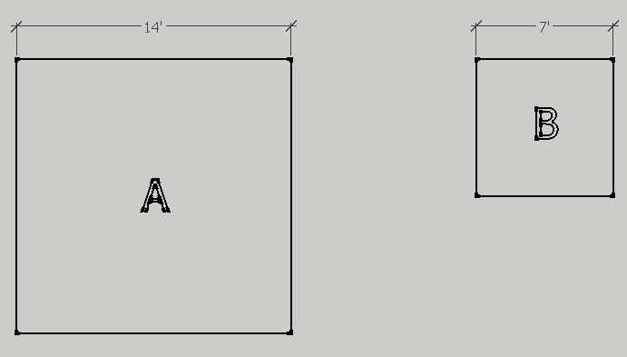
- The squares are now cubes. What scale factor makes the volume of B equal the volume of A?
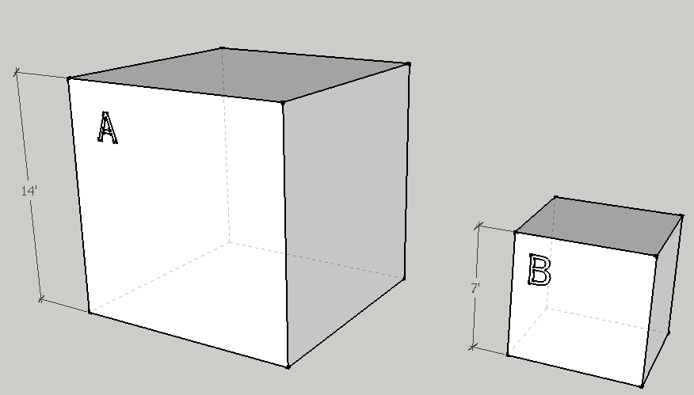
- What is the relationship do you see between the scale factors of side length, area, and volume? Describe that relationship as a ratio and in words. Do you think this will always work? Why?
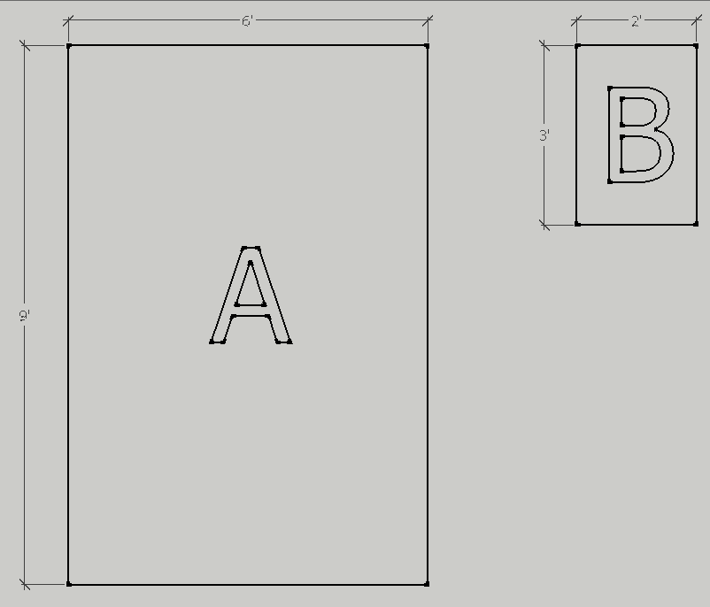
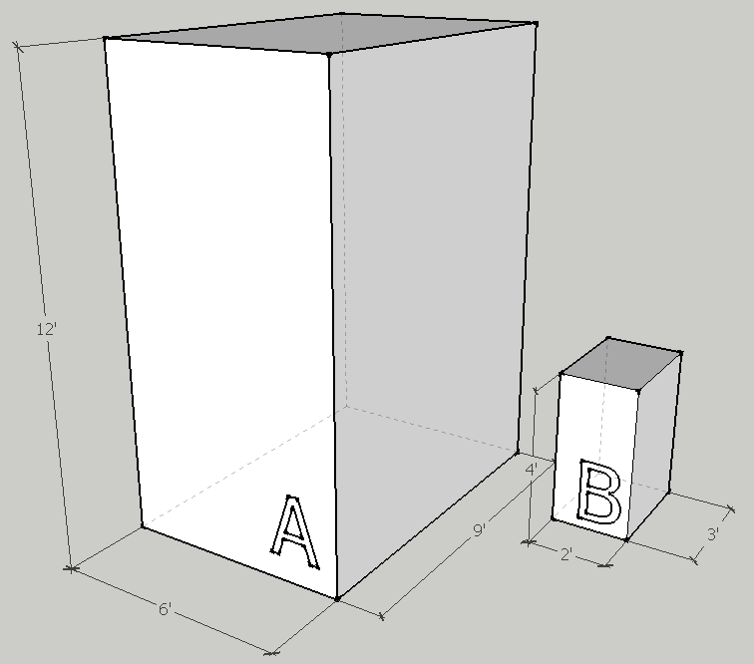

Commentary
Students will be able to work in pairs when completing the task. If they have any questions about the diagrams included they will be free to ask.
The task will have students explore the relationship of scale factor across different dimensions. Students will already know how to find the area of rectangles, and the volume of rectangular prisms. They will also already know how to find the scale factor. What students will discover is that the scale factor of each higher dimension is the original scale factor to the power of n^{th}-dimension. That is to say, given a scale factor s, the scale of the area is $s^{2}$ and the scale of volume is $s^{3}$. This is a property of dilation that students will see translates into the quantification of measurements of area and volume. This is somewhat nicely illustrated by using squares and cubes for the first three questions and asking that they use units when solving. Question four asks if this property works with other objects and asks students to think critically about why it works
Solution
- $\frac{14}{7}=2$
The scale factor is 2
- ${Area}_{A}=14ft*14ft=196ft^{2}$
$${Area}_{B}=7ft*7ft=49ft^{2}$$
$$\frac{196ft^{2}}{49ft^{2}}=4$$
The scale factor is 4
- ${Volume}_{A}=14ft*14ft*14ft=2744ft^{3}$
$${Volume}_{B}=7ft*7ft*7ft=343ft^{3}$$
$$\frac{2744ft^{3}}{343ft^{3}}=8$$
The scale factor is 8
- The scale factor of the areas is the scale factor of the shapes to the power of 2 (squared); the scale factor of volume is the scale factor to shapes to the power of three (cubed). A ratio for this relation would be $s:s^{2}:s^{3}$. The same relationship does apply:
$$\frac{6}{2}=3$$
The rectangles have a scale factor of 3
$${Area}_{A}=6ft*9ft=54ft^{2}$$
$${Area}_{B}=2ft*3ft=6ft^{2}$$
$$\frac{54ft^{2}}{6ft^{2}}=9=3^{2}$$
$${Volume}_{A}=6ft*9ft*12ft=648ft^{3}$$
$${Volume}_{B}=2ft*3ft*4ft=24ft^{3}$$
$$\frac{648ft^{3}}{24ft^{3}}=27=3^{3}$$
Because the number of dimensions increase, the number of measurements being multiplied also increases. This principal applies to scale factor as well. Since scale factor is a linear and consistent measurement. This means that it works well with describing the dilation of shape in one direction. However, if one wished to find the scale factor for area, one must account for area being a measurement of two directions. Thus, the scale factor is squared. Similarly, for volume the scale factor is cubed.

