G-SRT.6 Special Right Triangles

Alignment to Content Standards

The CCSS.Math this task is related to is G-SRT.6 which is:
Understand that by similarity, side ratios in right triangles are properties of the angles in the triangle, leading to definitions of trigonometric ratios for acute angles.
The purpose of this math task is to assess students understanding of Special Right Triangles, the 45-45-90 triangle and the 30-60-90 triangle. Throughout the discussion the students will come up with relationships between the sides of the triangles and then demonstrate their conceptual understanding of this and procedural fluency by completing the synthesis of learning handout.
The learning target for this task is: I will be able to determine the side lengths of a 45-45-90 triangle and 30-60-90 triangle.

Tasks
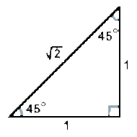
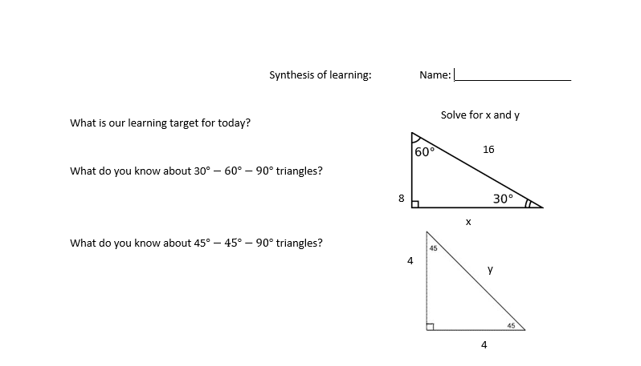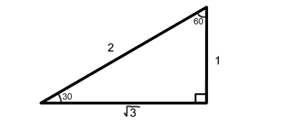
What ratio of the sides of a 30° - 60° - 90° triangle did you use to figure out the missing side?

What ratio of the sides of a 45° - 45° - 90° triangle did you use to figure out the missing side?

v
w
Solve for the missing side lengths

Commentary

Today we will start by having a class discussion about special right triangles

The central focus of this learning segment is special right triangles and understanding the relationship between the angles and the side lengths. Prior to this lesson students have learned about right triangles and how to use the Pythagorean theorem to find side lengths. The concepts that students are going to be focusing on is the side lengths of special right triangles and their angle measures. They will complete the Synthesis of Learning half sheet following a class discussion that is student led and the teacher only mediates. The critical thinking function students will be using is drawing conclusions. They know that the goal of today is to understand the relationship between sides and angles of right triangles and to be able to synthesize that. So they will be drawing conclusions from their discussion and with this information they will complete their Synthesis of Learning half sheet. The connections students should be using/making is that in a 30-60-90 triangle the hypotenuse is 2 times the shortest leg and that the longer leg is the square root of 3 times the shortest leg. In a 45-45-90 triangle the two legs are the same length and the hypotenuse is the square root of 2 times the length of the leg. They should be able to describe these relationships and solve for missing side lengths.

Solution
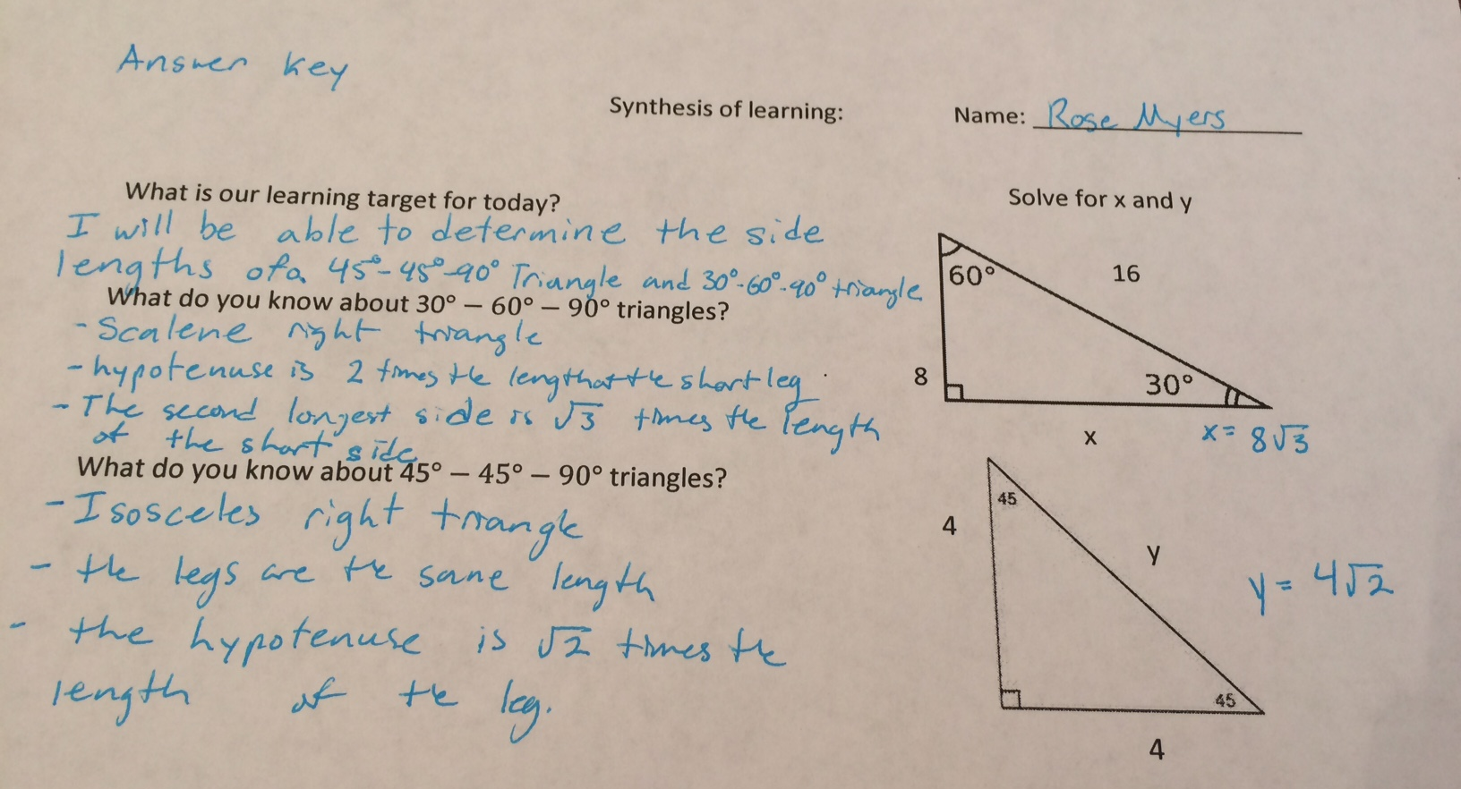
What ratio of the sides of a 30° - 60° - 90° triangle did you use to figure out the missing side? $1:\frac{1}{2} : \frac{\sqrt{3}}{2}$
$\frac{8}{x}=\frac{1}{\sqrt{3}} so x=8\sqrt{3}$
And
$\frac{x}{\sqrt{3}}=\frac{1}{\sqrt{3}}$ so x = 1
What ratio of the sides of a 45° - 45° - 90° triangle did you use to figure out the missing side? $1 :1 : \sqrt{2}$

$$\frac{4}{y}=\frac{1}{\sqrt{2}} so y=4\sqrt{2}$$
And $\frac{v}{\sqrt{2}}=\frac{1}{\sqrt{2}}$ so v = 1

