What Are Functions?

Group Members: Date:

Answer the Lead in question: What is a function and how is it useful?
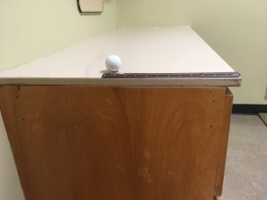
Activity Instructions:
- Decide which group members will video tape the trials and push the ball.
- Position ruler on the side of your desk so that the entire length of the ruler will be seen in the video and is parallel to the floor.
- Open Video Physics on your iPad.

- Position the ball at the end of the ruler that is the farthest away from the edge of the table.
- Now record three individual videos using Video Physics.
- In the first video, push the ball off of the table along the length of the ruler by using a moderate amount of force.
- In the second video, push the ball off of the table along the length of the ruler by using less force than used in the first video so that the ball rolls slower than in the first video.
- In the third, video push the ball off of the table along the length of the ruler by using more force than what was used in the first video so that the ball rolls faster than in the first video.
- Now it is time to use the features of Video Physics to graph the movement of the ball:
- First, go slowly through the video and place dots along the path of the ball so that the path is clearly represented. Make sure to have a dot at the starting point, the point where the ball first touches the ground, and at the ending point of the ball’s motion.
- Next, set the scale so that it is the same length as the ruler.
- Then, move the axis so that the point at which the ball first touched the ground is along the x-axis and the ball’s starting point is along the y-axis.
- Repeat these steps for each of the three videos.
- Now look at each graph that you have create.
- Now that you have three graphs, use what you know about finding slopes to compare all three graphs. How are they different, how are they the same?
- What do the points that you have plotted represent in these graphs? What variable is represented by the x coordinates? What variable is represented by the y coordinates?
- Can you create a function that represents this data? If so what is it?
- In your own words, give a general definition of a function based off of what you have learned.

