Solving Linear Systems
Learning Targets for lesson:
• I can solve a linear system, algebraically and graphically, and describe if it has no, one, or infinite solutions
• I can use proper mathematical language to describe my thinking (process and reasoning)
• I can decontextualize a problem and contextualize the solution(s) of a linear systems problem
Warm Up
Solve these single variable equations
$35=2(x+3)$ $29=\left(x-39\right)+5(x+7)$ $\frac{1}{3}=2x-\frac{1}{3}$

Solve for y
$60=x+y$ $125=3x-2y$ $8=x-\frac{y}{5}$

Finding the Intersection
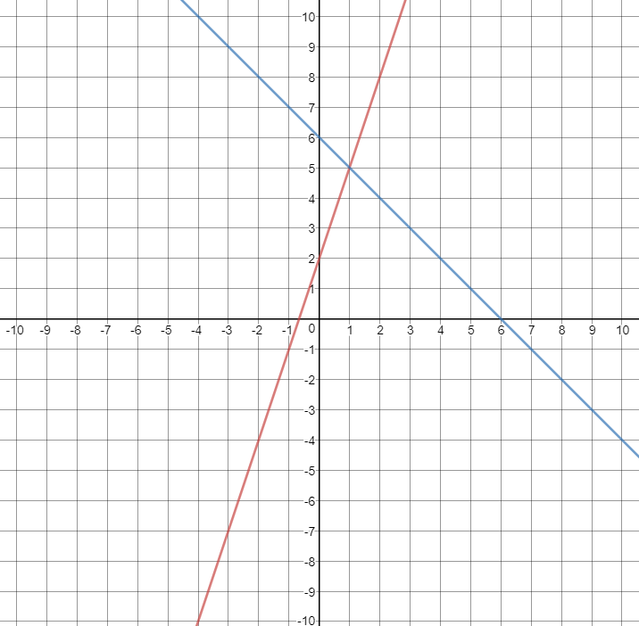
Use the graph to answer the following questions
- What is the equation for the red line?

- What is the equation for the blue line?

- Where do the lines intersect?
At x = ___ and y = ___
- How could you find the same x and y without using the graph? Work with your partner to think of a way.

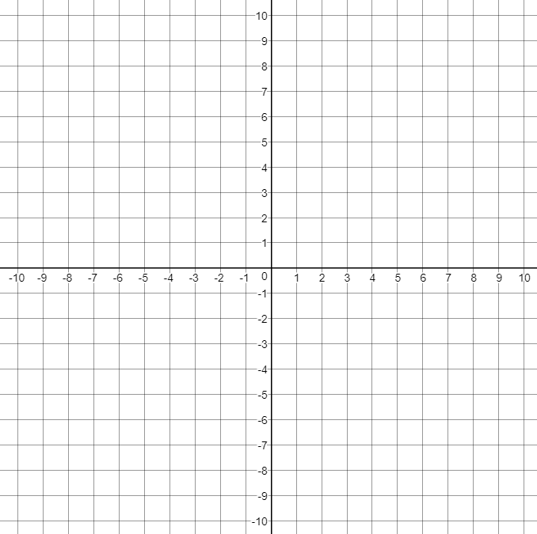
Solve the following systems and THEN graph the equations on the given Cartesian planes to check your answers.
- $y=4x+2$
$$y=2x+1$$

- $3y=x+2$
$$4y=-4x+40$$

- $5=x+y$
$$4=2x+y$$

Special Cases
Sometimes we have systems with no solutions, or infinitely many solutions! Look at the systems below and try and figure out which is system with no solutions, and which one has an infinite number of solutions. Use the graph AND solve the system algebraically to give a reason why for your answers.
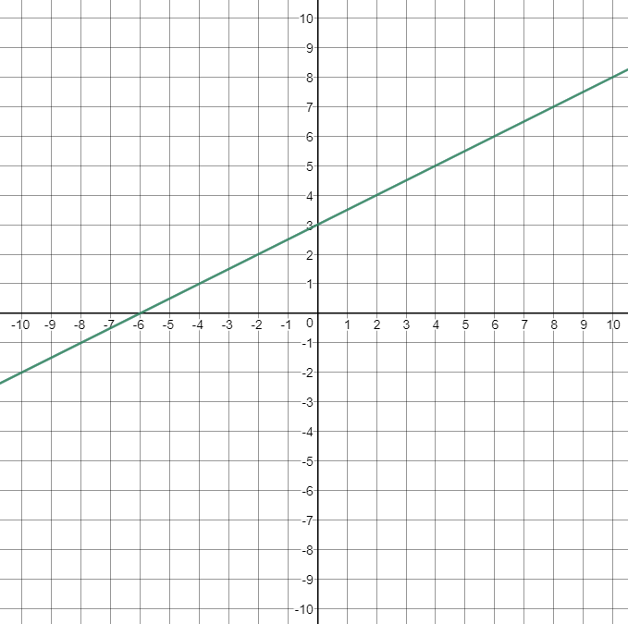
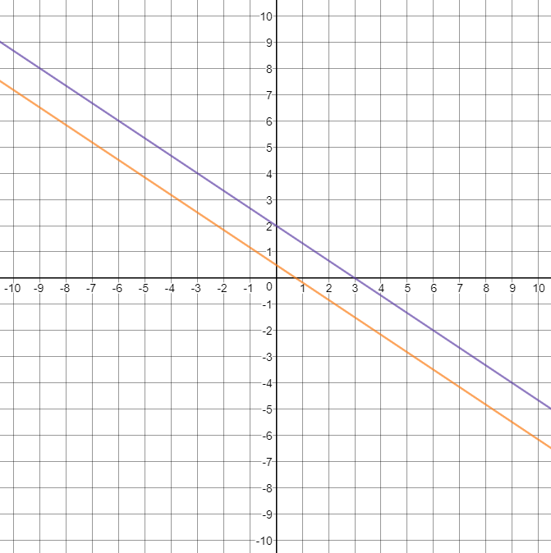

$6=2x+3y$ $-3=\frac{1}{2}x-y$
$3=4x+6y$ $-6=x-2y$

What do you notice between the no solution, the one solution, and the zero solutions systems? Talk with each other to come up with some ideas.

Systems IRL
Systems are everywhere in the real world. The following is one example of such a real-world system of equations:

Vilma and Barbara were having a bicycle race. Vilma cheated and got a head start of about 5 feet. Barbara, however, was going at a nice 15 feet per second (about 10 miles per hour)! Vilma, however, was going at 8 feet per second because she was riding a tricycle.

- Write two equations, one for Vilma and Barbara, and solve the system. Round your solution to the nearest tenth.

- Graph the system below and check to see if your solution.
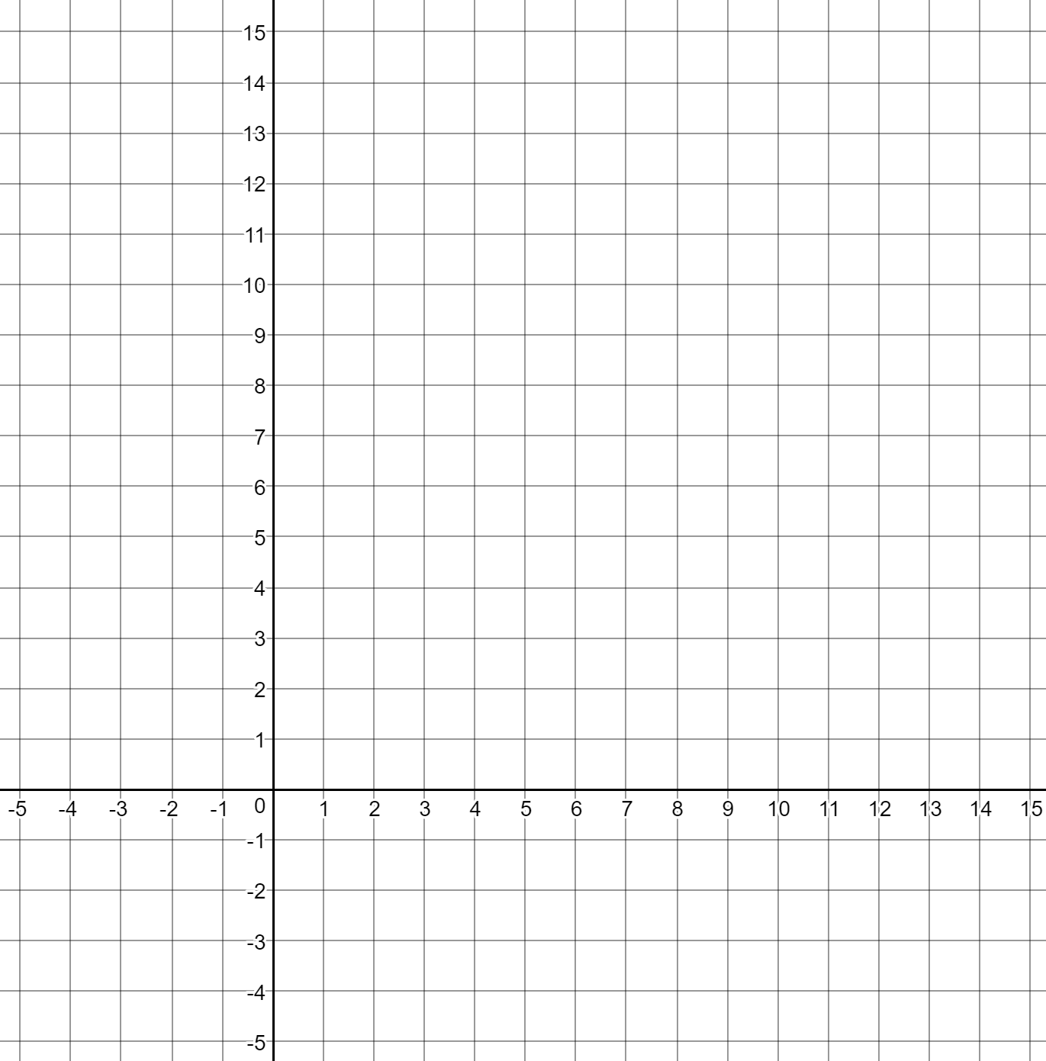
- This system only had one solution. But what if it had infinite solutions? Without changing the equation for Vilma, what would have to change about the word problem, Barbara’s equation, and the graph to make the system have infinite solutions?

- Do problem 3 again, but for no solutions (keeping Vilma’s equation the same).

