Rolling Through Motion
Names:

Learning Target- I will be able to visualize what the path of the object(s) used will be when rolled on an incline. Then I will be able to use a motion detector with a graphing calculator to create a graph that represents the path in relation to time and distance of the object(s).
Introduction Task-
- Roll the tennis ball up the incline, not to let it go off the edge, and let it roll back to the bottom.
- Draw a graph of what you think the path of the ball, in relation to distance and time, will look like.
- Now repeat the task for the toy car. (Hint: The speed of the car may be different than the ball)
Tennis Ball Car
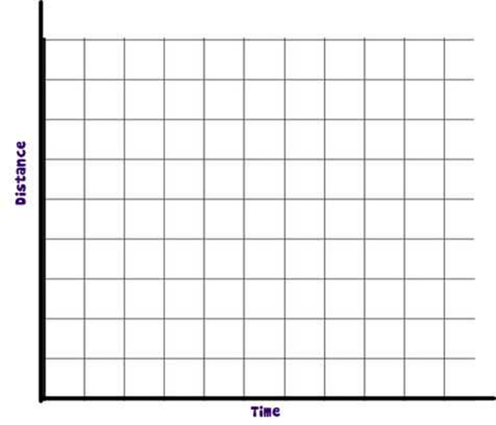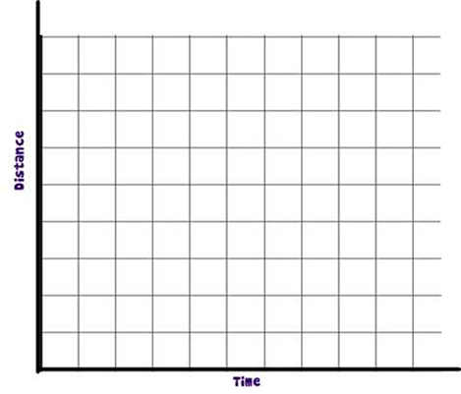

Procedure- Using the motion detector, placed at the top of the ramp, and a TI-84 Plus graphing calculator, do the following:
- Roll the tennis ball up the incline, not to let it go off the edge, and let it roll back to the bottom.
  - Observe the graph on the calculator and sketch it below.
  - Explain what you have observed from the graph and the movement of the ball.
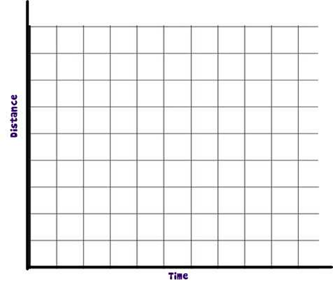

Explain:

- Push the toy car up the ramp and let it roll back down, similar to the first part.
  - Observe the graph on the calculator and sketch it below.
  - Explain what you have observed from the graph and the movement of the toy car.

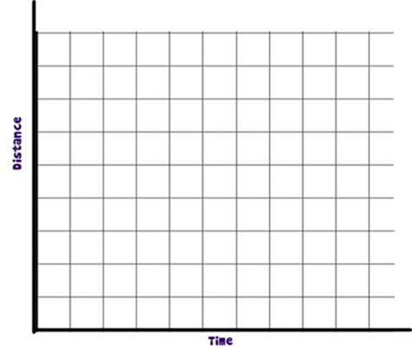
Explain:

- Compare the two objects rolled up the ramp. What is the difference? Same? What factors may have caused them to be different/similar?

