Chocolate Chip Cookies (Makes 5 dozen)
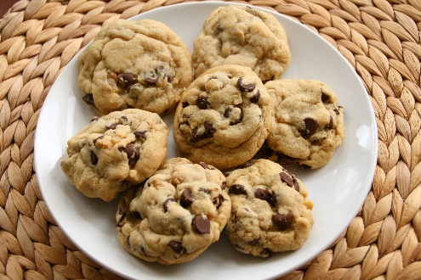
- 2 ¼ cups all- purpose flour
- 1 teaspoon baking soda
- 1 teaspoon salt
- 1 cup (2 sticks) butter, softened
- 3/4 cup granulated sugar
- 3/4 cup packed brown sugar
- 1 teaspoon vanilla extract
- 2 large eggs
- 2 cups semi-sweet chocolate chip cookies
Instructions for baking https://www.verybestbaking.com/recipes/18476/original-nestle-toll-house-chocolate-chip-cookies/
Brownies (Makes 10 Brownies)
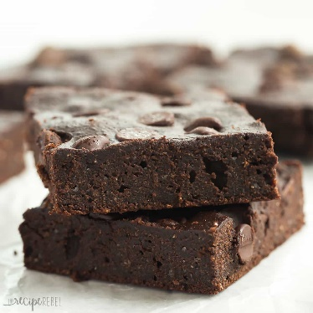
- ¹⁄₂ cup vegetable oil
- 1 cup sugar
- 1 teaspoon vanilla
- 2 large eggs
- ¹⁄₄ teaspoon baking powder
- ¹⁄₃ cup cocoa powder
- ¹⁄₄ teaspoon salt
- ¹⁄₂ cup flour
- 1 ½ cups semi-sweet chocolate chips
Instructions for baking http://www.geniuskitchen.com/recipe/the-best-brownies-54225
Healthy Substitutes
- Baking powder 1 cup = ½ tsp baking soda and ½ cup of buttermilk
- Brown Sugar 1 cup = ½ cup of liquid brown sugar
- Butter 1 cup = ½ cup of coconut oil and ½ cup of applesauce
- Egg 1 = ¼ cup of mashed banana
- Chocolate chips 1 ounce = 3/5-ounce unsweetened chocolate chips
- Flour 1 cup = 7/8 cup of rice flour OR 5/8 cup potato flour
- Sugar 1 cup = ¾ cup of honey
- Vegetable oil 1 cup = 1 cup applesauce

