No Bake Recipe Options
Banana Pudding
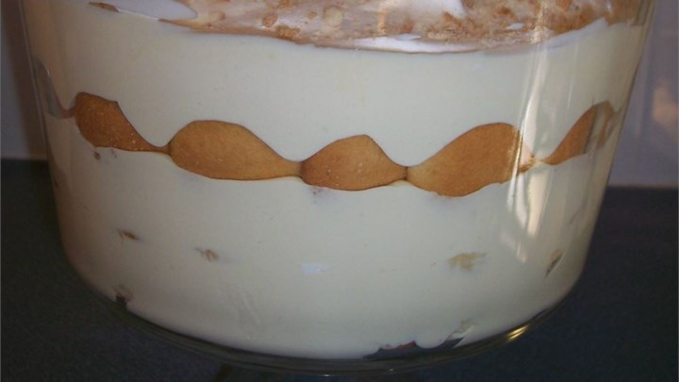
Serves 4
INGREDIENTS
¼ (5 ounce) package instant vanilla pudding mix
1/3 cup and 1 tablespoon cold milk
¼ (14 ounce) can sweetened condensed milk
½ teaspoon vanilla extract
¼ (12 ounce) container frozen whipped topping, thawed
¼ (16 ounce) package vanilla wafers
2 ¾ cups bananas sliced
Cookies and Cream Mousse
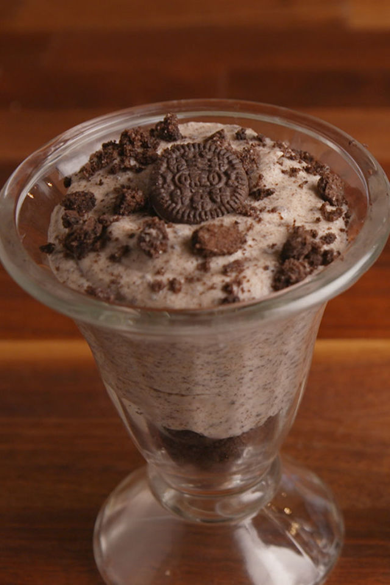
Serves 4
INGREDIENTS
1 tsp. powdered gelatin
1/8 cup water
1¼ c. heavy cream, divided
1½ c. white chocolate chips
1 tsp. pure vanilla extract
1 ¼ cups crushed Oreos
4 mini Oreos, for garnish
Edible Cookie Dough Bites
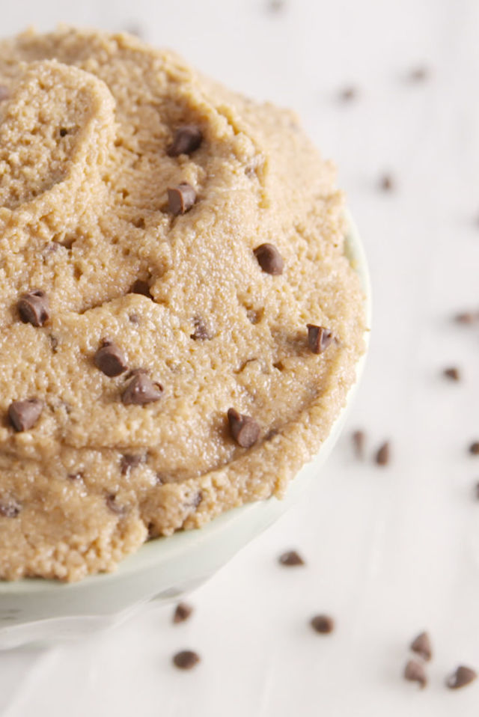
Serves 4
INGREDIENTS
¼ cup and 2 tablespoons packed brown sugar
¼ cup butter
½ teaspoon vanilla extract
¼ teaspoon salt
½ cup all-purpose flour
1 tablespoon milk
¼ cup milk chocolate chips
¼ cup mini chocolate chips
No Bake Cookies
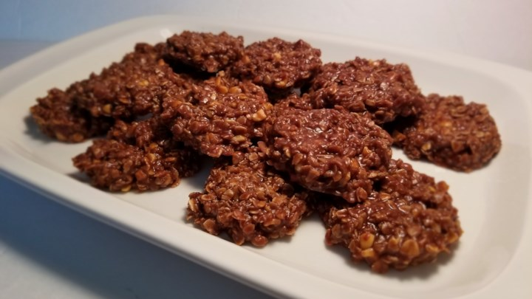
Serves 4
Ingredients
3 tablespoons and 1 ¾ teaspoons white sugar
1 ¼ teaspoons unsweetened cocoa powder
2 ¾ teaspoons milk
2 ¾ teaspoons margarine
1/8 teaspoon vanilla extract
1/8 pinch salt
2 ¾ teaspoons sun butter
1/3 cup quick cooking oats

