Gillian Giles
CCSS-Math

7.G.A.1 Geometry: Draw, construct, and describe geometrical figures and describe the relationship between them.
- The students will be finding areas and demonstrating their knowledge of the different shapes used throughout the unit.

HSG-GPE.B.7 Expressing Geometric Properties with Equations: Use coordinates to prove simple geometric theorems algebraically.
- During lesson 6.7, there will be a couple problems where the students need to use the distance formula to algebraically solve for one side of a shape in the coordinate plane.

HSG-SRT.B.4 Similarity, Right Triangles, & Trigonometry: Prove theorems involving similarity.
- During the lesson about areas, 6.7, the students will need to use the Pythagorean Theorem to solve for the height of triangles.

Learning Progression: Geometry

This learning progression was created with the intent of using it in a high school, 10th grade, geometry class with a mix of visual, kinesthetic, and auditory learners. The Common Core State Standards for this learning progression are 7.G.A.1, HSG-GPE.B.7, and HSG-SRT.B.4. This cluster of standards ranges from algebraically solving the lengths of a shape that is located on the coordinate plane, to using the Pythagorean Theorem to solve for an unknown side length of a right triangle. The CCSS that pertain to this learning progression all incorporate a skill needed to solve different mathematical problems involving shapes and their corresponding areas. The students will be able to apply their new knowledge of areas and area formulas to specific problems, as well as use their prior knowledge of algebra and geometry.

The curriculum the students are learning is based off the textbook Geometry by Mcdougal Little. This unit is focused on areas and the different components of what makes a specific shape categorized as it is. The students may have some background on the types of shapes we will focus on, i.e. kite, rhombus, rectangle, etc., but limited knowledge on the aspects of areas and area formulas.

The central focus of this learning progression is to allow time for the students to retain some new information about shapes and areas, as well as review material for their upcoming unit test. By the end of this unit, the students should be able to identify the name of a given shape, decide how to solve for any missing side lengths, and use the area formulas to solve for the areas of trapezoids, rhombuses, kites, quadrilaterals, parallelograms, and triangles. Each task for this learning progression will be based off the students’ learning styles, and, for this specific class, there seems to be more visual/kinesthetic learners rather than auditory. The main lesson, chapter 6.7, was created based on the ideas of Bruner’s Constructivism theory, that learning is benefitial to all students when the lesson is more discovery-based. For the students who might not grasp the concepts of area, I will be available for any clarification and guidance. The students will also be able to collaborate and discuss ideas with their peers.
*The chapter 6.7 lesson will include a walk around activity, an entry/exit task, and some note taking.

Hinge question (entry task):

Did you know that a TV’s size is based on the measure of the diagonal? Based on the picture below, how might you solve for the missing side length? How might you solve for the area?

*There will be a picture of a TV with a diagonal of 42” and a length of 36”. The students will need to use the Pythagorean Theorem to solve for the missing side length (prior knowledge) and they will need to make a conjecture on how to solve for the area
.

Task 1:
The first task the students will be performing is a simple entry task. This entry task will include a picture of a TV and its diagonal length in inches as well as the base length in inches. This task was made for me to be able to assess whether the students recall the Pythagorean Theorem in order to solve for missing side lengths of a right triangle (picture is shown below).
36”
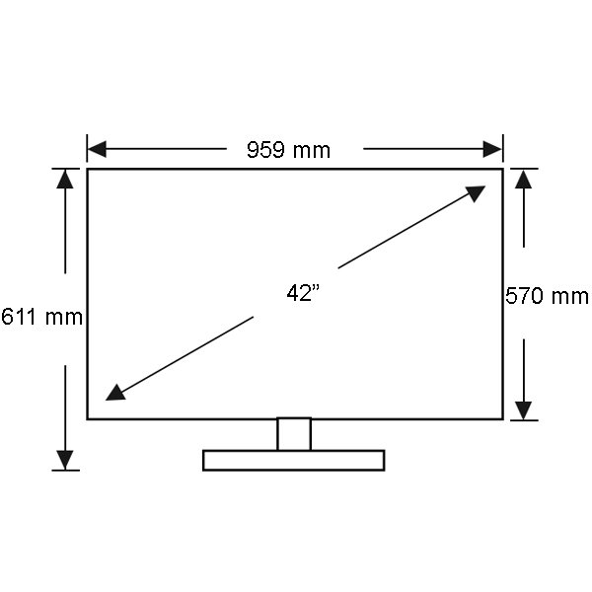
x

There will be some practice problems in the next task that the students will need to use the Pythagorean Theorem to eventually solve for the area.

Task 2:

*For task 2, the more challenging problem I explain will show me whether or not they are able to use their prior knowledge of the distance formula to solve for the lengths of the trapezoid.

This next task will still focus on the areas of triangles, quadrilaterals, parallelograms, trapezoids, kites, and rhombuses. For this task, there will be 12 different problems that involve solving areas taped to the walls around the room. These problems will vary from simpler to more challenging. The students will be able to use their notes and their peers for guidance on how to solve for the area of each shape in each problem. The students will be getting up and moving around the room, choosing at least eight of the problems to work on. One of the easier problems I created was a trapezoid with only the midsegment length and the height length, where the students will need to write the name of the shape and what the area is (midsegment multiplied by the height). One of the more challenging, or tedious, problems was a trapezoid with the vertices written as coordinates on the coordinate plane. For this problem, the students need to solve the distance between the points in order to find the two base lengths by using the distance formula. Then they will need to assess what the height is by subtracting one of the coordinate’s y distance from another coordinate’s y distance. They will use the area formula for a trapezoid, ½(base 1+base 2), in ordre to solve for the area. This activity will allow the more visual/kinesthetic learners to get up and move around while also using their new area solving skills.

Task 3:
This task is an exit slip that relates to the task 1 entry task. This will be used as more of a high-ceiling resource for the students who may need more of a challenge, however, it will also assess whether the students retained any of the information regarding solving for areas. The exit slip will include the previously mentioned picture of the TV, however, this time, it will be mounted on a six foot by eight foot wall. The students will be asked how much wall space will be left if the TV were mounted anywhere on the wall. The students will need to use inquistitve thinking skills in order to grasp the concepts of subtracting one area from the next in order to solve for the surrounding wall space of the TV.

*For the exit task, the students will need to pay close attention to the conversions between inches and feet and may choose either inches or feet to convert the left over wall space area to. The students will also need to be aware of the original distance of the TV, and will need to know how to solve for the area of a rectangular wall.

Hinge question (exit task):

If I were to mount this 42” TV on a rectangular wall with dimensions six feet by eight feet, how much wall space will I have left over?

